UNITED STATES

SECURITIES AND EXCHANGE COMMISSION

Washington, D.C. 20549

_______________________

FORM 10-Q

_______________________

(Mark One)

- QUARTERLY REPORT PURSUANT TO SECTION 13 OR 15(d) OF THE SECURITIES EXCHANGE ACT OF 1934

For the quarterly period ended March 31, 2024

OR

- TRANSITION REPORT PURSUANT TO SECTION 13 OR 15(d) OF THE SECURITIES EXCHANGE ACT OF 1934

For the transition period from

Commission File Number: 001-39463

_______________________

to

 | Ouster, Inc.
 | (Exact name of registrant as specified in its charter)
 | _______________________
Delaware |  |  |  |  |  | 86-2528989
(State or other jurisdiction |  |  |  |  |  | (I.R.S. Employer
of incorporation) |  |  |  |  |  | Identification No.)
 | 350 Treat Avenue
 | San Francisco, California 94110
(Address of principal executive offices) (Zip Code)
 | (415) 949-0108
(Registrant’s telephone number, including area code)
 |  |  | N/A
(Former name, former address, and former fiscal year, if changed since last report)
 | _______________________
 |  |  | Trading |  |  | Name of each exchange
Title of each class |  |  | Symbol(s) |  |  | on which registered
Common stock, $0.0001 par value per share |  |  | OUST |  |  | New York Stock Exchange
Warrants to purchase common stock |  |  | OUST WS |  |  | New York Stock Exchange
Warrants to purchase common stock expiring 2025 |  |  | OUST WSA |  |  | NYSE American

Indicate by check mark whether the registrant (1) has filed all reports required to be filed by Section 13 or 15(d) of the Securities Exchange Act of 1934 during the preceding 12 months (or for such

shorter period that the registrant was required to file such reports), and (2) has been subject to such filing requirements for the past 90 days. Yes ☒ No ☐

Indicate by check mark whether the registrant has submitted electronically every Interactive Data File required to be submitted pursuant to Rule 405 of Regulation S-T (§232.405 of this chapter)

during the preceding 12 months (or for such shorter period that the registrant was required to submit such files). Yes ☒ No ☐

Indicate by check mark whether the registrant is a large accelerated filer, an accelerated filer, a non-accelerated filer, a smaller reporting company, or an emerging growth company. See the definitions of “large accelerated filer,” “accelerated filer,” “smaller reporting company,” and “emerging growth company” in Rule 12b-2 of the Exchange Act.

Large accelerated filer | ☐ | Accelerated filer | ☐
Non-accelerated filer | ☒ | Smaller reporting company | ☒
Emerging growth company | ☐

If an emerging growth company, indicate by check mark if the registrant has elected not to use the extended transition period for complying with any new or revised financial accounting standards provided pursuant to Section 13(a) of the Exchange Act. ☐

Indicate by check mark whether the registrant is a shell company (as defined in Rule 12b-2 of the Exchange Act). Yes ☐ No ☒

As of May 9, 2024, the registrant had 45,225,055 shares of common stock, $0.0001 par value per share, outstanding.

1

Table of Contents
 |  |  |  |  |  |  |  |  |  |  |  |  |  |  |  |  |  | TABLE OF CONTENTS
 |  |  |  |  |  |  |  |  |  |  |  |  |  |  |  |  | Part I - Financial Information |  |  |  |  | Page
 | Item 1. |  |  |  | Financial Statements |  |  |  |  |  |  |  |  |  |  |  |  |  |  |  |  | 4
 |  |  |  |  | Condensed Consolidated Balance Sheets (Unaudited) |  |  |  |  |  |  |  |  |  |  |  |  |  |  |  |  | 4
 |  |  |  |  | Condensed Consolidated Statements of Operations and Comprehensive Loss (Unaudited) |  |  |  |  |  |  |  |  |  |  |  |  |  |  |  |  | 5
 |  |  |  |  | Condensed Consolidated Statements of Stockholders’ Equity (Unaudited) |  |  |  |  |  |  |  |  |  |  |  |  |  |  |  |  | 6
 |  |  |  |  | Condensed Consolidated Statements of Cash Flows (Unaudited) |  |  |  |  |  |  |  |  |  |  |  |  |  |  |  |  | 7
 |  |  |  |  | Notes to Condensed Consolidated Financial Statements (Unaudited) |  |  |  |  |  |  |  |  |  |  |  |  |  |  |  |  | 9
 | Item 2. |  |  |  | Management’s Discussion and Analysis of Financial Condition and Results of Operations |  |  |  |  |  |  |  |  |  |  |  |  |  |  |  |  | 29
 | Item 3. |  |  |  | Quantitative and Qualitative Disclosures About Market Risk |  |  |  |  |  |  |  |  |  |  |  |  |  |  |  |  | 40
 | Item 4. |  |  |  | Controls and Procedures |  |  |  |  |  |  |  |  |  |  |  |  |  |  |  |  | 41
 |  |  |  |  |  |  |  |  |  |  |  |  |  |  |  |  | Part II - Other Information
 | Item 1. |  |  |  | Legal Proceedings |  |  |  |  |  |  |  |  |  |  |  |  |  |  |  |  | 43
 | Item 1A. |  |  |  | Risk Factors |  |  |  |  |  |  |  |  |  |  |  |  |  |  |  |  | 43
 | Item 2. |  |  |  | Unregistered Sales of Equity Securities and Use of Proceeds |  |  |  |  |  |  |  |  |  |  |  |  |  |  |  |  | 43
 | Item 3. |  |  |  | Defaults Upon Senior Securities |  |  |  |  |  |  |  |  |  |  |  |  |  |  |  |  | 43
 | Item 4. |  |  |  | Mine Safety Disclosures |  |  |  |  |  |  |  |  |  |  |  |  |  |  |  |  | 43
 | Item 5. |  |  |  | Other Information |  |  |  |  |  |  |  |  |  |  |  |  |  |  |  |  | 43
 | Item 6. |  |  |  | Exhibits |  |  |  |  |  |  |  |  |  |  |  |  |  |  |  |  | 44
 | Signature |  |  |  |  |  |  |  |  |  |  |  |  |  |  |  |  |  |  |  |  | 46
 |  |  |  |  | 2

Table of Contents

SPECIAL NOTE REGARDING FORWARD-LOOKING STATEMENTS

This Quarterly Report on Form 10-Q (“Quarterly Report”) contains forward-looking statements within the meaning of the Private Securities Litigation Reform Act of 1995. Ouster, Inc. (the “Company”, “Ouster,” or “we”) intend such forward-looking statements to be covered by the safe harbor provisions for forward-looking statements contained in Section 27A of the Securities Act of 1933, as amended (the “Securities Act”), and Section 21E of the Securities Exchange Act of 1934, as amended (the “Exchange Act”). All statements contained in this Quarterly Report other than statements of historical fact, including, without limitation, statements regarding expected contractual obligations and capital expenditures; the capabilities of and demand for Ouster’s products; Ouster’s anticipated new product launches and developments; including software-related solution systems, and the timing for those launches and developments; Ouster’s ability to grow its sales and marketing organizations; Ouster’s future results of operations, cash reserve and financial position; projected industry and business trends; the remediation of material weaknesses; potential risks of inventory obsolescence; Ouster’s future business strategy, plans, distribution partnerships, market growth and its objectives for future operations; Ouster’s competitive market position within its industry and the impact of market conditions and other macroeconomic factors on Ouster’s business, financial condition and results of operation, are forward-looking statements. The words “believe,” “may,” “will,” “estimate,” “continue,” “anticipate,” “intend,” “expect,” “could,” “would,” “project,” “plan,” “potentially,” “preliminary,” “likely,” “aim,” “forecast,” “should,” “can have,” “likely,” and similar expressions are intended to identify forward-looking statements. The Company has based these forward-looking statements largely on its current expectations and projections about future events and trends that it believes may affect its financial condition, results of operations, business strategy, short-term and long-term business operations and objectives, and financial needs. These forward-looking statements speak only as of the date of this Quarterly Report and are subject to a number of risks, uncertainties, and assumptions that may cause actual results to differ materially from those that Ouster expected, including, but not limited to, Ouster’s limited operating history and history of losses; its ability to successfully integrate its business with Velodyne and achieve the anticipated benefits and synergies of the Velodyne Merger; substantial research and development costs needed to develop and commercialize new products; fluctuations in its operating results; Ouster’s ability to maintain competitive average selling prices or high sales volumes or reduce product costs; conditions in its customers’ industries; the competitive environment in which Ouster operates; the negotiating power and product standards of its customers; the creditworthiness of Ouster’s customers; the ability of its lidar technology roadmap and new software solutions to catalyze growth; the selection of Ouster’s products for inclusion in target markets; risks of product delivery problems or defects; costs associated with product warranties; Ouster’s future capital needs and ability to secure additional capital on favorable terms or at all; inaccurate forecasts of market growth; Ouster’s ability to manage growth; Ouster’s ability to grow its sales and marketing organization; risks related to acquisitions; risks related to international operations and compliance; cancellation or postponement of contracts or unsuccessful implementations; Ouster’s ability to maintain inventory and the risk of inventory write-downs; its ability to use tax attributes; Ouster’s dependence on key third-party suppliers, in particular Benchmark Electronics, Inc. and Fabrinet; supply chain constraints and challenges; risks related to Ouster’s indebtedness; Ouster’s ability to recruit and retain key personnel; Ouster’s ability to effectively respond to evolving regulations and standards; Ouster’s ability to adequately protect and enforce its intellectual property rights, including as it relates to Hesai; risks related to operating as a public company; and other important factors discussed in the Company’s Annual Report on Form 10-K for the fiscal year ended December 31, 2023, that are further updated from time to time in the Company’s other filings with the Securities and Exchange Commission (the “SEC”) that may cause its actual results, performance or achievements to differ materially and adversely from those expressed or implied by the forward-looking statements. Any forward-looking statements made herein speak only as of the date of this Quarterly Report, and you should not rely on forward-looking statements as predictions of future events. Although we believe that the expectations reflected in the forward-looking statements are reasonable, we cannot guarantee that the future results, performance, or achievements reflected in the forward-looking statements will be achieved or occur. Except as required by applicable law, we undertake no obligation to update any of these forward-looking statements for any reason after the date of this Quarterly Report or to conform these statements to actual results or revised expectations.

GENERAL

Unless the context otherwise indicates, references in this Quarterly Report to the terms “Ouster,” “the Company,” “we,” “our” and “us” refer to Ouster, Inc.

We may announce material business and financial information to our investors using our investor relations website at https://investors.ouster.com/overview. We therefore encourage investors and others interested in Ouster to review the information that we make available on our website, in addition to following our SEC filings, webcasts, press releases and conference calls. Information contained on our website is not part of this Quarterly Report.

3

Table of Contents

PART I. FINANCIAL INFORMATION

Item 1. Financial Statements

OUSTER, INC.

CONDENSED CONSOLIDATED BALANCE SHEETS

(unaudited)

(in thousands, except share and per share data)

 |  | March 31, |  |  | December 31,
 |  | 2024 |  |  | 2023
Assets
Current assets:
Cash and cash equivalents | $ | 48,270 |  | $ | 50,991
Restricted cash, current |  | 564 |  |  | 552
Short-term investments |  | 139,546 |  |  | 139,158
Accounts receivable, net |  | 12,220 |  |  | 14,577
Inventory |  | 21,070 |  |  | 23,232
Prepaid expenses and other current assets |  | 34,808 |  |  | 34,647
Total current assets |  | 256,478 |  |  | 263,157
Property and equipment, net |  | 10,513 |  |  | 10,228
Unbilled receivable, non-current portion |  | 7,043 |  |  | 10,567
Operating lease, right-of-use assets |  | 17,411 |  |  | 18,561
Intangible assets, net |  | 22,592 |  |  | 24,436
Restricted cash, non-current |  | 1,091 |  |  | 1,091
Other non-current assets |  | 2,555 |  |  | 2,703
Total assets | $ | 317,683 |  | $ | 330,743
Liabilities and stockholders’ equity
Current liabilities:
Accounts payable | $ | 6,122 |  | $ | 3,545
Accrued and other current liabilities |  | 56,375 |  |  | 58,166
Contract liabilities, current |  | 13,429 |  |  | 12,885
Operating lease liability, current portion |  | 7,153 |  |  | 7,096
Total current liabilities |  | 83,079 |  |  | 81,692
Operating lease liability, non-current portion |  | 17,278 |  |  | 18,827
Debt |  | 43,973 |  |  | 43,975
Contract liabilities, non-current portion |  | 4,483 |  |  | 4,967
Other non-current liabilities |  | 1,638 |  |  | 1,610
Total liabilities |  | 150,451 |  |  | 151,071
Commitments and contingencies (Note 8)
Stockholders’ equity:
Common stock, $0.0001 par value; 100,000,000 shares authorized at March 31, 2024 and December 31, 2023; 44,978,704 and 43,257,863 issued |  | 44 |  |  | 42
and outstanding at March 31, 2024 and December 31, 2023, respectively. |  | 44 |  |  | 42
Additional paid-in capital |  | 1,007,502 |  |  | 995,464
Accumulated deficit |  | (839,875) |  |  | (816,026)
Accumulated other comprehensive (loss) income |  | (439) |  |  | 192
Total stockholders’ equity |  | 167,232 |  |  | 179,672
Total liabilities and stockholders’ equity | $ | 317,683 |  | $ | 330,743

The accompanying notes are an integral part of these condensed consolidated financial statements

4

Table of Contents

OUSTER, INC.

CONDENSED CONSOLIDATED STATEMENTS OF OPERATIONS AND COMPREHENSIVE LOSS

(unaudited)

(in thousands, except share and per share data)

 |  | Three Months Ended March 31,
 |  | 2024 |  |  | 2023
Revenue | $ | 25,944 |  | $ | 17,230
Cost of revenue |  | 18,519 |  |  | 17,606
Gross profit (loss) |  | 7,425 |  |  | (376)
Operating expenses:
Research and development |  | 13,806 |  |  | 32,459
Sales and marketing |  | 6,860 |  |  | 13,533
General and administrative |  | 12,580 |  |  | 31,325
Goodwill impairment charges |  | — |  |  | 99,409
Total operating expenses |  | 33,246 |  |  | 176,726
Loss from operations |  | (25,821) |  |  | (177,102)
Other income (expense):
Interest income |  | 2,651 |  |  | 1,719
Interest expense |  | (741) |  |  | (1,669)
Other income, net |  | 193 |  |  | 54
Total other income, net |  | 2,103 |  |  | 104
Loss before income taxes |  | (23,718) |  |  | (176,998)
Provision for income tax expense |  | 131 |  |  | 282
Net loss | $ | (23,849) |  | $ | (177,280)
Other comprehensive loss
Changes in unrealized (loss) gain on available for sale securities | $ | (459) |  | $ | 51
Foreign currency translation adjustments | $ | (172) |  | $ | (81)
Total comprehensive loss | $ | (24,480) |  | $ | (177,310)
Net loss per common share, basic and diluted | $ | (0.55) |  | $ | (6.03)
Weighted-average shares used to compute basic and diluted net loss per share
 |  | 43,454,127 |  |  | 29,411,612

The accompanying notes are an integral part of these condensed consolidated financial statements

5

Table of Contents

OUSTER, INC.

CONDENSED CONSOLIDATED STATEMENTS OF STOCKHOLDERS’ EQUITY

(unaudited)

(in thousands, except share data)

 | Common Stock |  |  |  |  |  | Additional |  |  |  |  |  |  |  |  | Total
 |  |  |  |  |  |  | Paid-in- |  |  | Accumulated |  |  | Accumulated other |  |  | Stockholders’
 | Shares |  | Amount |  |  |  | Capital |  |  | Deficit |  |  | comprehensive loss |  |  | Equity
Balance — December 31, 2023 | 43,257,863 |  | $ | 42 |  | $ | 995,464 |  | $ | (816,026) |  | $ | 192 |  | $ | 179,672
Issuance of common stock upon exercise of stock options | 54,374 |  |  | — |  |  | 108 |  |  | — |  |  | — |  |  | 108
Issuance of restricted stock awards | 533,601 |  |  | 1 |  |  | — |  |  | — |  |  | — |  |  | 1
Proceeds from at-the-market offering, net of commissions and fees of $72 | 343,571 |  |  | — |  |  | 2,331 |  |  | — |  |  | — |  |  | 2,331
Issuance of common stock in connection with Velodyne Merger | 29,376 |  |  | — |  |  | — |  |  | — |  |  | — |  |  | —
Issuance of common stock upon vesting of restricted stock | 759,919 |  |  | 1 |  |  | — |  |  | — |  |  | — |  |  | 1
Common stock warrants issuable to customer | — |  |  | — |  |  | 195 |  |  | — |  |  | — |  |  | 195
Stock-based compensation expense | — |  |  | — |  |  | 9,404 |  |  | — |  |  | — |  |  | 9,404
Net loss | — |  |  | — |  |  | — |  |  | (23,849) |  |  | — |  |  | (23,849)
Other Comprehensive loss | — |  |  | — |  |  | — |  |  | — |  |  | (631) |  |  | (631)
Balance — March 31, 2024 | 44,978,704 |  | $ | 44 |  | $ | 1,007,502 |  | $ | (839,875) |  | $ | (439) |  | $ | 167,232
 | Common Stock |  |  |  |  |  | Additional |  |  |  |  |  |  |  |  | Total
 |  |  |  |  |  |  | Paid-in- |  |  | Accumulated |  |  | Accumulated other |  |  | Stockholders’
 | Shares |  | Amount |  |  |  | Capital |  |  | Deficit |  |  | comprehensive loss |  |  | Equity
Balance — December 31, 2022 | 18,658,799 |  | $ | 19 |  | $ | 613,665 |  | $ | (441,916) |  | $ | (149) |  | $ | 171,619
Issuance of common stock upon Velodyne Merger | 19,483,269 |  |  | 20 |  |  | 306,582 |  |  | — |  |  | — |  |  | 306,602
Issuance of common stock upon exercise of stock options | 10,007 |  |  | — |  |  | 18 |  |  | — |  |  | — |  |  | 18
Issuance of common stock upon vesting of restricted stock | 568,675 |  |  | — |  |  | — |  |  | — |  |  | — |  |  | —
Repurchase of common stock | (3,753) |  |  | — |  |  | — |  |  | — |  |  | — |  |  | —
Stock-based compensation expense | — |  |  | — |  |  | 21,780 |  |  | — |  |  | — |  |  | 21,780
Vesting of early exercised stock options | — |  |  | — |  |  | 27 |  |  | — |  |  | — |  |  | 27
Net loss | — |  |  | — |  |  | — |  |  | (177,280) |  |  | — |  |  | (177,280)
Other Comprehensive loss | — |  |  | — |  |  | — |  |  | — |  |  | (30) |  |  | (30)
Balance — March 31, 2023 | 38,716,997 |  | $ | 39 |  | $ | 942,072 |  | $ | (619,196) |  | $ | (179) |  | $ | 322,736

The accompanying notes are an integral part of these condensed consolidated financial statements

6

Table of Contents

OUSTER, INC.

CONDENSED CONSOLIDATED STATEMENTS OF CASH FLOWS

(unaudited)

(in thousands)

 | Three Months Ended March 31,
 | 2024 |  |  | 2023
CASH FLOWS FROM OPERATING ACTIVITIES
Net loss | $ | (23,849) |  | $ | (177,280)
Adjustments to reconcile net loss to net cash used in operating activities:
Goodwill impairment charges |  | — |  |  | 99,409
Depreciation and amortization |  | 2,897 |  |  | 6,159
Loss on write-off of construction in progress and right-of-use asset impairment |  | — |  |  | 1,423
Stock-based compensation |  | 9,404 |  |  | 21,780
Reduction of revenue related to stock warrant issued to customer |  | 195 |  |  | —
Amortization of right-of-use asset |  | 1,150 |  |  | 1,112
Interest expense |  | — |  |  | 685
Amortization of debt issuance costs and debt discount |  | — |  |  | 62
Accretion or amortization on short-term investments |  | (1,486) |  |  | (805)
Change in fair value of warrant liabilities |  | 21 |  |  | (106)
Inventory write down |  | 737 |  |  | 2,836
Provision (recovery of) for doubtful accounts |  | (208) |  |  | 445
Loss from disposal of property and equipment |  | — |  |  | 145
Realized gain on available for sale securities |  | (275) |  |  | —
Changes in operating assets and liabilities:
Accounts receivable |  | 6,089 |  |  | (3,450)
Inventory |  | 1,425 |  |  | (2,329)
Prepaid expenses and other assets |  | (1,268) |  |  | 672
Accounts payable |  | 2,636 |  |  | 5,488
Accrued and other liabilities |  | (1,758) |  |  | (9,218)
Contract liabilities |  | 60 |  |  | 944
Operating lease liability |  | (1,492) |  |  | (984)
Net cash used in operating activities |  | (5,722) |  |  | (53,012)
CASH FLOWS FROM INVESTING ACTIVITIES
Proceeds from sale of property and equipment |  | — |  |  | 168
Purchase of short-term investments |  | (24,485) |  |  | (5,003)
Proceeds from sales of short-term investments |  | 25,398 |  |  | 19,981
Purchases of property and equipment |  | (1,382) |  |  | (1,006)
Cash and cash equivalents acquired in the Velodyne Merger |  | — |  |  | 32,137
Net cash (used in) provided by investing activities |  | (469) |  |  | 46,277
CASH FLOWS FROM FINANCING ACTIVITIES
Proceeds from exercise of stock options |  | 109 |  |  | 18
Proceeds from the issuance of common stock under at-the-market offering, net of commissions and fees |  | 3,587 |  |  | —
At-the-market offering costs for the issuance of common stock |  | (43) |  |  | —
Net cash provided by financing activities |  | 3,653 |  |  | 18
Effect of exchange rates on cash and cash equivalents |  | (170) |  |  | (79)
Net decrease in cash, cash equivalents and restricted cash |  | (2,708) |  |  | (6,796)
Cash, cash equivalents and restricted cash at beginning of period |  | 52,633 |  |  | 124,278
Cash, cash equivalents and restricted cash at end of period | $ | 49,925 |  | $ | 117,482

7

Table of Contents

OUSTER, INC.

CONDENSED CONSOLIDATED STATEMENTS OF CASH FLOWS (continued)

(unaudited)

(in thousands)

 | Three Months Ended March 31,
 | 2024 |  |  | 2023
SUPPLEMENTAL DISCLOSURES OF OPERATING ACTIVITIES:
Cash paid for interest | $ | 740 |  | $ | 1,383
SUPPLEMENTAL DISCLOSURES OF NON-CASH INVESTING AND FINANCING INFORMATION:
Property and equipment purchases included in accounts payable and accrued liabilities | $ | 45 |  | $ | 258
Common stock shares issued in the Velodyne Merger | $ | — |  | $ | 297,425
Common stock warrants issued in the Velodyne Merger
Common stock warrants issued in the Velodyne Merger | $ | — |  | $ | 9,177

The accompanying notes are an integral part of these condensed consolidated financial statements

8

Table of Contents

OUSTER, INC.

NOTES TO CONDENSED CONSOLIDATED FINANCIAL STATEMENTS

(unaudited)

Note 1 – Description of Business and Basis of Presentation

Description of Business

Ouster, Inc. was incorporated in the Cayman Islands on June 4, 2020 as “Colonnade Acquisition Corp”. (“CLA”). Following the closing of the business combination in March 2021, the Company domesticated as a Delaware corporation and changed its name to “Ouster, Inc.” The Company’s prior operating subsidiary, Ouster Technologies, Inc. (“OTI” and prior to the Merger (as defined below)), was incorporated in the state of Delaware on June 30, 2015. The Company is a leading provider of high-resolution digital lidar sensors that offer advanced 3D vision to machinery, vehicles, robots, and fixed infrastructure assets, allowing each to understand and visualize the surrounding world and ultimately enabling safe operation and ubiquitous autonomy. Unless the context otherwise requires, references in this subsection to “the Company” refer to the business and operations of OTI (formerly known as Ouster, Inc.) and its consolidated subsidiaries prior to the Merger (as defined below) and to Ouster, Inc. (formerly known as CLA) and its consolidated subsidiaries following the consummation of the Merger.

CLA, the Company’s legal predecessor, was originally a blank check company incorporated as a Cayman Islands exempted company on June 4, 2020. CLA was formed for the purpose of effecting a merger, share exchange, asset acquisition, share purchase, reorganization or similar business combination with one or more businesses. On March 11, 2021, CLA consummated a merger (the “Merger”) with OTI pursuant to an Agreement and Plan of Merger (the “Merger Agreement”) dated as of December 21, 2020. As a result of the Merger, among a number of other things, (1) each of the then issued and outstanding 10,000,000 redeemable warrants of CLA (the “CLA warrants”) converted automatically into a redeemable warrant to purchase one share of Ouster common stock (the “Public warrants”) pursuant to the Warrant Agreement, dated August 20, 2020 (the “Warrant Agreement”), between CLA and Continental Stock Transfer & Trust Company (“Continental”), as warrant agent and (2) each of the then issued and outstanding 6,000,000 private placement warrants of CLA (the “Private Placement warrants”) converted automatically into a Public warrant pursuant to the Warrant Agreement. No fractional Public warrants were issued upon separation of the CLA units.

On February 10, 2023, the Company completed the merger with Velodyne Lidar, Inc., a Delaware corporation (“Velodyne”) pursuant to the terms of the Agreement and Plan of Merger (the “Velodyne Merger Agreement”) with Velodyne, Oban Merger Sub, Inc. (“Merger Sub I”) and Oban Merger Sub II LLC (“Merger Sub II”) (the “Velodyne Merger”) dated as of November 4, 2022, accounted for as a business combination with the Company being an accounting acquiror (Note 3).

Basis of Presentation and Principles of Consolidation

The unaudited condensed consolidated financial statements include the accounts of the Company and its subsidiaries (all of which are wholly owned) and have been prepared in conformity with U.S.

generally accepted accounting principles (“U.S. GAAP”) applicable to interim periods. All intercompany balances and transactions have been eliminated in consolidation.

The unaudited condensed consolidated financial statements include all adjustments (consisting of only normal recurring adjustments) necessary for a fair statement of the results of operations for the periods shown. The unaudited condensed consolidated financial statements should be read in conjunction with the Company’s audited consolidated financial statements as of and for the year ended December 31, 2023 and the notes related thereto, included in the Company’s Annual Report on Form 10-K filed with the Securities and Exchange Commission (“SEC”) on March 28, 2024. The year-end condensed balance sheet data was derived from audited financial statements, but does not include all disclosures required by U.S. GAAP. Certain information and note disclosures normally included in the audited financial statements prepared in accordance with U.S. GAAP have been condensed or omitted from this report, as is permitted by applicable rules and regulations. The results of operations for any interim period are not necessarily indicative of the results to be expected for the year ending December 31, 2024 or for any other future years or interim periods.

On April 6, 2023, the Board of Directors approved a one-for-10 reverse stock split and a corresponding reduction in authorized shares of common stock (the “Reverse Stock Split”). On April 20, 2023, the Company filed with the Secretary of State of the State of Delaware a Certificate of Amendment to its Certificate of Incorporation to effect the one-for-10 Reverse Stock Split of the Company’s common stock and a corresponding reduction in authorized shares of common stock. The par value of the Company’s common stock was not adjusted as a result of the Reverse Stock Split. All share and per share amounts and related stockholders’ equity balances presented herein have been retroactively adjusted to reflect the Reverse Stock Split.

Liquidity

The Company’s principal sources of liquidity are its cash and cash equivalents, short-term investments, cash generated from revenues, sales of common stock under its at-the-market equity offering program and debt financing.

9

Table of Contents

The accompanying unaudited condensed consolidated financial statements have been prepared on a going concern basis. The Company has experienced recurring losses from operations, and negative cash flows from operations. As of March 31, 2024, the Company’s existing sources of liquidity included cash, cash equivalents, restricted cash and short-term investments of approximately $189.5 million. The Company has incurred losses and negative cash flows from operations for several years. If the Company continues to incur losses in the future, it may need to improve liquidity and raise additional capital through the issuance of equity and/or debt. There can be no assurance that the Company would be able to raise such capital. However, management believes that the Company’s existing sources of liquidity are adequate to fund its operations for at least twelve months from the date the unaudited condensed consolidated financial statements were available for issuance.

Note 2 – Summary of Significant Accounting Policies

During the three months ended March 31, 2024, there were no significant changes to the Company’s significant accounting policies as disclosed in the Company’s Annual Report on Form 10-K filed with the SEC on March 28, 2024. The Company has consistently applied the accounting policies to all periods presented in these unaudited condensed consolidated financial statements.

Recently Issued Accounting Pronouncements Not Yet Adopted

The Company considers the applicability and impact of all Accounting Standards Update (“ASUs”). ASUs not referenced below were assessed and determined to be either not applicable or are not expected to have a material impact on the Company’s unaudited condensed consolidated financial statements.

Concentrations of Credit Risk

Financial instruments that potentially subject the Company to credit risk consist primarily of cash, cash equivalents, restricted cash, short-term investments and accounts receivable. Although the Company deposits its cash, cash equivalents, restricted cash and short-term investments with financial institutions that Company believes are of high credit quality, its deposits, at times, may exceed federally insured limits. As of March 31, 2024 and December 31, 2023, the Company had cash, cash equivalents, short-term investments and restricted cash with financial institutions in the U.S. of $179.3 million and $184.8 million, respectively. As of March 31, 2024 and December 31, 2023, the Company also had cash with financial institutions in countries other than the U.S. of approximately $10.2 million and $7.0 million, respectively.

The Company generally does not require collateral or other security deposits for accounts receivable.

To reduce credit risk, the Company considers customer creditworthiness, past transaction history with the customer, current economic industry trends, and changes in customer payment terms when determining the collectability of specific customer accounts. Past due balances over 90 days and other higher risk amounts are reviewed individually for collectability. Based on management’s assessment, the Company provides for estimated uncollectible amounts through a charge to earnings and a credit to valuation allowance. Balances that remain outstanding after the Company has used reasonable collection efforts are written off through a charge to the valuation allowance and a credit to accounts receivable.

Accounts receivable from the Company’s major customers representing 10% or more of total accounts and unbilled receivable was as follows:

 |  | March 31, |  |  |  | December 31,
 | 2024 |  |  |  | 2023
Customer A |  |  | 41 % |  |  |  | 42 %
Customer B |  |  | 12 % |  |  |  | 12 %
Revenue from the Company’s major customers representing 10% or more of total revenue was as follows:
 |  | Three Months Ended March 31,
 |  | 2024 | 2023
Customer C |  |  | * |  |  |  | 11%
Customer E |  |  | 11% |  |  |  | *

* Customer accounted for less than 10% of total revenue in the period.

10

Table of Contents
Concentrations of Supplier Risk
Purchases from the Company’s suppliers and vendors representing 10% or more of total purchases were as follows:
 |  |  | March 31, 2024 |  |  |  | December 31, 2023
Supplier A |  | 17 % |  |  |  | 11 %
Supplier B |  | 25 % |  |  |  | 17 %
Accounts payable to the Company’s major suppliers representing 10% or more of total accounts payable were as follows:
 |  |  | March 31, 2024 |  |  |  | December 31, 2023
Supplier A |  |  | 21 % |  |  |  | — %
Supplier B |  | 59 % |  |  |  | 44 %

Note 3. Business Combination and Related Transactions

On February 10, 2023, the Company completed the Velodyne Merger. Velodyne shares ceased trading on the Nasdaq Stock Market LLC after market close on February 10, 2023, and each Velodyne share was exchanged for 0.8204 shares of the Company’s common stock. Velodyne is treated as the acquired company for financial reporting purposes. This determination is primarily based on the Company’s senior management prior to the Velodyne Merger comprising a majority of the senior management of the Company following the Velodyne Merger, the Company being the initiator of acquiring Velodyne and the Company being the party issuing shares in the Velodyne Merger. The acquisition price for the Velodyne Merger was $306.6 million, primarily consisting of fair value of the Company’s common stock issued in exchange for Velodyne shares and fair value of the Amazon Warrant (Note 7) of $8.6 million.

11

Table of Contents

Under the acquisition method of accounting in accordance with ASC 805, the total purchase price was allocated to identifiable tangible and intangible assets acquired and liabilities assumed based on their respective estimated fair values using management’s best estimates and assumptions to assign fair value as of the acquisition date. The purchase accounting, including the identification and allocation of consideration to assets acquired was completed as of the fourth quarter of 2023. The following table provides the assets acquired and liabilities assumed as of the date of acquisition (in thousands):

 |  | Estimated Fair Value
Purchase consideration | $ | 306,602
Amounts of identifiable assets and liabilities assumed
Cash and cash equivalents | $ | 32,137
Short-term investments |  | 155,031
Accounts receivable, net |  | 8,611
Inventory |  | 9,700
Prepaid expenses and other current assets |  | 4,387
Unbilled receivable, non-current portion |  | 6,657
Property and equipment, net |  | 9,900
Operating lease, right-of-use assets |  | 10,887
Intangible assets, net |  | 13,000
Other non-current assets |  | 1,047
Accounts payable |  | (3,356)
Accrued and other current liabilities |  | (32,821)
Contract liabilities, current |  | (5,475)
Operating lease liability, current portion |  | (3,735)
Operating lease liability, non-current portion |  | (11,940)
Contract liabilities, non-current portion |  | (2,206)
Other non-current liabilities |  | (745)
Total identifiable net assets | $ | 191,079
Goodwill | $ | 115,523
 | $ | 306,602

Identified intangible assets acquired and their estimated useful lives as of February 10, 2023, were (in thousands, except years):
 | Estimated Useful Life |  | Estimated Fair Value
 | (in years) |  | Estimated Fair Value
Developed technology - Hardware | 3 | $ | 2,500
Developed technology - Software | 5 |  | 5,100
Customer relationships | 8 |  | 5,400
Intangible assets, net | 5.9 | $ | 13,000

Developed technology relates to Velodyne’s lidar sensors and Blue City AI software used to monitor traffic networks and public spaces. The Company applied significant judgment in estimating the fair value of the developed technology, which involved significant assumptions related to the relief-from-royalty rate, the migration curve, the discount rate, and the economic life. The Company valued the hardware developed technology using the relief-from-royalty method under the income approach. Software developed technology was valued using the excess earnings method. The economic useful life was determined based on the technology cycle related to each developed technology, as well as the cash flows over the forecasted period.

The estimated fair value of the customer relationships was determined using the distributor method, which involved significant assumptions related to the distributions margin. The Company estimated customer relationships useful life of 8 years that approximates the pattern in which the economic benefits are expected to be realized.

The estimated fair value of the inventory was determined using the comparative sales method, which estimated the expected sales price of the product, reduced by all costs expected to be incurred to complete or dispose of the inventory, as well as a profit on the sale.

12

Table of Contents

The estimated fair value of property and equipment utilized a replacement cost method incorporating the age, quality and condition of the assets.

The excess of the purchase consideration and the fair value of identifiable assets acquired and liabilities assumed at the acquisition date over the fair value of net tangible and identified intangible assets acquired was recorded as goodwill, which is not deductible for tax purposes. Goodwill is primarily attributable to the assembled workforce and the anticipated operational synergies at the time of the Velodyne Merger.

The unaudited supplemental pro forma information below presents the combined historical results of operations of the Company and Velodyne as if Velodyne had been acquired as of January 1, 2022 (in thousands):

 |  | Three Months Ended
 |  | March 31, 2023
Revenue | $ | 20,886
Net loss | $ | (175,835)

The unaudited supplemental pro forma information above includes the following adjustments to net loss in the appropriate pro forma periods (in thousands):

 |  | Three Months Ended
 |  | March 31, 2023
An increase in amortization expense related to the fair value of acquired identifiable intangible assets, net of the amortization expense already reflected in actual historical results | $ | (277)
A decrease (increase) in expenses related to the transaction expenses | $ | 6,058
A net increase in revenue related to the impact of the acceleration of the Amazon Warrant vesting recognized by Velodyne at the close of the Velodyne Merger transaction | $ | 3,656
A decrease in expenses related to the impact of the acceleration of the Amazon Warrant vesting recognized by Velodyne at the close of the Velodyne Merger transaction | $ | 26,704
Represents decrease (increase) in additional stock-based compensation expense related to Ouster employee terminations due to change in control. | $ | 6,383
Represents a decrease (increase) in severance expense in connection with the Velodyne Merger transaction | $ | 10,586

The unaudited supplemental pro forma information has been presented for illustrative purposes only and is not necessarily indicative of results of operations that would have been achieved had the Velodyne Merger taken place on the date indicated, or of the Company's future consolidated results of operations. The supplemental pro forma information presented above has been derived from the Company’s historical consolidated financial statements and from historical consolidated financial statements and the historical accounting records of Velodyne.

Note 4. Fair Value of Financial Instruments

The following table provides information by level for the Company’s assets and liabilities that were measured at fair value on a recurring basis (in thousands):

 |  |  |  |  |  | March 31, 2024
 |  | Level 1 |  |  |  | Level 2 |  | Level 3 |  |  |  | Total
Assets
Cash and cash equivalents:
Money market funds | $ |  | 21,793 |  | $ | — |  | $ | — |  | $ | 21,793
Short-term investments:
Commercial paper |  |  | — |  |  | 82,917 |  |  | — |  |  | 82,917
Corporate debt and U.S. government agency securities |  |  | — |  |  | 56,629 |  |  | — |  |  | 56,629
Total short-term investments |  |  | — |  |  | 139,546 |  |  | — |  |  | 139,546
Total financial assets |  | $ | 21,793 |  | $ | 139,546 |  | $ | — |  | $ | 161,339
Liabilities
Warrant liabilities | $ |  | — |  | $ | — |  | $ | 250 |  | $ | 250
Total financial liabilities |  | $ | — |  | $ | — |  | $ | 250 |  | $ | 250
 | 13

Table of Contents

 |  |  |  |  | December 31, 2023
 | Level 1 |  |  |  | Level 2 |  | Level 3 |  |  |  | Total
Assets
Cash and cash equivalents:
Money market funds | $ | 7,354 |  | $ | — |  | $ | — |  | $ | 7,354
Commercial paper |  | — |  |  | 2,989 |  |  | — |  |  | 2,989
Short-term investments:
Commercial paper |  | — |  |  | 80,620 |  |  | — |  |  | 80,620
Corporate debt and U.S. government agency securities |  | — |  |  | 58,538 |  |  | — |  |  | 58,538
Total short-term investments |  | — |  |  | 139,158 |  |  | — |  |  | 139,158
Total financial assets | $ | 7,354 |  | $ | 142,147 |  | $ | — |  | $ | 149,501
Liabilities
Warrant liabilities | $ | — |  | $ | — |  | $ | 229 |  | $ | 229
Total financial liabilities | $ | — |  | $ | — |  | $ | 229 |  | $ | 229

Money market funds are included within Level 1 of the fair value hierarchy because they are valued using quoted market prices in active markets. Market valuations of our investments which are classified as Level 2 are provided by an independent third party. In accordance with the fair value hierarchy, the market valuation sources include observable market inputs and are therefore considered Level 2 inputs for purposes of determining the fair values.

The fair value of the Private Placement warrant liabilities is based on significant unobservable inputs, which represent Level 3 measurements within the fair value hierarchy. In determining the fair value of the warrant liabilities, the Company used the Black-Scholes option pricing model to estimate the fair value using unobservable inputs including the expected term, expected volatility, risk-free interest rate and dividend yield (see Note 7).

The following table presents a summary of the changes in the fair value of the Company’s Level 3 financial instruments (in thousands):

 | Private Placement Warrant
 |  | Liability
Fair value as of December 31, 2023 | $ | 229
Change in the fair value included in other income, net |  | 21
Fair value as of March 31, 2024 | $ | 250
Fair value as of December 31, 2022 |  | 180
Change in the fair value included in other income, net |  | (106)
Fair value as of March 31, 2023 | $ | 74

Non-Recurring Fair Value Measurements

The Company has certain assets, including intangible assets, which are measured at fair value on a non-recurring basis and are adjusted to fair value only if an impairment charge is recognized. The categorization of the framework used to measure fair value of the assets is considered to be within the Level 3 valuation hierarchy due to the subjective nature of the unobservable inputs used.

Disclosure of Fair Values

The Company’s financial instruments that are not re-measured at fair value include accounts receivable, accounts payable, accrued and other current liabilities and debt. The carrying values of these financial instruments approximate their fair values. The Company acquired short-term investments consisting of commercial paper, corporate debt and U.S. government agency securities as a result of the merger with Velodyne that closed on February 10, 2023 (see Note 3). Unrealized gains and losses on the Company’s short-term investments were not significant as of March 31, 2024 and therefore, the amortized cost of the Company’s short-term investments approximated their fair value.

14

Table of Contents

Note 5. Balance Sheet Components

Cash, and Cash Equivalents, Short-Term Investments

The Company’s cash and cash equivalents consist of the following (in thousands):

 | March 31, |  |  |  | December 31,
 | 2024 |  |  |  | 2023
Cash | $ | 26,477 |  | $ | 40,648
Cash equivalents:
Money market funds⁽¹⁾ |  | 21,793 |  |  | 7,354
Commercial paper |  | — |  |  | 2,989
Total cash and cash equivalents | $ | 48,270 |  | $ | 50,991

⁽¹⁾The Company maintains a cash sweep account, which is included in money market funds as of March 31, 2024 and December 31, 2023. Cash is invested in short-term money market funds that earn interest.

Restricted Cash

Restricted cash consists of collateral to merchant credit card and certificates of deposit held by a bank as security for outstanding letters of credit. The Company had a restricted cash balance of $1.7 million and $1.6 million as of March 31, 2024 and December 31, 2023, respectively, which has been excluded from the Company’s cash and cash equivalents balances. The Company presented $0.6 million of the total amount of restricted cash within current assets on the unaudited condensed consolidated balance sheets as of March 31, 2024 and December 31, 2023, respectively. The remaining restricted cash balance of $1.1 million and $1.1 million is included in non-current assets on the unaudited condensed consolidated balance sheets as of March 31, 2024 and December 31, 2023, respectively.

The following table provides a reconciliation of cash, cash equivalents and restricted cash reported in the unaudited condensed consolidated balance sheets to the amounts reported in the unaudited condensed consolidated statements of cash flows (in thousands):

 | March 31, |  |  |  | March 31,
 | 2024 |  |  |  | 2023
Cash and cash equivalents | $ | 48,270 |  | $ | 115,827
Restricted cash, current |  | 564 |  |  | 566
Restricted cash, non-current |  | 1,091 |  |  | 1,089
Total cash, cash equivalents and restricted cash | $ | 49,925 |  | $ | 117,482
Inventory
Inventory, consisting of material, direct and indirect labor, and manufacturing overhead, consists of the following (in thousands):
 | March 31, |  |  |  | December 31,
 | 2024 |  |  |  | 2023
Raw materials | $ | 7,819 |  | $ | 10,062
Work in process |  | 119 |  |  | 75
Finished goods |  | 13,132 |  |  | 13,095
Total inventory | $ | 21,070 |  | $ | 23,232
15

Table of Contents

Prepaid Expenses and Other Current Assets

Prepaid expenses and other current assets consist of the following (in thousands):

 |  |  | March 31, |  |  | December 31,
 |  |  | 2024 |  |  | 2023
Prepaid expenses |  | $ | 6,634 |  | $ | 6,025
Receivable from contract manufacturers |  |  | 3,267 |  |  | 2,028
Insurance receivable |  |  | 23,375 |  |  | 23,375
Other current assets |  |  | 1,532 |  |  | 3,219
Total prepaid and other current assets |  | $ | 34,808 |  | $ | 34,647
Property and Equipment, Net
Property and equipment consists of the following (in thousands):
 | Estimated Useful Life |  | March 31, |  |  | December 31,
 | (in years) |  | 2024 |  |  | 2023
Machinery and equipment | 3 | $ | 16,527 |  | $ | 16,535
Computer equipment | 3 |  | 1,104 |  |  | 1,104
Automotive and vehicle hardware | 5 |  | 93 |  |  | 22
Software | 3 |  | 590 |  |  | 593
Furniture and fixtures | 7 |  | 945 |  |  | 946
Construction in progress |  |  | 4,930 |  |  | 3,572
Leasehold improvements | Shorter of useful life or lease term |  | 10,879 |  |  | 10,879
 |  |  | 35,068 |  |  | 33,651
Less: Accumulated depreciation |  |  | (24,555) |  |  | (23,423)
Property and equipment, net |  | $ | 10,513 |  | $ | 10,228

Depreciation expense associated with property and equipment was $1.1 million and $4.6 million during the three months ended March 31, 2024 and 2023, respectively.

Intangible Assets, Net

The following tables present acquired intangible assets, net as of March 31, 2024 and December 31, 2023 (in thousands):

 |  |  |  |  |  | March 31, 2024
 | Estimated Useful Life |  | Gross Carrying amount |  | Accumulated Amortization |  |  |  | Net Book Value
 | (in years) |  |  |  |  |  |  |  | Net Book Value
Developed technology | 3 - 8 | $ | 23,500 |  | $ | (6,999) |  | $ | 16,501
Vendor relationship | 3 |  | 6,600 |  |  | (5,317) |  |  | 1,283
Customer relationships | 3 - 8 |  | 6,300 |  |  | (1,492) |  |  | 4,808
Intangible assets, net |  | $ | 36,400 |  | $ | (13,808) |  | $ | 22,592
 |  |  |  |  |  | December 31, 2023
 | Estimated Useful Life |  | Gross Carrying amount |  | Accumulated Amortization |  |  |  | Net Book Value
 | (in years) |  |  |  |  |  |  |  | Net Book Value
Developed technology | 3 - 8 | $ | 23,500 |  | $ | (5,948) |  | $ | 17,552
Vendor relationship | 3 |  | 6,600 |  |  | (4,767) |  |  | 1,833
Customer relationships | 3 - 8 |  | 6,300 |  |  | (1,249) |  |  | 5,051
Intangible assets, net |  | $ | 36,400 |  | $ | (11,964) |  | $ | 24,436

Amortization expense was $1.8 million and $1.1 million during the three months ended March 31, 2024 and 2023, respectively.

16

Table of Contents
The following table summarizes estimated future amortization expense of finite-lived intangible assets-net (in thousands):
Years: |  |  |  |  |  | Amount
2024 (the remainder of 2024) |  |  |  |  | $ | 4,853
2025 |  |  |  |  |  | 4,515
2026 |  |  |  |  |  | 3,776
2027 |  |  |  |  |  | 3,682
2028 |  |  |  |  |  | 2,779
Thereafter |  |  |  |  |  | 2,987
Total |  |  |  |  | $ | 22,592
Accrued and Other Current Liabilities
Accrued and other current liabilities consist of the following (in thousands):
 |  | March 31, |  |  |  | December 31,
 |  | 2024 |  |  |  | 2023
Uninvoiced receipts |  | $ | 10,826 |  | $ | 12,980
Accrued compensation |  |  | 7,009 |  |  | 6,387
Accrued legal contingencies |  |  | 27,500 |  |  | 27,500
Sales and use tax |  |  | 1,842 |  |  | 2,667
Other |  |  | 9,198 |  |  | 8,632
Total accrued and other current liabilities |  | $ | 56,375 |  | $ | 58,166

Note 6. Debt

Loan and Security Agreement

On April 29, 2022, the Company entered into a Loan Agreement with Hercules Capital, Inc. (“Hercules”) (as amended, the “Loan Agreement”). The Loan Agreement provided the Company with a term loan facility of up to $50.0 million, subject to certain terms and conditions. The Company borrowed the initial tranche of $20.0 million on April 29, 2022. On October 17, 2022, the Company borrowed an additional $20.0 million.

The Loan Agreement included a minimum liquidity financial covenant whereby the Company was required to maintain at least $60.0 million of cash in deposit accounts that are subject to an account control agreement in favor of Hercules.

On February 10, 2023, the Company, entered into the Third Amendment, which amended the Loan Agreement to (i) increase the existing debt baskets for (a) purchase money debt and capital leases, and (b) letter of credit obligations, (ii) provide for increased flexibility to maintain cash in non-US accounts, and (iii) provide for increased flexibility to relocate certain equipment.

Advances under the Loan Agreement bore interest at the rate of interest equal to greater of either (i) (x) the prime rate as reported in The Wall Street Journal plus (y) 6.15%, and (ii) 9.40%, subject to compliance with financial covenants and other conditions. The Loan Agreement included covenants, limitations, and events of default customary for similar facilities.

In connection with the Loan Agreement, the Company paid the lender a cash facility and legal fees of $0.6 million and incurred debt issuance costs to third parties that were directly related to issuing debt in the amount of $0.3 million. The effective interest rate on this debt was 17.90% after giving effect to the debt discount, debt issuance costs and the end of term charge. Amortization expense included in the interest expense related to debt discount and debt issuance costs of the Loan Agreement was not material for the year ended December 31, 2023.

On October 25, 2023, the Loan Agreement was repaid with proceeds of the loans drawn under the Credit Agreement (as defined below) with UBS Bank USA and UBS Financial Services Inc. resulting in a loss on extinguishment of debt of $3.6 million and recorded it as interest expense in its consolidated statements of operations and comprehensive loss for the twelve months ended December 31, 2023.

Revolving Credit

17

Table of Contents

On October 25, 2023, the Company entered into the Credit Line Account Application and Agreement for Organizations and Businesses (the “Credit Agreement”) and the Addendum to Credit Line Account Application and Agreement (the “Addendum”; and the Credit Agreement as amended, modified, and/or supplemented by the Addendum, the “UBS Agreement”) by and among the Company, UBS Bank USA (the “Bank”), and UBS Financial Services Inc. The facility under the UBS Agreement matures and terminates on August 2, 2025 (the “Maturity Date”).

The UBS Agreement provides the Company with a revolving credit line of up to $45.0 million, subject to certain terms and conditions. The Company borrowed $44.0 million on October 25, 2023, and all of the proceeds were used to prepay and terminate the Company’s Loan Agreement on October 25, 2023. The Company recognized constructive financing cash outflows and financing cash inflows on the statement of cash flows of $44.0 million, even though no funds were actually paid or received.

Pursuant to the terms of the UBS Agreement, the Company has agreed to maintain minimum liquidity, that can be comprised of unencumbered cash and cash equivalents, U.S. treasuries and other assets acceptable to the Bank, of $52.0 million in an account maintained with the Bank or its affiliates at all times. As of March 31, 2024, the Company is in compliance with this minimum liquidity requirement within the loan agreement.

Loans under the UBS Agreement bear interest at a rate equal to (x) for variable rate loans, the sum of (i) the applicable SOFR average plus 0.110%, plus (ii) 1.20%, and (y) for fixed rate loans, the sum of either (1) CME Term Rate or (2) the U.S. Treasury Rate, as applicable and as defined in the UBS Agreement, as determined based on the duration of the advance, plus the applicable liquidity premium with a range of 0.15% to 0.50%, as set forth in the UBS Agreement. Interest payments are due (x) for variable rate loans, on the last day of each calendar month, and on each date that any portion of the principal amount is due, including on the Maturity Date, and (y) for fixed rate loans, on the last day of the applicable interest period, and on each date that any portion of the principal amount is due, including on the Maturity Date. The Company may repay any variable rate loans at any time in whole or in part, without penalty. The Company may repay any fixed rate loans in whole, but not in part, subject to certain breakage costs.

The Company has agreed to pay an unused line fee in an amount equal to (i) the commitment amount of $45.0 million less the average daily balance of the sum of the principal amount of the obligations outstanding during the preceding calendar quarter, multiplied by (ii) 0.50% per annum, and such unused line fee is payable quarterly in arrears on the last day of each calendar quarter.

The UBS Agreement also contains affirmative and negative covenants customary for a credit line of this type, including requirements for maintenance of the collateral accounts and certain limitations on withdrawal of cash from such collateral accounts. The UBS Agreement also provides for customary events of default, including, among others, non-payment, failure to maintain an amount equal to the greater of (x) the outstanding loans and (y) the collateral value as determined by the Bank, in the securities accounts maintained with the Bank, bankruptcy, or breach of a covenant, representation and warranty.

As of March 31, 2024, the Company was in compliance with the covenants set forth in the UBS Agreement.

Note 7. Warrants

Private Placement Warrants

Simultaneously with the closing of the Company’s initial public offering (the “IPO”) in August 2020, the sponsor of CLA, Colonnade Sponsor LLC, purchased an aggregate of 600,000 Private Placement warrants at a price of $10.00 per warrant, for an aggregate purchase price of $6,000,000. The Private Placement warrants became exercisable 12 months following the closing of the Company’s IPO, and expire 5 years from the completion of the Colonnade Merger, or earlier upon redemption or liquidation. On March 11, 2021, as adjusted to reflect the Reverse Stock Split, each outstanding Private Placement warrant automatically converted into a warrant to purchase one-tenth of a share of Ouster common stock pursuant to the Warrant Agreement. Each 10 Private Placement warrants is exercisable for one share of Ouster common stock at an exercise price of $115.00 per share, with no fractional shares being issuable upon exercise of a warrant.

The private placement warrant liability was initially recognized as a liability at a fair value of $19.4 million and the private placement warrant liability was remeasured to fair value as of March 31, 2024 and 2023, resulting in immaterial charges for the three months ended March 31, 2024 and 2023, respectively, classified within other income, net in the unaudited condensed consolidated statements of operations and comprehensive loss.

18

Table of Contents

The Private Placement warrants were valued using the following assumptions under the Black-Scholes option-pricing model:

 |  | March 31, 2024 |  |  | December 31, 2023 |  |  | March 31, 2023
Stock price | $ | 7.94 |  | $ | 7.67 |  | $ | 8.40
Exercise price of warrant |  | 115.00 |  |  | 115.00 |  |  | 115.00
Expected term (years) |  | 1.94 |  |  | 2.19 |  |  | 2.95
Expected volatility |  | 100.00 % |  |  | 94.00 % |  |  | 65.00 %
Risk-free interest rate |  | 4.62 % |  |  | 4.19 % |  |  | 3.82 %

Public Warrants

CLA, in its IPO in August 2020, issued units that each consisted of one Class A ordinary share and one-half warrant to purchase a Class A ordinary share (the “Public warrants”). The warrants became exercisable 12 months following the closing of the Company’s IPO, and expire five years from the completion of the Merger or earlier upon redemption or liquidation. On March 11, 2021, upon the closing of the Colonnade Merger, each of the 999,999 outstanding warrants, as adjusted for any fractional warrants that were not issued upon separation was converted automatically into a redeemable Public warrant to purchase one share of the Company’s common stock. As adjusted for the Reverse Stock Split, each 10 Public warrants is exercisable for one share of Ouster common stock at an exercise price of $115.00 per share, with no fractional shares issuable upon exercise of a warrant. The Public warrants were recognized as equity upon the Merger in the amount of $17.9 million.

Prior to their expiration, the Company may redeem the Public warrants at a price of $0.10 per warrant, provided that the closing price of the Company’s common stock equals or exceeds $180.00 per share for any 20 trading days within a 30 trading-day period ending on the third trading day prior to the date on which the Company gives proper notice of such redemption to the warrants holders.

The Company also assumed 5,973,170 outstanding public warrants upon closing the Velodyne Merger to purchase shares of the Company’s common stock (the “Velodyne Public warrants”). Each warrant entitles the holder to purchase 0.06153 shares of the Company’s common stock. Each 10 Velodyne Public warrants is exercisable for 0.6153 shares of the Company’s common stock at an exercise price of $140.20 per 0.6153 share of common stock, with no fractional shares being issuable upon exercise of a warrant. The warrants are exercisable at any time and expire in September 2025. The Company may redeem the outstanding warrants in whole and not in part at a price of $0.10 per warrant at any time after they become exercisable, provided that the last sale price of the Company’s common stock equals or exceeds $219.41 per share, subject to adjustments, for any 20-trading days within a 30-trading day period ending three business days prior to the date on which the Company sends the notice of redemption to the warrant holders. The Velodyne Public warrants were recognized as equity upon the Velodyne Merger.

Amazon Warrant

On February 10, 2023, as part of the Velodyne Merger, the Company assumed a warrant agreement and a transaction agreement, pursuant to which Velodyne agreed to issue to Amazon.com NV Investment Holdings LLC, a wholly-owned subsidiary of Amazon.com Inc. (“Amazon”), a warrant to acquire, following customary antidilution adjustments, up to an aggregate of 3,263,898 shares of the Company’s common stock at an exercise price of $50.71 per share (the “Amazon Warrant”). The exercise price and the warrant shares issuable upon exercise of the Amazon Warrant are subject to further antidilution adjustments, including in the event the Company makes certain sales of common stock (or securities exercisable or convertible into or exchangeable for shares of the Company’s common stock) at a price less than the exercise price of the Amazon Warrant. As a result of the issuance and sale by the Company of an additional 343,571 shares of common stock in the three months ended March 31, 2024 pursuant to the At-Market-Issuance Sales Agreement at prices below the exercise price of the Amazon Warrant, an antidilution adjustment to the terms of the Amazon Warrant occurred (see Note 10), resulting in the increase in the number of shares issuable under the Amazon Warrant by 618 shares of common stock and a reduction to the original strike price of the Amazon Warrant to $50.69 per share. As of March 31, 2024, there were 3,264,516 shares of common stock issuable under the Amazon Warrant.

The Amazon Warrant is subject to vesting. As a result of the Velodyne Merger, 50% of the unvested Amazon Warrant as of the date of the Velodyne Merger have vested and the remainder will vest over time based on payments by Amazon or its affiliates to us in connection with Amazon’s purchase of goods and services from the Company. The vested portion of the Amazon Warrant, representing 1,848,694 shares of Ouster common stock with a fair value of $8.6 million, was included in the Velodyne Merger purchase price consideration on February 10, 2023.

19

Table of Contents

The Amazon Warrant shares vest in multiple tranches over time based on payments of up to $100.0 million by Amazon or its affiliates (directly or indirectly through third parties) to the Company in connection with Amazon’s purchase of goods and services. The fair value of the unvested Amazon Warrant, representing 1,330,903 unvested Ouster common stock shares will be recognized as a non-cash stock-based reduction to revenue when Amazon makes payments and vesting conditions become probable of being achieved.

The fair value of the Amazon Warrant shares was estimated on February 10, 2023, the date of completion of the Velodyne Merger, using the Black-Scholes option pricing model on the remaining contractual term of 6.98 years, an expected volatility of 53.7%, a 3.86% risk-free interest rate and a 0% expected dividend yield. The Company estimated expected volatility by using historical volatility of the Company’s publicly traded stock and historical volatility of a group of publicly traded peer companies for the period commencing February 16, 2016 and ending on the date of the Merger.

The right to exercise the Amazon Warrant and receive the warrant shares that have vested expires February 4, 2030.

In the three months ended March 31, 2024, 56,634 Amazon Warrant shares vested and the Company recognized non-cash stock-based reduction to revenue of $0.2 million. As of March 31, 2024, there were 1,990,247 Amazon Warrant shares vested.

Note 8. Commitments and Contingencies

Letters of Credit

In connection with certain office leasehold interests in real property located in San Francisco (350 Treat Ave and, 2741 16th Street) and in Paris, the Company obtained letters of credit from certain banks as required by the lease agreements. If the Company defaults under the terms of the applicable lease, the lessor will be entitled to draw upon the letters of credit in the amount necessary to cure the default. The amounts covered by the letters of credit are collateralized by certificates of deposit, which are included in restricted cash on the unaudited condensed consolidated balance sheets as of March 31, 2024 and December 31, 2023. The outstanding amount of the letters of credit was $1.4 million as of March 31, 2024 and December 31, 2023, respectively.

Contingencies

From time to time, the Company may be involved in legal and administrative proceedings arising in the ordinary course of business. The Company records a liability in its consolidated financial statements for these matters when a loss is known or considered probable and the amount can be reasonably estimated. Management reviews these estimates in each accounting period as additional information becomes known and adjusts the loss provision when appropriate. If the loss is not probable or cannot be reasonably estimated, a liability is not recorded in the consolidated financial statements. If a loss is probable but the amount of loss cannot be reasonably estimated, the Company discloses the loss contingency and an estimate of possible loss or range of loss (unless such an estimate cannot be made). Legal costs incurred in connection with loss contingencies are expensed as incurred.

Litigation

The Company is involved in various legal proceedings arising in the ordinary course of business. Significant judgment is required in both the determination of probability and the determination as to whether an exposure is reasonably estimable. Actual outcomes of these legal and regulatory proceedings may materially differ from our current estimates.

Velodyne Legacy Litigation

On March 3, 2021, a purported shareholder of Velodyne filed a complaint for a putative class action against Velodyne, Anand Gopalan and Andrew Hamer in the United States District Court, Northern District of California, entitled Moradpour v. Velodyne Lidar, Inc., et al., No. 3:21-cv01486-SI. The complaint alleged purported violations of the federal securities laws and that, among other things, the defendants made materially false and/or misleading statements and failed to disclose material facts about Velodyne’s business, operations and prospects, including with respect to David Hall’s role with Velodyne and removal as Chairman of Velodyne’s Board of Directors. The complaint alleged that purported class members have suffered losses and sought, among other things, an award of compensatory damages on behalf of a putative class of persons who purchased or otherwise acquired Velodyne’s securities between November 9, 2020 and February 19, 2021. On March 12, 2021, a putative class action entitled Reese v. Velodyne Lidar, Inc., et al., No. 3:21-cv-01736-VC, was filed against Velodyne, Mr. Gopalan and Mr. Hamer in the United States District Court for the Northern District of California, based on allegations similar to those in the earlier class action and seeking recovery on behalf of the same putative class. On March 19, 2021, another putative class action entitled Nick v. Velodyne Lidar, Inc., et al., No. 4:21-cv-01950-JST, was filed in the United States District Court for the Northern District of California, against Velodyne, Mr. Gopalan, Mr. Hamer, two current or former directors, and three other

20

Table of Contents

entities. The complaint was based on allegations similar to those in the earlier class actions and sought, among other things, an award of compensatory damages on behalf of a putative class of persons who purchased or otherwise acquired Velodyne’s securities between July 2, 2020 and March 17, 2021.

The class actions have been consolidated, lead plaintiffs have been appointed and an amended consolidated complaint was filed on September 1, 2021, based on allegations similar to those in the earlier class actions. After multiple motions to dismiss, on July 1, 2022, the court denied the motion to dismiss as it relates to the claims related to David Hall’s role with Velodyne, but granted the motion to dismiss as to all other claims. On July 14, 2023, the Court granted Diane Smith’s motion for class certification.

On March 13, 2024, the parties to the consolidated securities class action lawsuits filed a stipulation of settlement to settle this lawsuit, without any admission or concession of wrongdoing or liability by Velodyne Lidar, Inc. (“Velodyne”) or the individual defendants. On April, 23, 2024, the court preliminary approved the settlement and set a hearing on final settlement approval for August 16, 2024. The settlement provides for a payment of $27.5 million, of which the Company expects approximately $23.4 million to be funded by insurance proceeds. The Company accrued for and recorded the entire amount of this $27.5 million settlement liability and recorded expense within general and administrative expenses in 2023 after concluding such settlement amount is probable and reasonably estimable. The Company recorded an insurance receivable of $23.4 million in prepaid expenses and other current assets to be funded by insurance proceeds based on the terms of the settlement. The $23.4 million insurance receivable allows the Company to recover the settlement expense, resulting in a net charge of $4.1 million in its 2023 consolidated statement of operations. The Company will continue to assess the probable amount of insurance proceeds expected to be received in future reporting periods based on any additional facts that arise.

On January 18, 2022, David and Marta Hall filed a lawsuit in the Superior Court of California, County of Alameda, against current and former officers and directors of Velodyne, as well as Jeff Vetter, Velodyne’s outside counsel. The Halls sought to recover damages for financial and other injuries they allegedly sustained as a result of the merger between Graf and Velodyne. On May 3, 2022, certain defendants filed motions to compel arbitration and other defendants filed motions to quash service of process for lack of personal jurisdiction. The court conducted a hearing on the motions on July 20, 2022. On August 30, 2022, the court granted the motion to quash service with respect the out of state defendants. On October 3, 2022, the court granted the motion to compel Mr. Hall to arbitrate his claims, and stayed proceedings on Ms. Hall’s claims pending arbitration of Mr. Hall’s claims. On October 20, 2022, the Halls voluntarily dismissed the action without prejudice. On January 3, 2023, the Halls filed an arbitration demand with substantially the same allegations as the prior lawsuit. On or about August 22, 2023, the Halls filed an application in Texas District Court, Dallas County to compel arbitration of Messrs. Graf and Dee who had been dismissed from the prior court action for lack of personal jurisdiction. Messrs. Graf and Dee agreed to participate in the arbitration and thus the Texas action has been stayed. The arbitrator has set the arbitration hearing for February 3, 2025. The Company does not believe the claims are meritorious and intends to defend the action vigorously.

On August 10, 2023, Plaintiffs David and Marta Hall filed a complaint against Velodyne in the Superior Court of California, County of San Francisco asserting claims for breach of contract and failure to reimburse expenses in violation of California Labor Code Section 2802 (the “2023 Hall Matter”). The 2023 Hall Matter seeks indemnification for legal fees incurred on the Halls’ behalf in connection with a prior derivative action against certain Velodyne officers and directors, and naming Velodyne as a nominal defendant, captioned In Re Velodyne Lidar, Inc. Derivative Action, Case No. 1:21-cv-00369-TMH (D. Del.) (dismissed on November 7, 2023). On November 21, 2023, Velodyne denied all allegations. The 2023 Hall Matter is set for trial on September 9, 2024. The Company does not believe the claims are meritorious and intends to defend the action vigorously.

On December 8, 2021, Velodyne received a subpoena for documents related to Wei Weng’s trading in stock of Graf Acquisition Corp. (Velodyne’s predecessor) stock during 2020, prior to the announcement that Velodyne was planning to merge into Graf Acquisition Corp. Velodyne has complied with the SEC’s requests to date; however, the SEC may request additional documents or information. No such follow up requests have been received to date.

On August 25, 2023, a putative shareholder class action suit was filed in the Delaware Court of Chancery against six former officers and directors of Graf Industrial Corp. (“GIC”), the predecessor entity of Velodyne, as well as two other entities (one of which has since been dismissed without prejudice), entitled Berger v. Graf Acquisition, LLC, et al., No. C.A. 2023 0873 LWW. The Company, GIC and Velodyne are not named as defendants. The plaintiff, who was allegedly a GIC shareholder, asserts claims for breach of fiduciary duty and unjust enrichment in connection with the merger of GIC and Velodyne on September 29, 2020, and seeks damages, disgorgement and other recovery on behalf of the putative class of GIC shareholders in an unspecified amount. The Company is obligated to indemnify such former officers and directors under certain circumstances. The court has set trial for July 14, 2025. The Company does not believe the claims are meritorious and intends to defend the action vigorously.

21

Table of Contents

Ouster Litigation

On June 10, 2021, the Company received a letter from the SEC notifying us of an investigation and document subpoena. The subpoena seeks documents regarding projected financial information in CLA’s Form S-4 registration statement filed on December 22, 2020. On August 15, 2023, the SEC informed the Company that they have concluded the investigation and that they do not intend to recommend any enforcement action.

On April 11, 2023, the Company filed a complaint with the United States International Trade Commission (the “Commission”) pursuant to 19 U.S.C. § 1337 (“Section 337”). The complaint requests that the Commission institute an investigation relating to the unlawful importation, sale for importation, and/or sale after importation into the United States by Hesai Group, Hesai Technology Co., Ltd., and Hesai Inc. (collectively “Hesai”) of certain LiDAR (Light Detection and Ranging) systems and/or components thereof. The complaint alleges that Hesai’s LiDAR products infringe certain claims of the Company’s U.S. Patent Nos. 11,175,405, 11,178,381, 11,190,750, 11,287,515 and/or 11,422,236. The complaint seeks the issuance of a permanent exclusion order and cease and desist order. On May 11, 2023, the Commission decided to institute an investigation based on the Company’s complaint as In the Matter of Certain LiDAR (Light Detection and Ranging) Systems and

Components Thereof, 337-TA-1363. On May 25, 2023, the Administrative Law Judge (“ALJ”) issued a procedural schedule whereby the evidentiary hearing was to begin on January 4, 2024, with a target date for completion of the Investigation by the Commission on October 17, 2024. On June 7, 2023, Hesai responded to the complaint and denied all allegations. On June 22, 2023, Hesai filed a motion to terminate or alternatively stay the investigation in light of an alleged agreement to arbitrate based on the Settlement Agreement signed in 2020 between Hesai and Velodyne (the “Settlement Agreement”). Hesai alleged that the Company is bound to the 2020 Settlement Agreement as a result of the Company’s merger with Velodyne in 2023. The Company opposed the motion, including any allegation that the Company has any obligation to arbitrate or that its patents are subject to any terms of the 2020 Settlement Agreement, which the Company never signed. On August 24, 2023, the ALJ issued an initial determination granting the motion to terminate, holding that a valid arbitration agreement exists as part of the Settlement Agreement, and thus the arbitrators should decide whether the Company has obligation to arbitrate. On August 31, 2023, the Company filed a petition for review of the initial determination with the Commission. On September 14, 2023, Hesai responded. On October 11, 2023, the Commission issued a notice of its determination to review and, on review, to affirm with modification the ALJ’s initial determination granting the motion to terminate the investigation in its entirety based upon the arbitration agreement. As a result, the investigation was terminated.

On April 11, 2023, the Company also filed a complaint in the District of Delaware alleging patent infringement of the same patents as in the aforestated Section 337 proceeding against Hesai Group and Hesai Technology Co., Ltd. The complaint seeks monetary damages as well as the issuance of a permanent injunction. On May 30, 2023, the Court granted a stay of the case pending the resolution, including all appeals, of In the Matter of Certain LiDAR (Light Detection and Ranging) Systems and Components Thereof, 337-TA-1363.

On May 12, 2023, Hesai Photonics Technology Co. Ltd. and Hesai Group (collectively “Hesai Photonics”) filed a request for arbitration with JAMS against the Company, Velodyne Lidar Inc., Velodyne, LLC, and Oban Merger Sub II LLC. Hesai Photonics alleges that the Company is bound by the terms and conditions, including an obligation to arbitrate disputes, of a Settlement Agreement signed in 2020 between Hesai Photonics and Velodyne as a result of the Company’s 2023 merger with Velodyne Lidar, Inc. On June 13, 2023, the Company responded to the arbitration demand. The Company denied all allegations. The Company also disputed that there was an obligation to arbitrate, and thus, alleged that JAMS lacked jurisdiction. The arbitration hearing date is set for November 18, 2024.

On September 14, September 25, and September 26, 2023, Hesai filed Petitions for Inter Partes Review with the Patent Trial and Appeal Board (“PTAB”) challenging the validity of the Company’s patents asserted in the ITC and Delaware patent actions. The Company provided preliminary responses to those petitions in late December 2023 and early January 2024. On March 19, 2024, March 28, 2024, and April 1, 2024, the PTAB issued decisions to institute inter partes review for four of the five patents and declined to institute review of the fifth patent. The case numbers and patents for the four matters in which review has been instituted, and the corresponding hearing dates, are: IPR2023-01421 (Patent No. 11,175,405), hearing date of December 17, 2024; IPR2023-01422 (Patent No. 11,287,515), hearing date of December 17, 2024; IPR2023-01456 (Patent No. 11,178,381), hearing date of January 13, 2025; and IPR2023-01457 (Patent No. 11,190,750), hearing date of January 13, 2025. The matter that was not instituted was IPR2023-01458, involving Patent No. 11,422,236.

Other than as set forth above, as of March 31, 2024 the Company is unable to estimate a possible loss or range of losses in respect to those disclosed matters.

22

Table of Contents

Indemnification

From time to time, the Company enters into agreements in the ordinary course of business that include indemnification provisions. Generally, in these provisions the Company agrees to defend, indemnify, and hold harmless the indemnified parties for claims and losses suffered or incurred by such indemnified parties for which the Company is responsible under the applicable indemnification provisions. The terms of the indemnification provisions vary depending upon negotiations between the Company and its counterpart; however, typically, these indemnification obligations survive the term of the contract and the maximum potential amount of future payments the Company could be required to make pursuant to these provisions are uncapped.

The Company has also entered into indemnity agreements pursuant to which it has indemnified its directors and officers, to the extent legally permissible, against all liabilities reasonably incurred in connection with any action in which such individual may be involved by reason of such individual being or having been a director or executive officer, other than liabilities arising from willful misconduct of the individual. To date, the Company is indemnifying and has incurred costs to defend lawsuits or settle claims described above under the heading “Litigation” pursuant to the indemnity agreements of former directors and officers.

Note 9. Common Stock

Pursuant to the terms of the Second Amended and Restated Certificate of Incorporation, the Company is authorized to issue the following shares and classes of capital stock, each with a par value of $0.0001 per share: (i) 100,000,000 shares of common stock; (ii) 100,000,000 shares of preferred stock. The holder of each share of common stock is entitled to one vote.

On April 29, 2022, the Company entered into an At-Market-Issuance Sales Agreement (the “ATM Agreement”) pursuant to which the Company may, subject to the terms and conditions set forth in the agreement offer and sell, from time to time, through or to the agents, acting as agent or principal, shares of the Company’s common stock, par value $0.0001 per share, having an aggregate offering price of up to $150.0 million.

During the three months ended March 31, 2024, the Company sold 343,571 shares of common stock under the ATM agreement at a weighted-average price of $6.79 per share, for net proceeds of $2.3 million which is net of sales commissions and other fees of approximately $0.1 million.

From the date of the ATM Agreement through March 31, 2024, the Company sold 4,005,817 shares at a weighted-average sales price of $8.87 per share, resulting in cumulative gross proceeds to the Company totaling approximately $35.6 million before deducting offering costs, sales commissions and fees. Cumulative net proceeds to the Company totaled approximately $34.5 million after deducting offering costs, sales commissions and fees. The Company plans to use the net proceeds from this offering for working capital and general corporate purposes.

The remaining availability under the ATM Agreement as of March 31, 2024 is approximately $114.4 million.

Note 10. Stock-based Compensation

As of March 31, 2024, the Company has five equity incentive plans: its Amended and Restated 2015 Stock Plan (the “2015 Plan”), the Sense Photonics, Inc. 2017 Equity Incentive Plan (the “Sense Plan”), the Velodyne Lidar, Inc. 2020 Equity Incentive Plan (the “Velodyne Plan”), its 2021 Incentive Award Plan (the “2021 Plan”) and its 2022 Employee Stock Purchase Plan (the “2022 ESPP” and, collectively with the 2015 Plan, the Sense Plan, the Velodyne Plan and the 2021 Plan, the “Plans”).

The Plans, other than the 2022 ESPP, provide for the grant of stock options, stock appreciation rights, restricted stock awards (“RSAs”), restricted stock units (“RSUs”), performance stock unit awards and other forms of equity compensation (collectively, “equity awards”). In addition, the 2021 Plan provides for the grant of performance bonus awards. New equity awards may only be granted under the Velodyne Plan and the 2021 Plan. Awards under the Velodyne Plan may be granted to employees, including officers, and other service providers who were not previously employed

by or who did not previously provide services to the Company or a subsidiary of the Company, in each case, prior to February 10, 2023, within the limits provided in the Velodyne Plan. Awards under the 2021 Plan can also be granted to employees, including officers, directors and consultants of the Company and its subsidiaries, in each case, within the limits provided in the 2021 Plan.

The Company’s 2022 ESPP has been offered to all eligible employees since August 2022 and generally permits certain employees to purchase shares of our common stock through payroll deductions of up to 15% of their compensation of each offering period, subject to certain limitations.

The 2022 ESPP provides offering periods that have a duration of 24 months in length and are comprised of purchase periods of six months in length. The offering periods are scheduled to start on the first trading day on or after May 16 and November 16 of each year. Under the 2022 ESPP, the purchase price of a share under the ESPP equals 85% of the lesser of the fair market value

23

Table of Contents

of a share of common stock on either the first or last day of the applicable offering period, or the last day of the applicable purchase period.

In May 2023, the Company increased the share purchase limit under the 2022 ESPP to 3,000 shares of Company common stock per offering period and added Velodyne Lidar, Inc. as a participating employer in the 2022 ESPP.

During the three months ended March 31, 2024, there were no shares of common stock issued under the 2022 ESPP Plan.

The stock-based compensation expense is calculated as of the beginning of the offering period as the fair value of the 2022 ESPP shares utilizing the Black-Scholes option valuation model and is recognized over the offering period. The first offering period under the 2022 ESPP commenced on September 6, 2022.

Certain employees have the right to early exercise unvested stock options, subject to rights held by the Company to repurchase unvested shares in the event of voluntary or involuntary termination. The Company accounts for cash received in consideration for the early exercise of unvested stock options as a non-current liability, included as a component of other liabilities in the Company’s unaudited condensed consolidated balance sheets.

Stock option activity for the three months ended March 31, 2024 is as follows (in thousands, except share and per share data):

 | Number of |  |  |  |  | Weighted-
 | Shares |  |  | Weighted- |  | Average |  |  | Aggregate
 | Underlying |  |  |  |  | Remaining |  |  | Aggregate
 | Outstanding |  |  | Average Exercise |  | Contractual |  |  | Intrinsic
 | Options |  |  | Price per Share |  | Term (in years) |  |  | Value
Outstanding—December 31, 2023 | 1,871,649 |  | $ | 7.36 |  | 6.71 |  | $ | 5,160
Options exercised | (54,374) |  |  | 1.92
Options cancelled | (6,403) |  |  | 16.90
Outstanding—March 31, 2024 | 1,810,872 | $ |  | 7.49 |  | 6.47 | $ |  | 6,135
Vested and expected to vest—March 31, 2024 | 1,810,872 | $ |  | 7.49 |  | 6.47 | $ |  | 6,135
Exercisable—March 31, 2024 | 1,578,366 | $ |  | 7.42 |  | 6.46 | $ |  | 5,423

The following table summarizes information about stock options outstanding and exercisable at March 31, 2024.

 |  |  | Options Outstanding
 |  |  |  |  |  | Weighted
 |  |  |  |  |  | Average
 | Exercise |  | Options |  |  | Remaining |  |  | Options
 |  |  |  |  |  | Contractual |  |  | Options
 | Price |  | Outstanding |  |  | Life (Years) |  |  | Exercisable
$ | 1.85 |  | 231,119 |  |  |  | 6.29 |  | 222,579
 | 2.13 |  | 814,027 |  |  |  | 6.52 |  | 700,364
 | 14.22 |  | 752,408 |  |  |  | 6.50 |  | 642,679
$ | 52.40 |  | 13,318 |  |  |  | 5.66 |  | 12,744
 |  |  | 1,810,872 |  |  |  |  |  | 1,578,366

As of March 31, 2024, there was approximately $3.0 million of unamortized stock-based compensation expense related to unvested stock options that is expected to be recognized over a weighted average period of 0.4 years.

Restricted Stock Units

A summary of RSU activity is as follows:

 | Number of |  |  | Weighted Average
 |  |  |  | Grant Date Fair
 | Shares |  |  | Value (per share)
Unvested—December 31, 2023 | 3,074,939 |  | $ | 13.19
Granted | 193,894 |  |  | 7.91
Canceled | (65,574) |  |  | 12.58
Vested | (759,919) |  |  | 10.53
Unvested—March 31, 2024 | 2,443,340 |  | $ | 13.62

Stock compensation expense is recognized on a straight-line basis over the vesting period of each award of RSUs. As of March 31, 2024, total compensation expense related to unvested RSUs granted to employees, but not yet recognized, was

24

Table of Contents

$31.0 million, with a weighted-average remaining vesting period of 1.9 years. RSUs settle into shares of the Company’s common stock upon vesting.

Restricted Stock Awards

A summary of RSA activity is as follows:

 | Number of |  |  | Weighted Average
 |  |  |  | Grant Date Fair
 | Shares |  |  | Value (per share)
Unvested—December 31, 2023 | 380,383 |  | $ | 15.30
Granted | 533,601 |  |  | 7.94
Vested | (168,271) |  |  | 12.66
Unvested—March 31, 2024 | 745,713 |  | $ | 10.63

Stock compensation expense is recognized on a straight-line basis over the vesting period of each award of RSAs. As of March 31, 2024, total compensation expense related to unvested RSAs granted to employees, but not yet recognized, was $6.7 million, with a weighted-average remaining vesting period of 1.4 years. The common stock comprising RSAs is issued at grant but, generally, is subject to a risk of forfeiture if the holder terminates service with the Company and its subsidiaries prior to vesting.

Stock-Based Compensation Expense

The Company recognized stock-based compensation expense for all share-based awards in the unaudited condensed consolidated statements of operations and comprehensive loss as follows (in thousands):

 | Three Months Ended March 31,
 | 2024 |  |  | 2023
Cost of revenue | $ | 913 |  | $ | 774
Research and development |  | 4,188 |  |  | 7,505
Sales and marketing |  | 1,400 |  |  | 2,881
General and administrative |  | 2,903 |  |  | 10,620
Total stock-based compensation | $ | 9,404 |  | $ | 21,780
The following table summarizes stock-based compensation expense by award type (in thousands):
 | Three Months Ended March 31,
 | 2024 |  |  | 2023
RSUs | $ | 6,809 |  | $ | 16,330
Stock Options |  | 1,530 |  |  | 2,005
Employee stock purchase plan |  | 505 |  |  | 184
RSAs |  | 560 |  |  | 3,261
Total stock-based compensation | $ | 9,404 |  | $ | 21,780

Share based compensation recognized upon completion of the Velodyne Merger

The Company recognized $6.1 million of stock-based compensation expense in the three months March 31, 2023 related to accelerated vesting of certain RSUs upon completion of the Velodyne Merger and termination of employment of some of its executives and members of the board, who had accelerated vesting provisions in the event of a change in control. Additionally, in the three months March 31, 2023, the Company recognized $2.4 million of stock-based compensation expense related to accelerated vesting of certain Velodyne restricted stock units, restricted stock awards and performance-based awards upon completion of the Velodyne Merger and termination of employment of some of Velodyne executives.

25

Table of Contents

Note 11. Net Loss Per Common Share

The following table sets forth the computation of basic and diluted net loss per common share attributable to common stockholders (in thousands, except share and per share data):

 |  | Three Months Ended March 31,
 |  | 2024 |  |  | 2023
Numerator:
Net loss | $ | (23,849) |  | $ | (177,280)
Denominator:
Weighted average shares used to compute basic and diluted net loss per share |  | 43,454,127 |  |  | 29,411,612
Net loss per common share—basic and diluted | $ | (0.55) |  | $ | (6.03)

The weighted average number of shares used to compute basic and diluted net loss per share excludes unvested early exercised common stock options subject to repurchase.

The following outstanding shares of potentially dilutive securities were excluded from the computation of diluted net loss per share attributable to common stockholders for the periods presented because including them would have been antidilutive:

 | March 31,
 | 2024 |  |  | 2023
Options to purchase common stock | 1,810,872 |  |  | 2,085,665
Public and private common stock warrants | 5,232,035 |  |  | 5,231,417
Restricted Stock Units | 2,443,340 |  |  | 3,088,938
Unvested early exercised common stock options | 8,984 |  |  | 52,435
ESPP shares pending issuance | 903,848 |  |  | 251,143
Restricted Stock Awards | 745,713 |  |  | 422,725
Total | 11,144,792 |  |  | 11,132,323

Note 12. Income Taxes

The Company’s income tax provision for interim periods is determined using an estimate of the Company’s annual effective tax rate, adjusted for discrete items arising in the quarter. The Company’s effective tax rate differs from the U.S. statutory tax rate primarily due to valuation allowances on the deferred tax assets as it is more likely than not that some, or all, of the Company’s deferred tax assets will not be realized. The Company continues to maintain a full valuation allowance against its net deferred tax assets. Due to tax losses and the offsetting valuation allowance, the income tax provision for three months ended March 31, 2024 and 2023, respectively, was not material to the Company’s unaudited condensed consolidated financial statements.

Note 13. Revenue

The majority of the Company’s revenue is recognized at a point in time when the customer obtains control of the respective lidar sensor kits. Revenue from the sale of licenses and services was not material for any period presented and, therefore, is not presented separately.

The following table presents total revenues by geographic area based on the location products were shipped to and services provided (in thousands):

 |  | Three Months Ended March 31,
 |  | 2024 |  |  | 2023
Americas |  | $ | 10,624 |  | $ | 9,904
Asia Pacific |  |  | 6,149 |  |  | 2,669
Europe, Middle East and Africa |  |  | 9,171 |  |  | 4,657
Total |  | $ | 25,944 |  | $ | 17,230
 | 26

Table of Contents

Country that accounted for more than 10% of revenue was as follows:

Three Months Ended March 31,

 | 2024 |  |  | 2023
United States |  | 36 % |  | 56 %

Revenue contract balances

Timing of revenue recognition may differ from the timing of invoicing to customers. An unbilled receivable is recorded in instances when revenue is recognized prior to invoicing, and amounts collected in advance of services being provided are recorded as deferred revenue. Contract assets are generated when contractual billing schedules differ from revenue recognition timing.

Unbilled receivables

A receivable for multi-year licensing services is generally recorded upon invoicing. A receivable for multi-year license contracts is recorded upon delivery, whether or not invoiced, to the extent the Company has an unconditional right to receive payment in the future related to those licenses. As of March 31, 2024, the current portion of these unbilled receivables in the amount of $3.2 million, primarily consisting of unbilled receivables from multi-year license contracts, is included in “Accounts receivable, net” on the unaudited condensed consolidated balance sheet.

Contract Assets

Contract assets primarily relate to the Company’s rights to consideration under license arrangements when the licenses have been transferred to the customers, but payment is contingent upon a future event, other than the passage of time (i.e. type of unbilled receivable) and for which the Company does not have an unconditional right at the reporting date.

Contract asset also arises when the timing of billing differs from the timing of revenue recognized, such as when revenue is recognized on guaranteed minimum payments at the inception of the contract when there is not yet a right to invoice in accordance with contract terms and payment is contingent upon future event.

Contract Liabilities

Contract liabilities consist of deferred revenue, customer advanced payments and customer deposits. Deferred revenue includes billings in excess of revenue recognized related to product sales, licenses, extended warranty and other services revenue, and is recognized as revenue when the Company performs under the contract. The long-term portion of deferred revenue, mostly related to obligations under license arrangements and extended warranty, is classified as non-current contract liabilities and is included in other non-current liabilities in the Company’s consolidated balance sheets. Customer advanced payments represent required customer payments in advance of product shipments according to customer’s payment term. Customer advance payments are recognized as revenue when control of the performance obligation is transferred to the customer. Customer deposits represent consideration received from a customer which can be applied to future product or service purchases, or refunded.

Contract assets and liabilities are presented net at the individual contract level in the unaudited condensed consolidated balance sheet and are classified as current or non-current based on the nature of the underlying contractual rights and obligations.

 | March 31, |  |  |  | December 31,
 | 2024 |  |  |  | 2023
Contract liabilities, current
Deferred revenues from licensing contracts | $ | 5,631 |  | $ | 4,723
Other contract liabilities |  | 7,798 |  |  | 8,162
Contract liabilities, long-term portion
Deferred revenues from licensing contracts |  | 3,088 |  |  | 3,997
Other contract liabilities |  | 1,395 |  |  | 970
Total contract liabilities | $ | 17,912 |  | $ | 17,852

Deferred revenues from multi-year licensing contracts mainly represent minimum royalty payments received from licensees relating to long-term IP license contracts for which the Company has future obligations under the license agreements. Royalties from the IP licenses are recognized at the later of the period the sales occur or the satisfaction of the performance obligation to which some or all of the royalties have been allocated. The Company evaluated its performance obligations under multi-year

27

Table of Contents

licensing contracts and did not recognize any revenue under such licensing contracts in 2023 and 2024 because the Company concluded there is significant uncertainty associated with resolving the Company’s performance.

Other contract liabilities mainly relate to one $6.6 million multiyear contract entered in 2023 with a customer to sell its products. During the three months ended March 31, 2024, the Company

partially satisfied the related performance obligation and recognized $0.3 million revenue that was included in the contract liabilities balance. As of March 31, 2024, $5.6 million remained deferred until a future product delivery date.

The following table provides information about contract liabilities (remaining performance obligations) and the significant changes in the balances three months ended March 31, 2024 and 2023 (in thousands).

 | Three Months Ended March 31,
 | 2024 |  |  | 2023
Beginning balance | $ | 17,852 |  | $ | 744
Contract liabilities acquired in the Velodyne Merger |  | — |  |  | 8,385
Net revenue deferred in the period |  | 1,347 |  |  | (141)
Revenue recognized that was included in the contract liability balance at the beginning of the period |  | (1,287) |  |  | (362)
Ending balance | $ | 17,912 |  | $ | 8,626
28

Table of Contents

Item 2. Management’s Discussion and Analysis of Financial Condition and Results of Operations

The following discussion and analysis of the results of operations and financial condition of Ouster, Inc. (“we,” “us,” “our,” the “Company,” “Ouster”) should be read in conjunction with the information set forth in our unaudited condensed consolidated financial statements and the notes thereto included elsewhere in this Quarterly Report, as well as our audited consolidated financial statements and the “Management’s Discussion and Analysis of Financial Condition and Results of Operations” included in Ouster’s Annual Report on Form 10-K (“2023 Annual Report”) filed with the Securities and Exchange Commission (“SEC”) on March 28, 2024. This discussion contains forward-looking statements based upon current plans, expectations and beliefs that involve risks and uncertainties. Ouster’s actual results may differ materially from those anticipated in these forward-looking statements as a result of various factors, including those set forth in the section titled “Risk Factors” in Ouster’s 2023 Annual Report as may be updated from time to time in the Company’s other filings with the SEC.

Unless the context otherwise requires, references in this subsection to “we”, “our”, “Ouster” and “the Company” refer to the business and operations of Ouster, Inc.

Overview

We founded Ouster in 2015 with the invention of our high-performance digital lidar. To continue to grow our business in the coming years, we have expanded and plan to continue to maintain and opportunistically expand our sales and marketing efforts and our software development capabilities, and to accelerate sensor development efforts. We are headquartered in San Francisco, CA.

We are a leading global provider of autonomy solutions. We provide high-resolution digital lidar sensors that offer advanced 3D vision to machinery, vehicles, robots, and fixed infrastructure assets, which allows each to understand and visualize the surrounding world and enable safe operation and autonomy. We design and manufacture digital lidar sensors that we believe are one of the highest-performing, lowest-cost lidar solutions available today across each of our four target markets: automotive, industrial, robotics, and smart infrastructure.

We also provide perception software platforms for smart infrastructure deployments. Our software enables real-time people and object detection, classification, and tracking for actionable, intuitive, and customizable insights while preserving personally identifiable information. Our digital lidar sensors leverage a simplified architecture based on two semiconductor chips and are backed by a suite of patent-protected technology.

We have invested heavily in patents since our inception, pursuing comprehensive coverage of invention families and use cases, with broad international coverage. We believe that our extensive patent coverage creates material barriers to entry for anyone aiming to compete in the digital lidar space.

Our hardware product offering currently includes four models of sensors in our OS product line: the hemispheric field of view OSDome, the ultra-wide field of view OS0, the mid-range OS1, and the long-range OS2. Within our OS sensor models, we offer numerous customization options, all enabled by embedded software. For each of our three models in the OS product line, we offer resolution options of 128 lines vertically (“channels”), 64 channels, or 32 channels, as well as many beam spacing options. On October 19, 2022, we announced the launch of our newest OS series scanning sensors, REV7, powered by our next-generation L3 chip. REV7 features the all-new OSDome sensor, as well as upgraded OS0, OS1, and OS2 sensors that deliver double the range, enhanced object detection, increased precision and accuracy, and greater reliability. The new REV7 sensors offer performance upgrades that we believe will enhance Ouster’s market opportunity, driven by new opportunities for longer-range and mapping applications. We are currently developing our solid-state digital flash (“DF”) product line, which is a suite of short, mid, and long-range solid-state digital lidar sensors that provide uniform precision imaging without motion blur across an entire field of view.

We also provide perception software platforms for smart infrastructure deployments. Our software enables real-time people and object detection, classification, and tracking for actionable, intuitive, and customizable insights while preserving personally identifiable information. For example, our Gemini perception software optimizes the high resolution and improved range of the Company’s OS sensors to enhance detection, classification and tracking accuracy. Users can mesh multiple lidar sensors together within the Gemini software interface allowing a seamless 3D view of object movement throughout the space, with each sensor providing up to ten times more coverage than a camera-based system.

We have invested heavily in patents since our inception, pursuing comprehensive coverage of invention families and use cases, with broad international coverage. We believe that our extensive patent coverage creates material barriers to entry for anyone aiming to compete in the digital lidar space.

29

Table of Contents

We believe the simplicity of our digital lidar design gives us a meaningful advantage in costs related to manufacturing, supply chain and production yields. Within our OS sensor models, we offer numerous customization options, all enabled by embedded software which minimizes changes to manufacturing or inventory. Our main manufacturing partners are Benchmark and Fabrinet, manufacturing the majority of our products at their facilities in Thailand, although some components in these products come from limited or single source suppliers. With the majority of our products being manufactured at the facilities in Thailand, we expect this will continue to reduce our product costs and allow us to continue to rapidly scale production to meet our anticipated product demand. Based on cost quotes for our products in mass production, we anticipate our manufacturing costs per unit will decrease further with higher volumes.

Merger with Velodyne Lidar, Inc.

On November 4, 2022, we entered into an Agreement and Plan of Merger (the “Velodyne Merger Agreement”) with Velodyne Lidar, Inc., a Delaware corporation (“Velodyne”), Oban Merger Sub, Inc., a Delaware corporation and one of our direct, wholly owned subsidiaries (“Velodyne Merger Sub I”) and Oban Merger Sub II LLC, a Delaware limited liability company and one of our direct, wholly owned subsidiaries (“Velodyne Merger Sub II”).

On February 10, 2023, we completed our merger of equals with Velodyne pursuant to the terms of the Agreement and Plan of Merger with Velodyne, Merger Sub I and Merger Sub II (the “Velodyne Merger”). In connection with the closing of the Velodyne Merger, we and Velodyne now operate as a single combined company.

Our product offerings acquired through the Velodyne Merger includes three models of sensors. The Alpha Prime (VLS-128) is a lidar sensor designed for autonomous driving and advanced vehicle safety, offering a 300-meter range with 128 lasers and real-time 3D data at 0.1-degree vertical and horizontal resolution. Recognized at the Pace Automotive Award in 2019, it provides a superior combination of range, resolution, and precision for Level 4 and Level 5 autonomous vehicles in both highway and low-speed urban environments. The Puck (VLP-16) is designed for mass production and affordability, featuring 16 lasers, a 100-meter range, and a design with lower power consumption, lighter weight, and a compact footprint, making it suitable for low-speed autonomy and driver assistance. The Puck Hi-Res (VLP-16 Hi-Res) is an enhanced version of the original Puck, designed for applications requiring high image resolution, maintaining a 100-meter range and introducing a tighter laser distribution for more details in the 3D image at longer ranges, enabling better object identification.

Factors Affecting Our Performance

Commercialization of Lidar Applications. We believe that lidar and system solutions, including our subscription-based software, are approaching an inflection point of adoption across our target end market applications, and that we are well-positioned to capitalize on this market adoption. However, as our customers continue research and development projects that rely on lidar technology, it is difficult to estimate the timing of ultimate end market and customer adoption. As a result, we expect that our results of operations, including revenue and gross margins, will continue to fluctuate on a quarterly and annual basis for the foreseeable future. As the market for lidar solutions matures and more customers reach a commercialization phase with solutions that rely on our technology, the fluctuations in our operating results may become less pronounced. In May 2023, the Company announced that it had been awarded a serial production agreement with Motional, a global leader in driverless technology, to be Motional’s exclusive supplier of long-range lidar using the VLS-128 lidar sensor through 2026, and we intend to seek to establish similar relationships with other customers. In 2024, our strategic business objectives include expanding software solutions, advancing the development of hardware, and progressing on the long-term financial framework. Accordingly, we expect to make progress towards growing our revenue and expanding gross margins. Nonetheless, our revenue and gross margins may not increase as we expect unless and until more customers commercialize their products and lidar technology becomes more prevalent across our target end markets.

Number of Customers in Production. For certain strategic customers and markets, our products must be integrated into a broader platform, which then must be tested, validated, and achieve system-level performance and reliability thresholds that enable commercial production and sales. The time necessary to reach commercial production varies from six months to seven years based on the market and application. For example, the production cycle in the automotive market tends to be substantially longer than in our other target markets, including industrial, robotics, and smart infrastructure. It is critical to our future success in each of our target end markets that our customers reach commercial production and sales, and select our products in their commercial production applications and that we avoid unexpected cancellations of major purchases of our products. Because the timelines to reach production vary significantly and the revenue generated by each customer in connection with commercial production and sales is unpredictable, it is difficult for us to reliably predict our financial performance.

Customers’ Sales Volumes. Our customer base is diversified and we aim to continue to penetrate into diverse end markets to increase our sales volumes. Ultimately widespread adoption of our customers’ products that incorporate our lidar solutions

30

Table of Contents

will depend on many factors, including the size of our customers’ end markets, end market penetration of our customer’s products that incorporate our digital lidar solutions, our end customers’

ability to sell their products, and the financial stability and reputation of the customers. In 2024, our strategic business objectives include growing our installed base of customers. We believe our sales volume by customer depends on the end market demand for our customers’ products that incorporate our digital lidar solutions as well as our ability to increase our sales force productivity.

Average Selling Prices (“ASPs”), Product Costs and Margins. Our product costs and gross margins depend largely on the volumes of sensors shipped, the mix of existing and new products sold and the number and variety of solutions we provide to our customers. We expect that our selling prices will vary by target end market and application due to market-specific supply and demand dynamics. We expect to continue to experience some downward pressure on prices from signing anticipated large multi-year agreements in the near term with multi-year negotiated pricing. We expect that these customer-specific selling price fluctuations combined with our volume-driven product costs may drive fluctuations in revenue and gross margins on a quarterly basis. However, notwithstanding any short-term price surcharges on our products, we expect that over time our volume-driven product costs will decrease.

Competition. Lidar is an emerging market, and there are many competitors for the growing market. This has created downward pressure on our ASPs. We expect this pressure to continue to push our ASPs lower in the coming years. However, we believe that because of our complementary metal-oxide-semiconductor digital lidar technology, we are well-positioned to scale more rapidly than our competitors and leverage our scale to deliver positive gross margins.

Continued Investment and Innovation. We believe that we are a leading lidar provider. Our financial performance is significantly dependent on our ability to maintain this leading position, which is further dependent on the investments we make in research and development. We believe it is essential that we continue to identify and respond to rapidly evolving customer requirements, including successfully progressing our digital lidar roadmap and developing technologies that will enhance the operating performance of our products. For example, our next generation custom silicon chip for OS, “L4”, is taped out and we believe it will bring significant improvements in range, field of view, and manufacturability, along with safety certifications to the OS sensor family. We currently plan to integrate our next-generation custom silicon chip for DF, “Chronos”, into our solid-state digital flash sensors in the next year. If we fail to continue our innovation, our market position and revenue may be adversely affected, and our investments in that area will not be recovered.

Supply Chain Continuity. Some of the key components in the products we have designed or are currently designing come from limited or single source suppliers. If these third parties experience financial, operational, manufacturing capacity or other difficulties, or experience shortages in required components, or if they are otherwise unable or unwilling to continue to manufacture these components in required volumes or at all, our supply may be disrupted or be on less favorable terms. We may also be required to seek alternate manufacturers or for our products. It would be time-consuming, and could be costly and impracticable, to begin to use and qualify new manufacturers, components or designs, and such changes could cause significant interruptions in supply and could have an adverse effect on our ability to meet our scheduled product deliveries and may subsequently lead to the loss of sales.

Market Trends and Uncertainties. We anticipate increasing demand for our digital lidar solution. We estimate a multibillion-dollar total addressable market (“TAM”) for our solutions in the future. We define our TAM as automation applications in the automotive, industrial, robotics, and smart infrastructure end markets where we actively engage and maintain customer relationships. Each of our target markets is potentially a significant global opportunity, and these markets have historically been underserved by limited or inferior technology or not served at all. We believe we are well-positioned in our market as a leading provider of high-resolution lidar sensors.

Although increasing adoption of semi-autonomous solutions that rely on lidar technology may generate higher demand, we may not be able to take advantage of demand if we are unable to anticipate regulatory changes and adapt quickly enough to meet such new regulatory standards or requirements applicable to us or to our customers’ products in which our lidar sensors are used. Market acceptance of semi-autonomous solutions and active safety technology depend upon many factors, including cost, performance, safety performance, regulatory requirements and international taxes or tariffs related to such technologies. These factors may impact the ultimate market acceptance of our lidar technology.

International Expansion. We view international expansion as an important element of our strategy to increase revenue and achieve profitability. We continue to position ourselves in geographic markets that we expect to serve as important sources of future growth. We have an existing presence in three regions: Americas; Asia Pacific; and Europe, Middle East and Africa. We intend to expand our presence in these regions over time including through distribution partnerships. Expanded global reach will require continued investment and may expose us to additional foreign currency risk, international taxes and tariffs, legal obligations and additional operational costs, risks and challenges that may impact our ability to meet our projected sales volumes, revenue and gross margins.

31

Table of Contents

Components of Results of Operations

Revenue

The majority of our revenue comes from the sale of our lidar sensors and accessories both directly to end users and through distributors both domestically and internationally. We recognize revenue from product sales when the performance obligation of transferring control of the product to the customer has been met, generally when the product is shipped. We also recognize revenue by performing services related to product development, validation, licenses, maintenance under our extended warranty contracts and shipping; however, we do not expect product development and validation and license and services to be material components of revenue, cost of revenue or gross margin in the foreseeable future. Performance obligations related to services are generally recognized over time, based on cost-to-cost input basis or straight-line over time. Amounts billed to customers related to shipping and handling are classified as revenue, and we have elected to recognize the cost of shipping activities that occur after control has transferred to the customer as a fulfillment cost rather than a separate performance obligation. All related costs are accrued and recognized within cost of revenue when the related revenue is recognized.

Most of our customers are innovators and early technology adopters incorporating our products into their solutions. Currently, our product revenue consists of both customers ordering small volumes of our products that are in an evaluation phase and customers that order larger volumes of our products and have more predictable long-term production schedules. However, we believe we are still at the very beginning of the lidar adoption curve, and some customers are still learning their growth and demand rates which can impact the timing of purchase orders quarter to quarter. As we grow our business, we expect to continue to improve our own understanding of our customers’ needs and timelines, and expect the timing of orders will have a less notable impact on our quarterly results.

Cost of Revenue

Cost of revenue consists of the manufacturing cost of our lidar sensors, which primarily consists of sensor components, personnel-related expenses, including salaries, benefits, and stock-based compensation directly associated with our manufacturing organization, and amounts paid to our third-party contract manufacturer and vendors. Our cost of revenue also includes depreciation of manufacturing equipment, amortization of intangible assets, an allocated portion of overhead, facility and IT costs, warranty expenses, excess and obsolete inventory and shipping costs.

Gross Profit and Gross Margin

Our gross profit equals total revenues less our total cost of revenues, and our gross margin is our gross profit expressed as a percentage of total revenue. Subject to quarterly fluctuations and volatility, we expect unit costs to decline as we manufacture higher unit volumes of sensors and a greater portion of our sensors are produced by our contract manufacturers in Thailand.

Operating Expenses

Research and Development Expenses

Research and development (“R&D”) activities are primarily conducted at our San Francisco based headquarters and our additional R&D facilities in Scotland and Canada and consist of the following activities:

- Design, prototyping, and testing of proprietary electrical, optical, and mechanical subsystems for our digital lidar products;

- Robust testing for industrial and autonomous vehicle safety certifications;

- Development of new products and enhancements to existing products in response to customer requirements including firmware development and software development of lidar integration products;

- Custom system-on-a-chip (“SoC”) design for Ouster’s digital lidar products; and

- Development of custom manufacturing equipment.

R&D expenses consist of personnel-related expenses, including salaries, benefits, and stock-based compensation, for all personnel directly involved in R&D activities, third-party engineering and contractor costs, prototype expenses, amortization of intangible assets, and an allocated portion of overhead, facility and IT costs that support R&D activities.

32

Table of Contents

R&D costs are expensed as they are incurred. Our investment in R&D will continue to grow as we invest in new lidar technology and related software. Our absolute amount of R&D expenses is expected to grow over time; however, we expect R&D as a percentage of revenue to decrease over time as our business grows.

Sales and Marketing Expenses

Our business development, customer support and marketing teams are located in offices worldwide. Selling and marketing expenses consist of personnel-related expenses, including salaries, benefits, and stock-based compensation, for all personnel directly involved in business development, customer support, and marketing activities, and marketing expenses including trade shows, advertising, and demonstration equipment. Sales and marketing expenses also include amortization expense of intangible assets related to customer relationships associated with the acquisitions and an allocated portion of facility and IT costs that support sales and marketing activities. Over the past few years, we have experienced additional sales and marketing expenses as a result of our global expansion, and expect sales and marketing spend as a percentage of revenue to decrease over time as our business grows.

General and Administrative Expenses

General and administrative expenses consist of personnel-related expenses, including salaries, benefits, and stock-based compensation, of our executives and members of the board of directors, finance, human resources, a portion of facility and IT costs that support general and administrative activities, as well as amortization of intangible assets, fees related to legal fees, patent prosecution, accounting, finance and professional services, as well as insurance and bank fees. Our absolute amount of general and administrative expenses will grow over time; however, we expect the general and administrative spend as a percentage of revenue to decrease over time as our business grows. We have experienced and may in the near term experience additional increases in general and administrative expenses related to legal, accounting, finance and professional services costs associated with the Velodyne Merger, litigation activities, hiring more personnel and consultants to support our growing international expansion and compliance with the applicable provisions of the Sarbanes-Oxley Act (“SOX”) and other SEC rules and regulations as a result of being a public company.

Goodwill impairment charges

During the three months ended March 31, 2023, we recorded goodwill impairment charges of approximately $99.4 million. These charges were primarily driven by the decrease in the Company’s market capitalization during the period. Our goodwill impairment analysis includes a comparison of the aggregate estimated fair value of our reporting unit to our total market capitalization. There was no addition to goodwill as of March 31, 2024, and as such our remaining goodwill balance was nil.

Interest Income, Interest Expense, and Other Income (Expense), Net

Interest income consists primarily of income earned on our cash and cash equivalents and short-term investments. These amounts will vary based on our respective balances and market rates. Interest expense consists primarily of interest on our debt, amortization of debt issuance costs and discounts. Other income (expense), net consists primarily of realized and unrealized gains and losses on foreign currency transactions and balances, realized gains and losses related to sales of our available-for-sale investments, the change in fair value of the private placement warrant liability.

Income Taxes

Our income tax provision consists of federal, state and foreign current and deferred income taxes. Our income tax provision for interim periods is determined using an estimate of our annual effective tax rate, adjusted for discrete items arising in the quarter. Our effective tax rate differs from the U.S. statutory tax rate primarily due to valuation allowances on deferred tax assets as it is more likely than not that some, or all, of our deferred tax assets will not be realized. We continue to maintain a full valuation allowance against our U.S. Federal and state deferred tax assets, excluding specific balances due to the Velodyne Merger. Income tax provision for the three months ended March 31, 2024 and 2023, respectively, was not material to the Company’s unaudited condensed consolidated financial statements.

33

Table of Contents

Results of Operations:

The results of operations presented below should be reviewed in conjunction with the unaudited condensed consolidated financial statements and notes included elsewhere in this Quarterly Report. The following table sets forth our condensed consolidated results of operations data for the periods presented:

 |  | Three Months Ended March 31,
 |  | 2024 |  |  | 2023
 |  |  | (dollars in thousands)
Revenue | $ |  | 25,944 |  | $ | 17,230
Cost of revenue⁽¹⁾ |  |  | 18,519 |  |  | 17,606
Gross profit (loss) |  |  | 7,425 |  |  | (376)
Operating expenses⁽¹⁾:
Research and development |  |  | 13,806 |  |  | 32,459
Sales and marketing |  |  | 6,860 |  |  | 13,533
General and administrative |  |  | 12,580 |  |  | 31,325
Goodwill impairment charges |  |  | — |  |  | 99,409
Total operating expenses |  |  | 33,246 |  |  | 176,726
Loss from operations |  |  | (25,821) |  |  | (177,102)
Other income (expense):
Interest income |  |  | 2,651 |  |  | 1,719
Interest expense |  |  | (741) |  |  | (1,669)
Other income, net |  |  | 193 |  |  | 54
Total other income, net |  |  | 2,103 |  |  | 104
Loss before income taxes |  |  | (23,718) |  |  | (176,998)
Provision for income tax expense |  |  | 131 |  |  | 282
Net loss |  | $ | (23,849) |  | $ | (177,280)
 | 34

Table of Contents

The following table sets forth the components of our unaudited condensed consolidated statements of operations and comprehensive loss data as a percentage of revenue for the periods presented:

Three Months Ended March 31,

 | 2024 |  |  |  | 2023
 |  | (% of total revenue)
Revenue |  | 100 % |  |  | 100 %
Cost of revenue(1) |  | 71 |  |  | 102
Gross profit (loss) |  | 29 |  |  | (2)
Operating expenses (1):
Research and development |  | 53 |  |  | 188
Sales and marketing |  | 26 |  |  | 79
General and administrative |  | 48 |  |  | 182
Goodwill impairment charges |  | — |  |  | 577
Total operating expenses |  | 127 |  |  | 1026
Loss from operations |  | (99) |  |  | (1029)
Other income (expense):
Interest income |  | 10 |  |  | 10
Interest expense |  | (3) |  |  | (10)
Other income, net |  | 1 |  |  | —
Total other income, net |  | 8 |  |  | 1
Loss before income taxes |  | (91) |  |  | (1028)
Provision for income tax expense |  | 1 |  |  | 2
Net loss |  | (92)% |  |  | (1030)%

⁽¹ ⁾Includes stock-based compensation expense as follows:

Cost of revenue

Research and development

Sales and marketing

General and administrative

Total stock-based compensation

Three Months Ended March 31,

 | 2024 |  |  | 2023
 | (dollars in thousands)
$ | 913 |  | $ | 774
 | 4,188 |  |  | 7,505
 | 1,400 |  |  | 2,881
 | 2,903 |  |  | 10,620
$ | 9,404 |  | $ | 21,780

35

Table of Contents

Comparison of the three months ended March 31, 2024 and 2023

Revenue

 | Three Months Ended March 31, |  |  |  |  |  | Change |  |  | Change
 | 2024 |  |  | 2023 |  |  | $ |  |  | %
 |  |  |  |  | (dollars in thousands)
Revenue by geographic location:
Americas | $ | 10,624 |  | $ | 9,904 |  | $ | 720 |  | 7 %
Asia Pacific |  | 6,149 |  |  | 2,669 |  |  | 3,480 |  | 130
Europe, Middle East and Africa |  | 9,171 |  |  | 4,657 |  |  | 4,514 |  | 97
Total | $ | 25,944 |  | $ | 17,230 |  | $ | 8,714 |  | 51 %

Revenue

Revenue increased by $8.7 million, or 51%, to $25.9 million for the three months ended March 31, 2024 from $17.2 million for the comparable period in the prior year. The increase in revenue was primarily driven by the launch of the REV7 sensor and full quarter results from the Velodyne product lines.

Geographic Locations

Revenue increased across the geographic regions of Americas; Asia Pacific; and Europe, Middle East and Africa as compared to the comparable period in the prior year. The revenue increases in those geographic regions were primarily attributable to the higher sales levels from the launch of the REV7 sensor in certain geographies, the full quarter impact from the Velodyne Merger, which occurred on February 10, 2023 and our continued focus and investment in our global sales team.

Cost of Revenue

 | Three Months Ended March 31, |  |  |  |  | Change |  |  | Change
 | 2024 |  | 2023 |  |  | $ |  |  | %
 |  |  |  | (dollars in thousands)
Cost of revenue | $ | 18,519 | $ | 17,606 |  | $ | 913 |  | 5 %

Cost of revenue increased by $0.9 million, or 5%, to $18.5 million for the three months ended March 31, 2024 from $17.6 million for the comparable period in the prior year. The increase in cost of revenue was primarily attributable to increased revenues, partially offset primarily by lower inventory write downs and compensation expenses.

Operating Expenses

 | Three Months Ended March 31, |  |  |  |  |  |  | Change |  | Change
 | 2024 |  |  | 2023 |  |  |  | $ |  | %
 |  |  |  |  | (dollars in thousands)
Operating expenses:
Research and development | $ | 13,806 |  | $ | 32,459 |  | $ | (18,653) |  | (57)%
Sales and marketing |  | 6,860 |  |  | 13,533 |  |  | (6,673) |  | (49)
General and administrative |  | 12,580 |  |  | 31,325 |  |  | (18,745) |  | (60)
Goodwill impairment charges |  | — |  |  | 99,409 |  |  | (99,409) |  | *
Total operating expenses | $ | 33,246 |  | $ | 176,726 |  | $ | (143,480) |  | (81)%

*Not meaningful

Research and Development

Research and development expenses decreased by $18.7 million, or 57%, to $13.8 million for the three months ended March 31, 2024 from $32.5 million for the comparable period in the prior year. The decrease was primarily attributable to the reduction in headcount expenses and other costs from the restructuring and cost cutting initiatives implemented in 2023.

36

Table of Contents

Sales and Marketing

Sales and marketing expenses decreased by $6.7 million, or 49%, to $6.9 million for the three months ended March 31, 2024 from $13.5 million for the comparable period in the prior year. The decrease was primarily attributable to the reduction in headcount expenses and other costs from the restructuring and cost cutting initiatives implemented in 2023.

General and Administrative

General and administrative expenses decreased by $18.7 million, or 60%, to $12.6 million for the three months ended March 31, 2024 from $31.3 million for the comparable period in the prior year. The decrease was primarily attributable to the reduction in headcount expenses and other costs from the restructuring and cost cutting initiatives implemented in 2023.

Goodwill Impairment Charges

There was no addition to goodwill as of March 31, 2024 from December 31, 2023, and as such our remaining goodwill balance was nil. Goodwill impairment charges were $99.4 million for the three months ended March 31, 2023 primarily driven by the decrease in the Company’s market capitalization during the period.

Interest Income, Interest Expense and Other Income, Net

 | Three Months Ended March 31, |  |  |  |  | Change |  |  | Change
 | 2024 |  | 2023 |  |  | $ |  |  | %
 |  |  |  | (dollars in thousands)
Interest income | $ | 2,651 | $ | 1,719 |  | $ | 932 |  | 54 %
Interest expense |  | (741) |  | (1,669) |  |  | 928 |  | (56)
Other income, net |  | 193 |  | 54 |  |  | 139 |  | 257

*Not meaningful

The increase in interest income was primarily attributable to a higher average cash and cash equivalent balances driven by additions from the Velodyne Merger transaction and higher interest rates earned on held balances.

The decrease in interest expense was related to term loan borrowings and amortization of debt issuance costs and discount under our Loan Agreement (as defined below) due to entering into the new UBS Agreement in October 2023, which had a lower interest rate.

Other income, net was not material for the three months ended March 31, 2024 and 2023, respectively.

Income Taxes

We were subject to income taxes in the United States, California, and miscellaneous foreign jurisdictions for the three months ended March 31, 2024 and 2023. Our income tax expense for three months ended March 31, 2024 and 2023 was not material to our unaudited condensed consolidated financial statements.

Liquidity and Capital Resources

Our principal sources of liquidity are our cash and cash equivalents and short-term investments, cash generated from product revenues, sales of common stock under our at-the market equity offering program and proceeds from debt financing.

Our primary requirements for liquidity and capital are working capital, inventory management, capital expenditures, public company costs and general corporate needs. We expect these needs to continue as we develop and grow our business.

As of March 31, 2024 we had an accumulated deficit of $839.9 million and cash, cash equivalents, restricted cash and short-term investments of approximately $189.5 million. Management believes that our existing sources of liquidity will be adequate to fund our operations for at least twelve months from the date of this Quarterly Report. However, we may need to raise additional capital in the future to support our operations.

We manage our cash and cash equivalents with financial institutions that we believe have high credit quality and, at times, such amounts exceed federally insured limits. The failure of any bank with which we maintain a commercial relationship could cause us to lose our deposits in excess of the federally insured or protected amounts. We have experienced recurring losses from operations, and negative cash flows from operations, and we expect to continue operating at a loss and to have negative

37

Table of Contents

cash flows from operations for the foreseeable future. Because we are in the growth stage of our business and operate in an emerging field of technology, we expect to continue to invest in research and development and expand our sales and marketing teams worldwide. We may require additional capital to respond to technological advancements, competitive dynamics or technologies, customer demands, business opportunities, challenges, acquisitions or unforeseen circumstances and in either the short-term or long-term may determine to engage in equity or debt financings or enter into credit facilities for other reasons. If we are unable to obtain adequate financing or financing on terms satisfactory to us, when we require it, our ability to continue to grow or support our business and to respond to business challenges could be significantly limited. In particular, current macroeconomic conditions, including elevated inflation rates and high interest rates, have resulted in, and may continue to result in, significant disruption of global financial markets, reducing our ability to access capital. If we are unable to raise additional funds when or on the terms desired, our business, financial condition and results of operations could be adversely affected.

ATM Agreement

On April 29, 2022, we entered into an open market sale agreement with B. Riley Securities, Inc., Cantor Fitzgerald & Co. and Oppenheimer & Co. Inc. (the “ATM Agreement”), pursuant to which we may offer and sell shares of our common stock with an aggregate offering price of up to $150.0 million under an “at-the-market” offering program. Subject to the terms and conditions of the agreement, we may sell the shares in amounts and at times to be determined by us but we are under no obligation to sell any of the shares. Actual sales, if any, will depend on a variety of factors to be determined by us from time to time, including, among other things, market conditions, the trading price of our common stock, capital needs and determinations by us of the appropriate sources of funding. During the three months ended March 31, 2024, we sold 343,571 shares of common stock for net proceeds of $2.3 million under the ATM Agreement and during the three months ended March 31, 2023, we did not sell any stock under the ATM Agreement. The remaining availability under the ATM Agreement as of March 31, 2024 is approximately $114.4 million. We currently intend to use the net proceeds from the sale of shares pursuant to the ATM Agreement for working capital and general corporate purposes.

Debt Arrangements

On April 29, 2022, we entered into the Loan Agreement with Hercules, which provided us with a term loan facility of up to $50.0 million, subject to terms and conditions (the “Term Loan Facility”). As of December 31, 2022, $40.0 million had been drawn under the Term Loan Facility, and could be used for general working capital purposes subject to certain terms and conditions. On October 25, 2023, the Company entered into the Credit Line Account Application and Agreement for Organizations and Businesses (the “Credit Agreement”) and the Addendum to Credit Line Account Application and Agreement (the “Addendum”; and the Credit Agreement as amended, modified, and/or supplemented by the Addendum, the “UBS Agreement”) by and among the Company, UBS Bank USA (the “Bank”), and UBS Financial Services Inc. The facility under the UBS Agreement matures and terminates on August 2, 2025 (the “Maturity Date”).

The UBS Agreement provides us with a revolving credit line of up to $45.0 million, subject to certain terms and conditions. We initially borrowed $44.0 million, and all of the proceeds were used to prepay and terminate our Term Loan Facility with Hercules on October 25, 2023. We recognized a loss on extinguishment of debt of $3.6 million and recorded it as interest expense in its consolidated statements of operations and comprehensive loss.

Pursuant to the terms of the UBS Agreement, we have agreed to maintain minimum liquidity, comprised of unencumbered cash and cash equivalents, U.S. treasuries and other assets acceptable to the Bank, of $52.0 million in an account maintained with the Bank or its affiliates at all times. The facility under the UBS Agreement is secured by our assets in securities accounts and any other accounts maintained with the Bank or its affiliates, and any supporting obligations, general intangibles and other rights ancillary or attributable to such assets, subject to customary exceptions.

Loans under the UBS Agreement bear interest at a rate equal to (x) for variable rate loans, the sum of (i) the applicable SOFR average plus 0.110%, plus (ii) 1.20%, and (y) for fixed rate loans, the sum of either (1) CME Term Rate or (2) the U.S. Treasury Rate, as applicable and as defined in the UBS Agreement, as determined based on the duration of the advance, plus the applicable liquidity premium with a range of 0.15% to 0.50%, as set forth in the UBS Agreement. Interest payments are due (x) for variable rate loans, on the last day of each calendar month, and on each date that any portion of the principal amount is due, including on the Maturity Date, and (y) for fixed rate loans, on the last day of the applicable interest period, and on each date that any portion of the principal amount is due, including on the Maturity Date. We may repay any variable rate loans at any time in whole or in part, without penalty. We may repay any fixed rate loans in whole, but not in part, subject to certain breakage costs.

We have agreed to pay an unused line fee in an amount equal to (i) the commitment amount of $45.0 million less the average daily balance of the sum of the principal amount of the obligations outstanding during the preceding calendar quarter,

38

Table of Contents

multiplied by (ii) 0.50% per annum, and such unused line fee is payable quarterly in arrears on the last day of each calendar quarter.

The UBS Agreement also contains affirmative and negative covenants customary for a credit line of this type, including requirements for maintenance of the collateral accounts and certain limitations on withdrawal of cash from such collateral accounts. The UBS Agreement also provides for customary events of default, including, among others, non-payment, failure to maintain an amount equal to the greater of (x) the outstanding loans and (y) the collateral value as determined by the Bank, in the securities accounts maintained with the Bank, bankruptcy, or breach of a covenant, representation and warranty.

For additional information regarding the terms of the UBS Agreement, see Note 6 to our unaudited condensed consolidated financial statements included in this Quarterly Report. Material Cash Requirements

We are a party to many contractual obligations involving commitments to make payments to third parties. These obligations impact our short-term and long-term liquidity and capital resource needs. Certain contractual obligations are reflected on the unaudited condensed consolidated balance sheet as of March 31, 2024, while others are considered future commitments. Our contractual obligations primarily consist of non-cancelable purchase commitments with various parties to purchase goods or services, primarily inventory, entered into in the normal course of business and operating leases. For information regarding our other contractual obligations, refer to Note 8, Commitments and Contingencies and Part II, Item 7 of our 2023 Annual Report.

Cash Flow Summary

The following table summarizes our cash flows from continuing operations for the periods presented:

 | Three Months Ended March 31,
 | 2024 |  | 2023
 |  | (dollars in thousands)
Net cash (used in) provided by:
Operating activities | $ | (5,722) | $ | (53,012)
Investing activities | $ | (469) | $ | 46,277
Financing activities | $ | 3,653 | $ | 18

Operating Activities

During the three months ended March 31, 2024, operating activities used $5.7 million in cash. The primary factors affecting our operating cash flows during this period were our net loss of

$23.8 million, impacted by our non-cash charges of $12.4 million primarily consisting of depreciation and amortization of $2.9 million, stock-based compensation of $9.4 million, change in right-of-

use asset of $1.2 million and inventory write down of $0.7 million. The changes in our operating assets and liabilities of $5.7 million were primarily due to an increase in accounts receivable of $6.1

million, an increase in inventory of $1.4 million, a decrease in accounts payable of $2.6 million and an increase in accrued and other liabilities of $1.8 million.

During the three months ended March 31, 2023, operating activities used $53.0 million in cash. The primary factors affecting our operating cash flows during this period were our net loss of $177.3 million, impacted by our non-cash charges of $133.1 million primarily consisting of stock-based compensation of $21.8 million, a $0.1 million change in fair value of warrant liabilities, depreciation and amortization of $6.2 million. The changes in our operating assets and liabilities of $8.9 million were primarily due to an increase in inventories of $2.3 million, decrease in prepaid expenses and other assets of $0.7 million, an increase of accounts payable of $5.5 million and a decrease in accrued and other current liabilities of $2.3 million.

Investing Activities

During the three months ended March 31, 2024, cash used in investing activities was $0.5 million, which was related to purchases of property, plant and equipment, partially offset by sales of short-term investments.

During the three months ended March 31, 2023, cash provided by investing activities was $46.3 million, which was attributed primarily to the Velodyne Merger and proceeds of short-term investments, partially offset by purchases of short-term investments and property, plant and equipment.

39

Table of Contents

Financing Activities

During the three months ended March 31, 2024, cash provided by financing activities was $3.7 million, consisting primarily of $3.6 million of proceeds from the issuance of common stock under the ATM Agreement.

Financing activities for the three months ended March 31, 2023 were not material.

Critical Accounting Estimates

Our critical accounting estimates are described in Management’s Discussion and Analysis of Financial Condition and Results of Operations in our Annual Report on Form 10-K for the fiscal year ended December 31, 2023. There have been no significant changes to our critical accounting policies since the filing of our Annual Report on Form 10-K for the fiscal year ended December 31, 2023 except for the revision in our revenue policies and addition of investments as a significant accounting policy, both in connection with Velodyne Merger, which is described in Note 2 – Summary of Significant Accounting Policies to our unaudited condensed consolidated financial statements included in this Quarterly Report.

The preparation of financial statements in conformity with U.S. GAAP requires us to make estimates and assumptions. Certain of these policies require the application of subjective or complex judgments, often as a result of the need to make estimates about the effect of matters that are inherently uncertain. These estimates and assumptions are based on historical experience, changes in the business environment and other factors that we believe to be reasonable under the circumstances. Different estimates that could have been applied in the current period or changes in the accounting estimates that are reasonably likely can result in a material impact on our financial condition and operating results in the current and future periods.

Item 3. Quantitative and Qualitative Disclosures about Market Risk

We are exposed to market risks in the ordinary course of our business. Market risk represents the risk of loss that may impact our financial position due to adverse changes in financial market prices and rates. Our market risk exposure is primarily the result of fluctuations in interest rates, foreign currency exchange rates and to a lesser extent, inflation risk. The following analysis provides quantitative and qualitative information regarding these risks.

Inflation Risk

General inflation in the U.S., Europe and other geographies has risen to levels not experienced in recent decades. General inflation, including rising prices for inputs and rising wages, as well as rising interest rates negatively impact our business by increasing our operating costs. General inflation also negatively impacts our business by decreasing the capital for our customers to deploy to purchase our products. Inflation may cause our customers to reduce or delay orders for our products thereby causing a decrease in sales. Increased instability relating to this higher inflation as well as rising interest rates may enhance volatility in currency exchange rates, limit our suppliers’ and customers’ access to credit and limit our ability to access debt and equity financing. These uncertainties may make it difficult for us and our suppliers and customers to accurately plan future business activities and materially adversely impact our operating results and financial condition. While we adjust our prices to try to offset rising operating costs, we may not be able to fully offset such higher costs or demand may decline. Our inability to offset costs or consequential decline in demand could harm our business, results of operations or financial condition. We do not believe that inflation has had a material effect on our business, financial condition, or results of operations, other than its impact on the general economy. We cannot assure you, however, that our results of operations and financial condition will not be materially impacted by inflation in the future.

Interest Rate Risk

As of March 31, 2024, we had cash and cash equivalents, restricted cash and short-term investments of approximately $189.5 million, out of which $21.8 million consisted of institutional money market funds, $82.9 million commercial paper, and $56.6 million consisted of corporate debt and U.S. government agency securities, all of which carries a degree of interest rate risk. The primary goals of our investment policy are liquidity and capital preservation. We do not enter into investments for trading or speculative purposes.

These investments are subject to interest rate risk, as sharp increases in market interest rates could have an adverse impact on their fair value. Although the fair values of these instruments can fluctuate, we believe that the short-term, highly liquid nature of these investments, and our ability to hold these instruments to maturity, reduces our risk for potential material losses. A hypothetical 100 basis point change in interest rates would not have a material impact on our financial condition or results of operations due to the short-term nature of our investment portfolio.

40

Table of Contents

In addition, our operating results are subject to risk from interest rate fluctuations on borrowings under our debt financing agreements, which carry variable interest rates. Interest rate risk is the exposure to loss resulting from changes in the level of interest rates and the spread between different interest rates. Because our borrowings under our financing agreements bear interest at variable rates, we are exposed to market risks relating to changes in interest rates. Interest rate risk is highly sensitive due to many factors, including U.S. monetary and tax policies, U.S. and international economic factors and other factors beyond our control. As of March 31, 2024, we had $44.0 million of variable rate debt outstanding under our Loan Agreement. Based upon a sensitivity analysis of our debt levels on March 31, 2024, an increase or decrease of 1% point in the effective interest rate under our UBS Agreement would cause an increase or decrease in interest expense of approximately $0.4 million over the next 12 months.

Foreign Currency Exchange Risk

Our results of operations and cash flows are subject to fluctuations due to changes in foreign currency exchange rates. Substantially all of our revenue is generated in U.S. dollars. Our expenses are generally denominated in the currencies of the jurisdictions in which we conduct our operations, which are primarily in the U.S. and to a lesser extent in Asia and Europe. Our results of operations and cash flows are, therefore, subject to fluctuations due to changes in foreign currency exchange rates and may be adversely affected in the future due to changes in foreign exchange rates. The effect of a hypothetical 10% change in foreign currency exchange rates applicable to our business would not have a material impact on our historical consolidated financial statements. To date, we have not engaged in any hedging strategies. As our international operations grow, we will continue to reassess our approach to manage our risk relating to fluctuations in currency rates. No strategy can completely insulate us from risks associated with such fluctuations and our currency exchange rate risk management activities could expose us to substantial losses if such rates move materially differently from our expectations.

Item 4. Controls and Procedures

Limitations on Effectiveness of Controls and Procedures

We maintain disclosure controls and procedures (as that term is defined in Rules 13a-15e(e) and 15d-15(e) under the Exchange Act) that are designed to ensure that information required to be disclosed in the reports filed or submitted under the Securities Exchange Act of 1934, as amended, (“Exchange Act”) is recorded, processed, summarized and reported, within the time periods specified in the SEC’s rules and forms, and that such information is accumulated and communicated to our management, including our Chief Executive Officer and Chief Financial Officer, as appropriate, to allow timely decisions regarding required disclosures.

In designing and evaluating our disclosure controls and procedures, management recognizes that any controls and procedures, no matter how well designed and operated, can provide only reasonable assurance of achieving the desired control objectives. In addition, the design of disclosure controls and procedures must reflect the fact that there are resource constraints and that management is required to apply judgment in evaluating the benefits of possible controls and procedures relative to their costs.

Evaluation of Disclosure Controls and Procedures

Our management, with the participation of our Chief Executive Officer and Chief Financial Officer, evaluated the effectiveness of our disclosure controls and procedures (as that term is defined in Rules 13a-15(e) and 15d-15(e) under the Exchange Act) as of March 31, 2024. Based on that evaluation, our Chief Executive Officer and Chief Financial Officer concluded that our disclosure controls and procedures were not effective as of March 31, 2024 due to the material weaknesses in our internal control over financial reporting described below.

Material weaknesses and remediation measures

Our management is responsible for establishing and maintaining adequate internal control over financial reporting (as such term is defined in Rules 13a-15(f) and 15d-15(f) under the Exchange

Act).

A material weakness is a deficiency, or a combination of deficiencies, in internal control over financial reporting such that there is a reasonable possibility that a material misstatement of our annual or interim financial statements will not be prevented or detected on a timely basis.

We did not design and maintain an effective control environment commensurate with our financial reporting requirements. Specifically, we did not maintain a sufficient complement of personnel with an appropriate degree of internal

41

Table of Contents

controls and accounting knowledge, experience, and training commensurate with our accounting and reporting requirements. This material weakness contributed to the following additional material weaknesses.

We did not design and maintain effective controls over the period-end financial reporting process to achieve complete, accurate and timely financial accounting, reporting and disclosures, including segregation of duties and adequate controls related to journal entries and certain other business processes, and verifying transactions are properly classified in the financial statements. These material weaknesses resulted in adjustments to several account balances and disclosures in the consolidated financial statements for the years ended December 31, 2019 and 2018, and adjustments to the equity and warrant liabilities accounts and related disclosures in the unaudited condensed consolidated financial statements for the three months ended March 31, 2024.

Additionally, each of these material weaknesses could result in a misstatement of account balances or disclosures that would result in a material misstatement to the annual or interim consolidated financial statements that would not be prevented or detected.

Remediation Measures

We are continuing to execute a remediation plan to address the control deficiencies underlying these material weaknesses. These remediation measures are ongoing and include the following:

- Continuing to recruit personnel with appropriate internal controls, accounting knowledge and experience commensurate with our accounting and reporting requirements, in addition to engaging and utilizing third party consultants and specialists. Our management also reallocated roles and responsibilities within the accounting team based on skills and experience of various personnel.

- Continuing to operate entity level controls (ELCs) including Board and Audit Committee oversight, senior management review of financial and business performance and internal controls, and expansion of the internal audit team. We have designed and implemented these controls in the previous financial years.

- Continuing to provide internal control training for personnel responsible for implementing internal controls for the Company.

- Continuing to operate internal controls for financial close and reporting including review of accounting policies, journal entry review controls including segregation of duties, period end close procedures, financial statement preparation, review, and reporting, and controls within various business processes as they relate to financial reporting, including controls to ensure segregation of duties. This included controls around classification of balances in our financial statements and strengthening processes for management oversight over financial reporting and disclosure controls. We have designed and implemented these controls in the previous financial years.

These investments in resources have improved the stability of our accounting organization. While significant progress has been made in response to the material weaknesses, time is needed to demonstrate sustainability as it relates to our internal control over financial reporting and improvements made to our complement of resources, including demonstrating sustained operating effectiveness of our internal controls. We are committed to continuous improvement and will continue to diligently review our internal control over financial reporting.

Changes in Internal Control over Financial Reporting

Other than the remediation measures described above, there were no changes in our internal control over financial reporting (as such term is defined in Rules 13a-15(f) and 15d-15(f) under the Exchange Act) during the quarter ended March 31, 2024 that have materially affected, or are reasonably likely to materially affect, our internal control over financial reporting.

42

Table of Contents

PART II. OTHER INFORMATION

Item 1. Legal Proceedings

We are, from time to time, party to various claims and legal proceedings arising in the ordinary course of our business.

See Part I, Item 1 “Financial Statements (Unaudited) - Note 8, Commitments and Contingencies” and Note 14, “Subsequent Events” in this Quarterly Report, which are incorporated herein by reference.

Item 1A. Risk Factors

Investing in our securities involves a high degree of risk. You should carefully consider the risks described under the heading “Risk Factors” in Part I, Item 1A. of our Annual Report on Form 10-K for the fiscal year ended December 31, 2023 (“2023 Form 10-K”), the other information in this Quarterly Report, including our unaudited condensed consolidated financial statements and the related notes, as well as our other public filings with the SEC, before deciding to invest in our securities. There have been no material changes to the Company’s risk factors previously disclosed in our 2023 Form 10-K. The occurrence of any of the events described therein could harm our business, financial condition, results of operations, liquidity or prospects. In such an event, the market price of our common stock could decline, and you may lose all or part of your investment.

Item 2. Unregistered Sales of Equity Securities and Use of Proceeds

Unregistered Sales of Equity Securities

Recent Sales of Unregistered Securities; Purchases of Equity Securities by the Issuer or Affiliated Purchaser

In January 2024, certain shareholders of a subsidiary of Velodyne (the "Bluecity Holders") exercised their right to exchange an aggregate of 358,075 shares in such subsidiary into 29,376 shares of our common stock. The Bluecity Holders acquired the shares in the Velodyne subsidiary as consideration for Velodyne’s acquisition of Bluecity Technology, Inc. in October 2022 and were exchangeable into Velodyne shares generally on a one-for-one basis, which ratio was adjusted to reflect the exchange ratio from the Velodyne Merger and our reverse stock split. The shares of our common stock were issued without registration under the Securities Act in reliance on Section 4(a)(2) and/or Regulation S of the Securities Act and the rules and regulations promulgated thereunder.

Item 3. Defaults Upon Senior Securities

None.

Item 4. Mine Safety Disclosures

Not applicable.

Item 5. Other Information

- Disclosure in lieu of reporting on a Current Report on Form 8-K. None.

- Material changes to the procedures by which security holders may recommend nominees to the board of directors. None.

- Insider trading arrangements and policies.

During the three months ended March 31, 2024, no director or officer of the Company adopted or terminated a Rule 10b5-1 trading arrangement” or “non-Rule 10b5-1 trading arrangement,” as each term is defined in Item 408(a) of Regulation S-K.

43

Table of Contents
Item 6. Exhibits
 |  | Exhibit |  |  |  | Description |  |  |  |  |  |  | Incorporated by Reference
 | Number
 |  |  |  |  |  |  |  |  |  | Form |  | File No. |  |  | Exhibit |  | Filing Date |  | Filed/ Furnished
 | 2.1† |  |  |  |  |  |  |  |  | Form |  | File No. |  |  |  |  |  |  | herewith
 | 2.1† |  |  |  |  | Agreement and Plan of Merger, dated as of December 21, 2020, by and among |  |  |  | S-4/A |  | 333-251611 | 2.1 |  |  |  | 2/10/2021
 |  |  |  |  |  | the Company, Beam Merger Sub, Inc. and Ouster, Inc.

2.2†

3.1

3.2.

3.3

Agreement and Plan of Merger, dated November 4, 2022, by and among |  |  |  |  |  |  |  | 8-K | 001-39463 | 2.1 | 11/7/2022
Velodyne Lidar, Inc., Ouster, Inc., Oban Merger Sub, Inc. and Oban Merger Sub
II LLC.
Certificate of Incorporation of Ouster, Inc. |  |  |  |  |  |  |  | S-4 POS | 333-251611 | 3.1 | 3/10/2021
Certificate of Amendment to Certificate of Incorporation of Ouster, Inc. |  |  |  |  |  |  |  | 8-K | 001-39463 | 3.1 | 4/20/2023
Second Amended and Restated Bylaws of Ouster, Inc. (effective as of April 18, |  |  |  |  |  |  |  | 8-K | 001-3946 | 3.1 | 4/22/2024
2024).

4.1 |  |  | Warrant Agreement, dated October 14, 2018, by and between Continental Stock |  |  |  |  |  |  |  |  |  | 8-K | 001-38703 | 4.1 | 10/18/2018
 |  |  | Transfer & Trust Company and Velodyne Lidar, Inc.
4.2
 |  |  | Warrant to Purchase Common Stock of Velodyne Lidar, Inc., by and between |  |  |  |  |  |  |  |  |  | 8-K | 001-38703 | 4.1 | 2/7/2022
 |  |  | Velodyne Lidar, Inc. and Amazon.com NV Investment Holdings LLC, dated |  |  |  |  |  | as
 |  |  | of February 4, 2022
10.1
 |  |  | Executive Transition and Separation Agreement, by and between Anna Brunelle |  |  |  |  |  |  |  |  |  |  |  |  | *
 |  |  | and Ouster, Inc., dated as of February 27, 2023.
10.2 |  |  | Executive Transition Agreement, by and between Adam Dolinko and Ouster, |  |  |  |  |  |  |  |  |  |  |  |  | *
 |  |  | Inc., dated as of February 17, 2023.

10.3

10.4

10.5

31.1

Third Amended and Restated Non-Employee Director Compensation Program. |  |  |  |  |  |  |  |  | *
Form of Restricted Stock Grant Notice and Restricted Stock Agreement. |  |  |  |  |  |  |  |  | *
Ouster, Inc. Amended and Restated 2022 Employee Stock Purchase Plan. |  |  |  |  |  | DEF 14A | 001-39463 | Annex A | 4/25/2024
Certification of Chief Executive Officer pursuant to Rules 13a-14(a)/15d-14(a) |  |  |  |  |  |  |  |  | *
under the Securities Exchange Act of 1934, as amended

31.2 |  | Certification of Chief Financial Officer pursuant to Rules 13a-14(a)/15d-14(a) |  |  |  |  | *
 |  | under the Securities Exchange Act of 1934, as amended
32.1 |  | Certification of Chief Executive Officer pursuant to 18 U.S.C. Section 1350, as |  |  |  |  | **
 |  | adopted pursuant to Section 906 of the Sarbanes-Oxley Act of 2002
32.2 |  | Certification of Chief Financial Officer pursuant to 18 U.S.C. Section 1350, as |  |  |  |  | **
 |  | adopted pursuant to Section 906 of the Sarbanes-Oxley Act of 2002

101.INS | Inline XBRL Instance Document - the instance document does not appear in the
 | Interactive Data file because its XBRL tags are embedded within the Inline
 | XBRL document.
101.SCH | Inline XBRL Taxonomy Extension Schema Document
101.CAL | Inline XBRL Taxonomy Extension Calculation Linkbase Document

*

*

*

44

Table of Contents
101.DEF |  | Inline XBRL Taxonomy Extension Definition Linkbase Document
101.LAB |  | Inline XBRL Taxonomy Label Linkbase Document
101.PRE |  | Inline XBRL Taxonomy Extension Presentation Linkbase Document

- Cover Page Interactive Data File (formatted as Inline XBRL and contained in Exhibit 101)

____________

- The annexes, schedules, and certain exhibits to this Exhibit have been omitted pursuant to Item 601(b)(2) of Regulation S-K.

- Filed herewith.

- Furnished herewith.

45

*

*

*

*

Table of Contents

SIGNATURE

Pursuant to the requirements of the Securities Exchange Act of 1934, the registrant has duly caused this report to be signed on its behalf by the undersigned thereunto duly authorized.

 | Ouster, Inc.
Date: May 13, 2024 | By: | /s/ Mark Weinswig
 | Name: | Mark Weinswig
 | Title: | Chief Financial Officer (principal financial officer and principal accounting officer)
 |  | 46

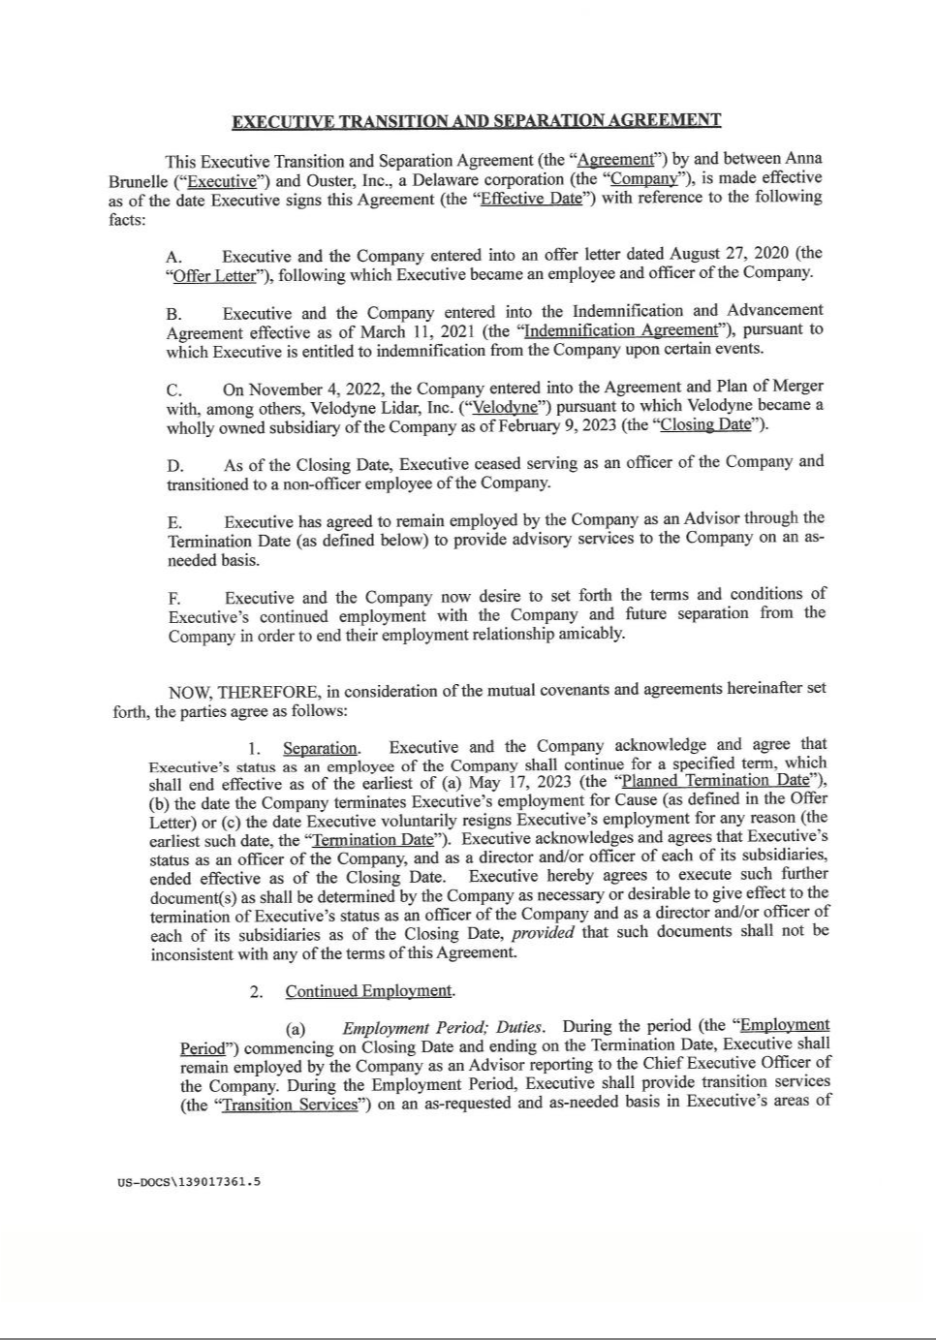

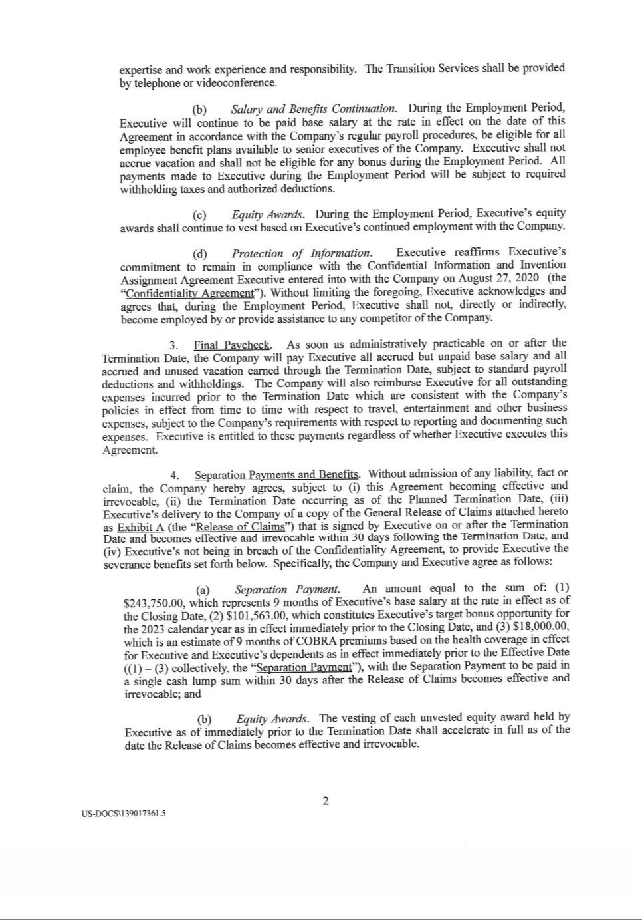

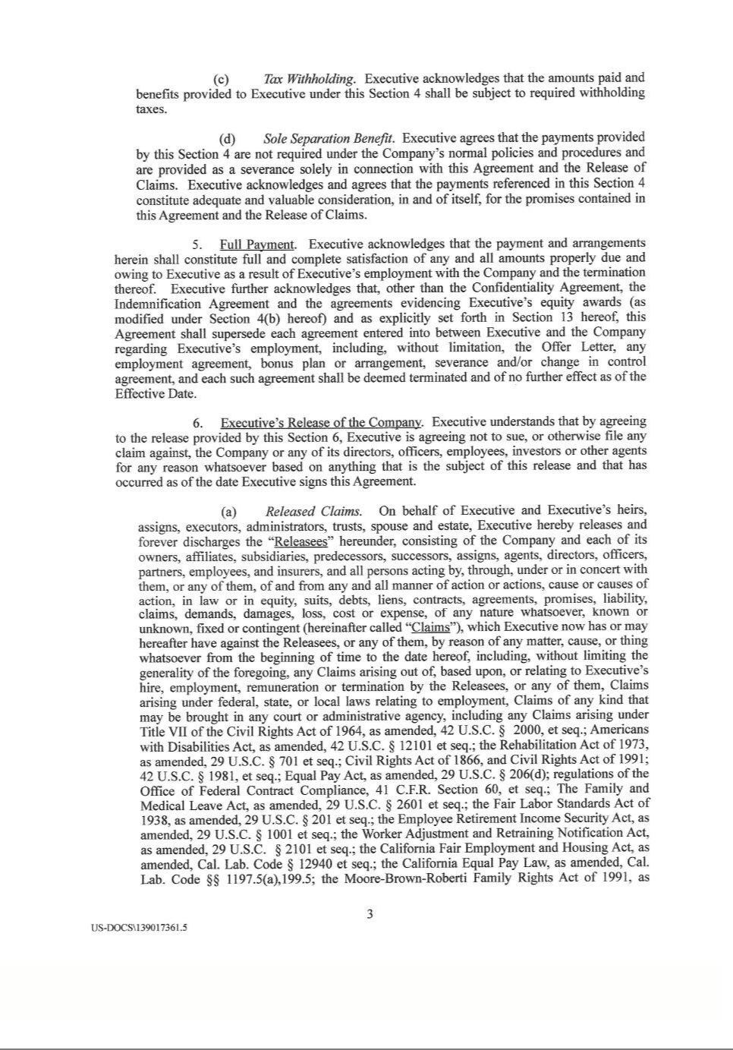

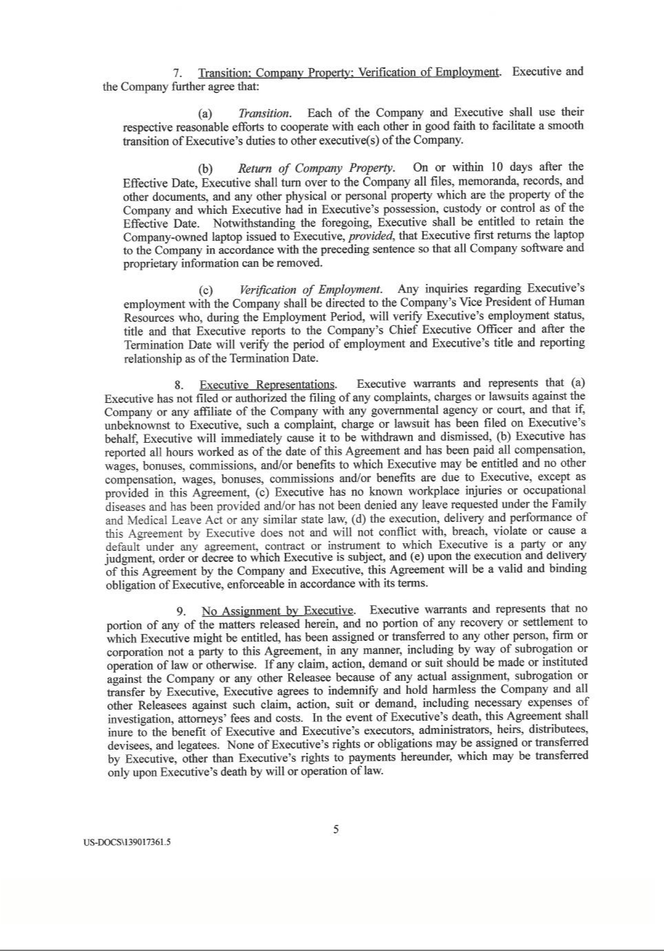

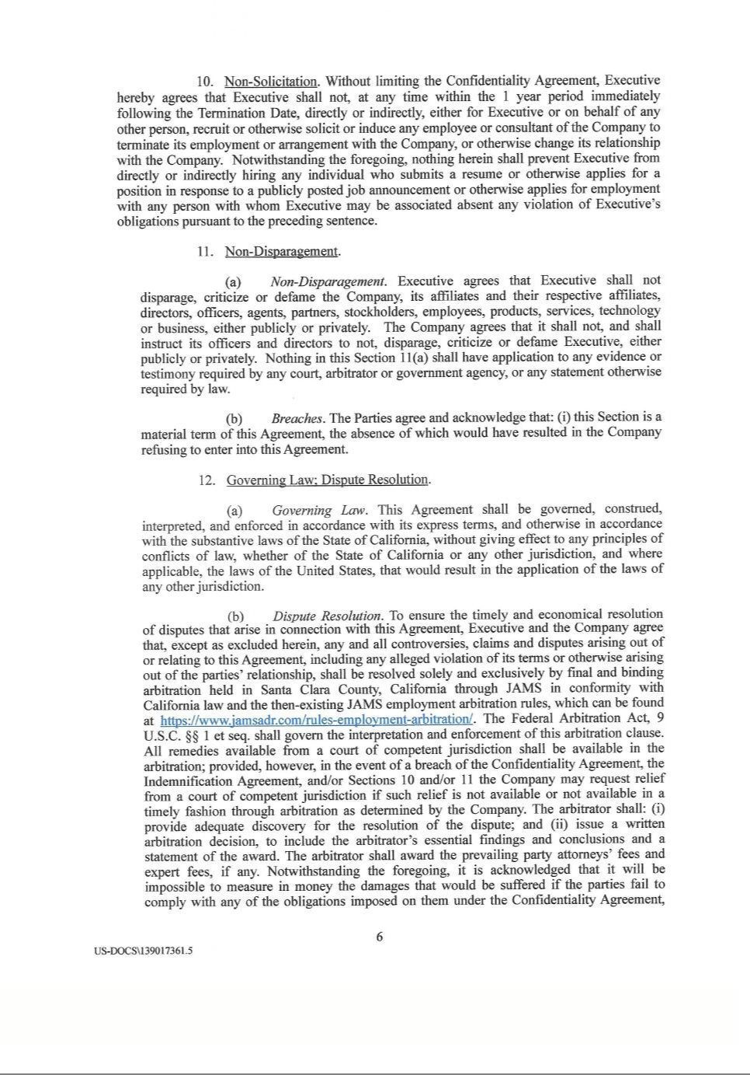

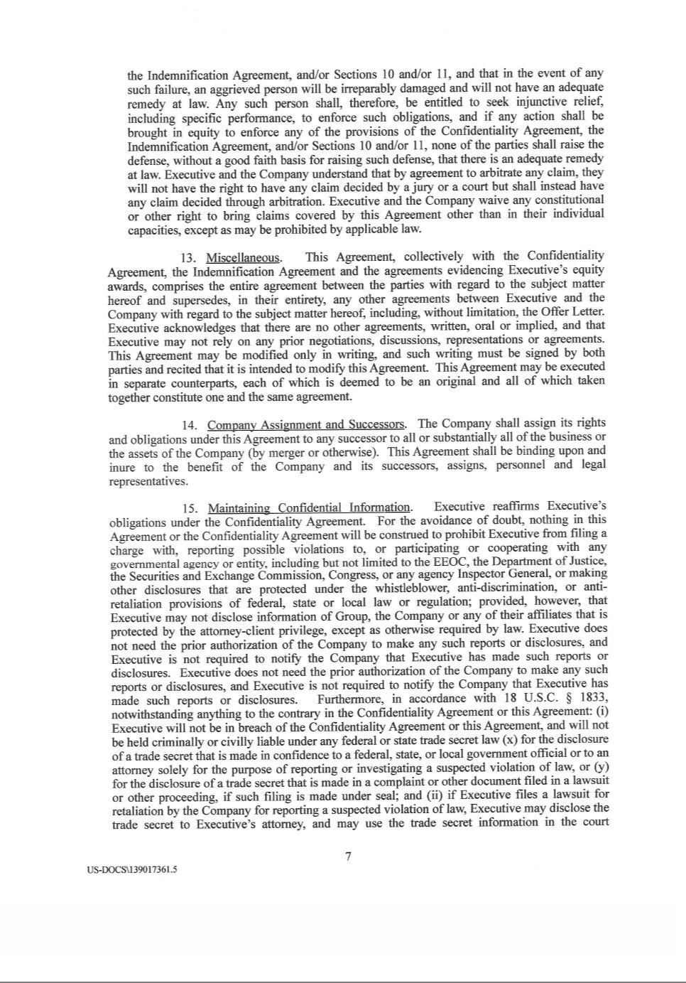



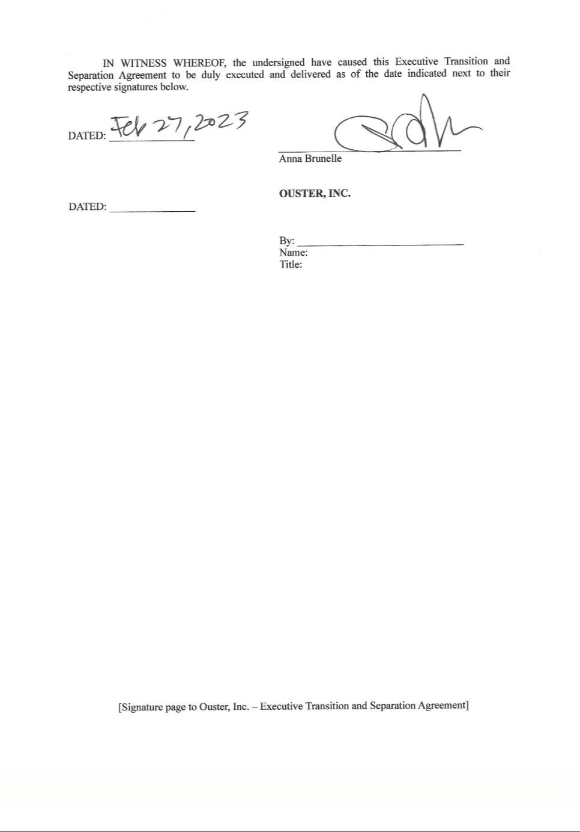

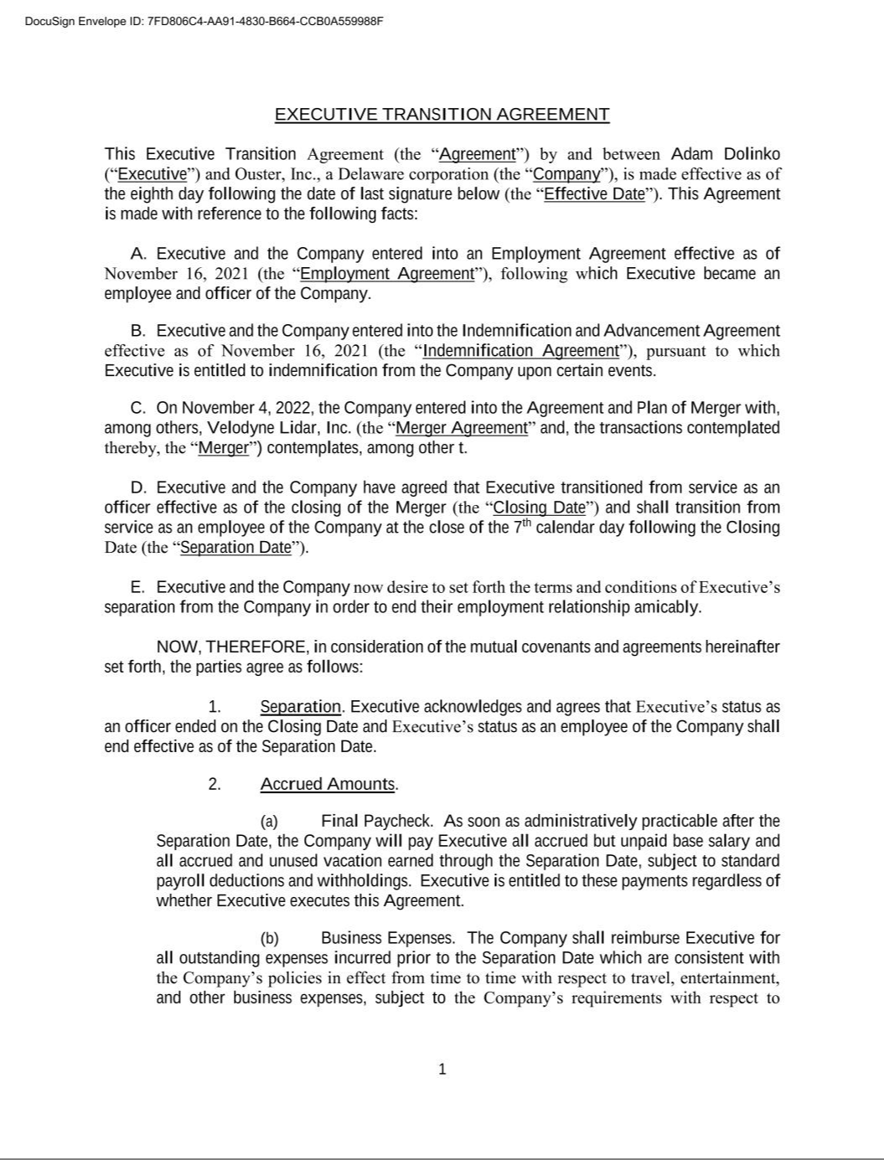

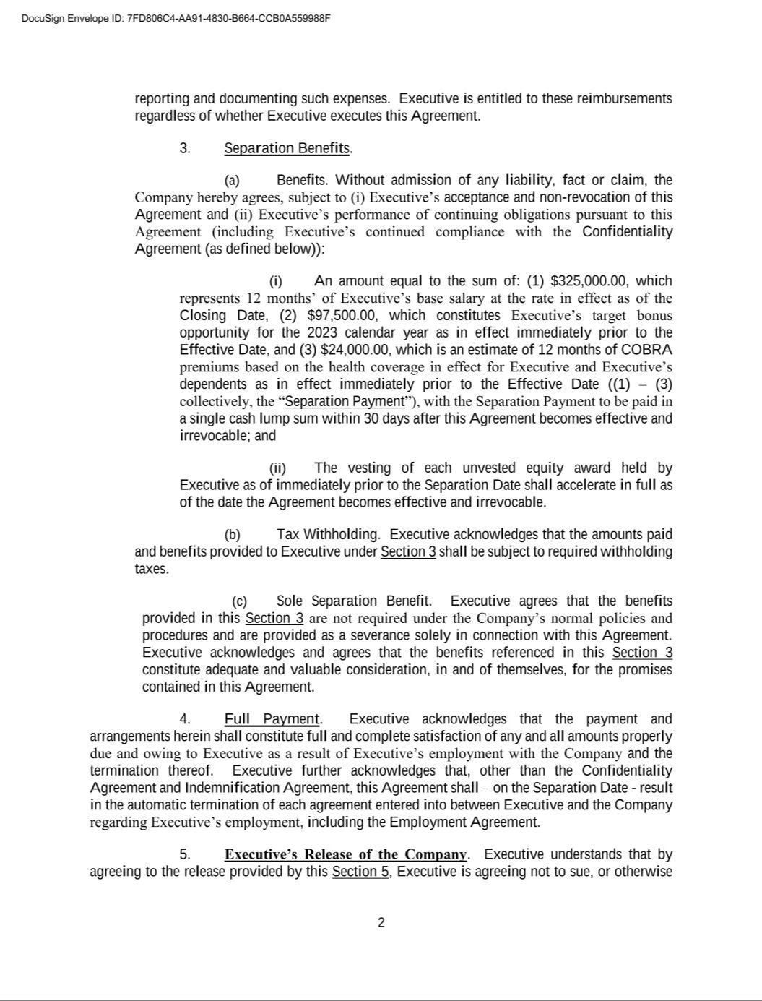

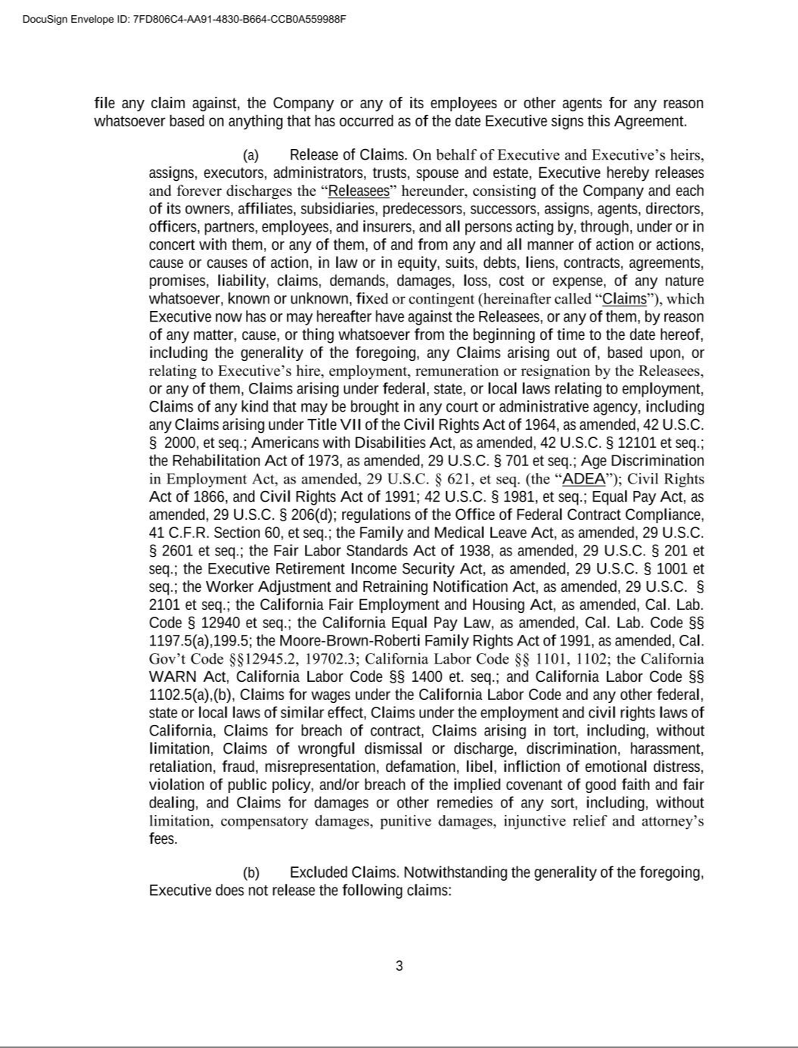

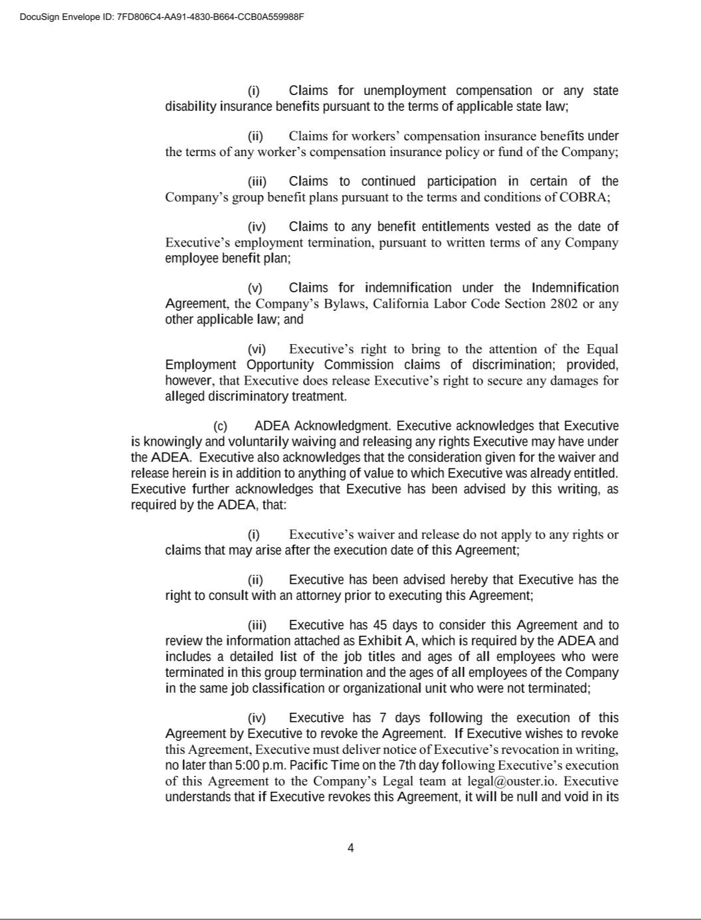

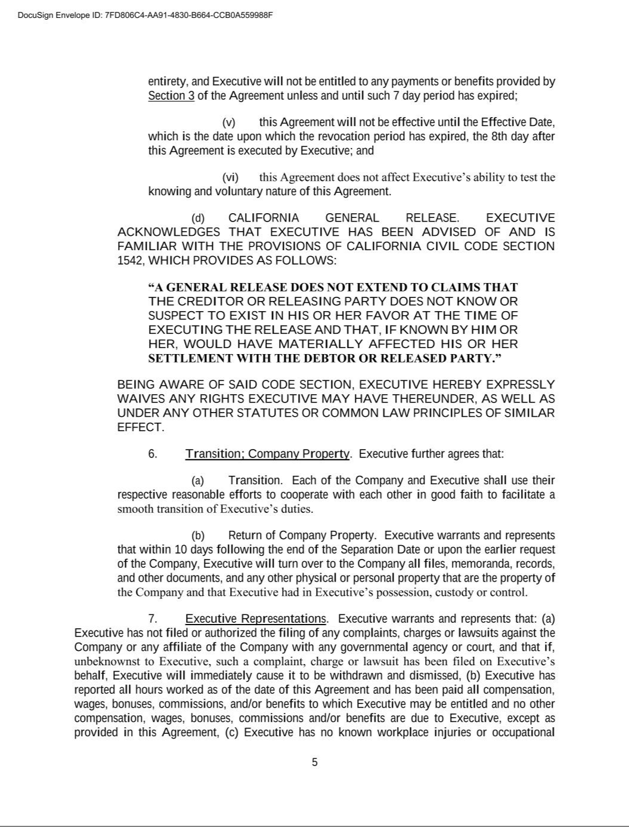

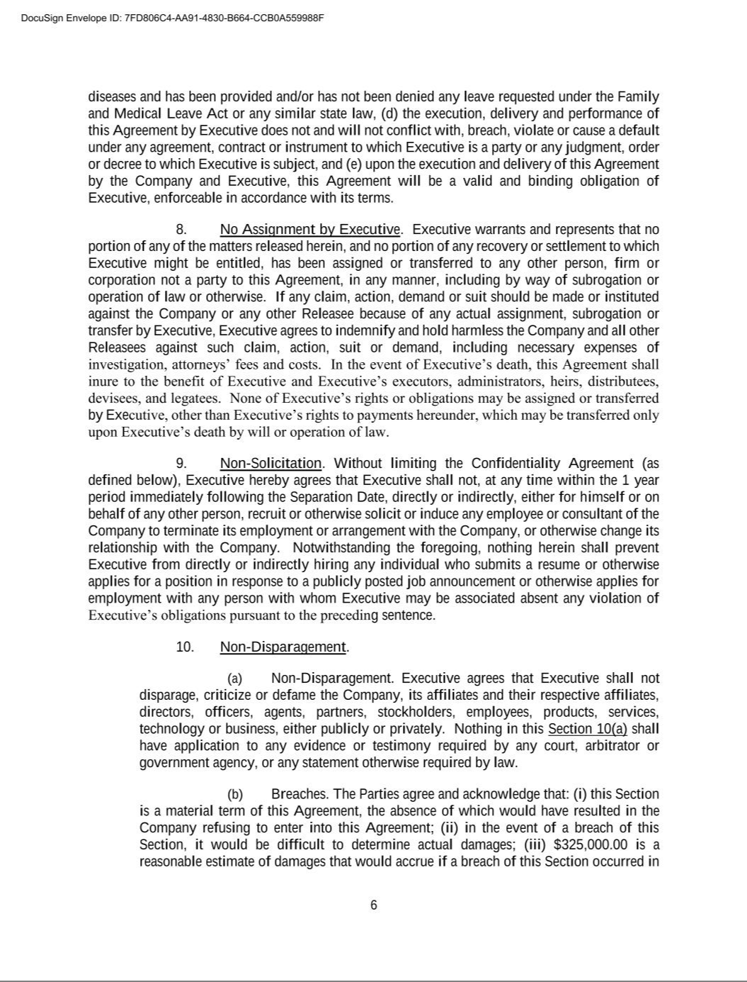

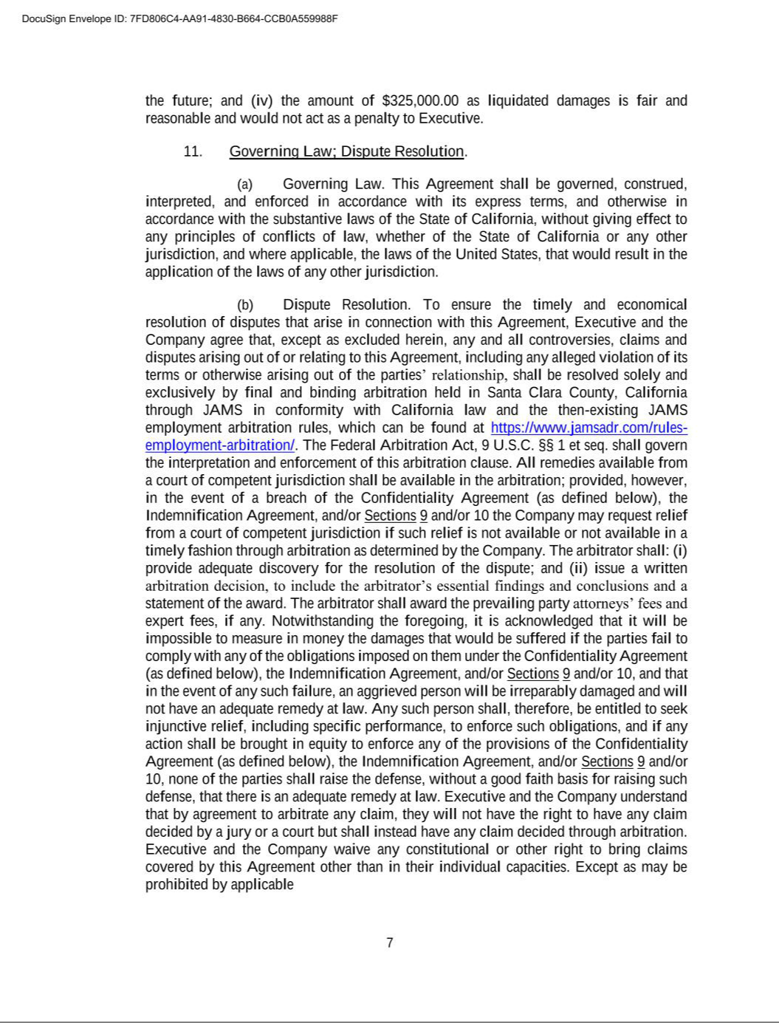

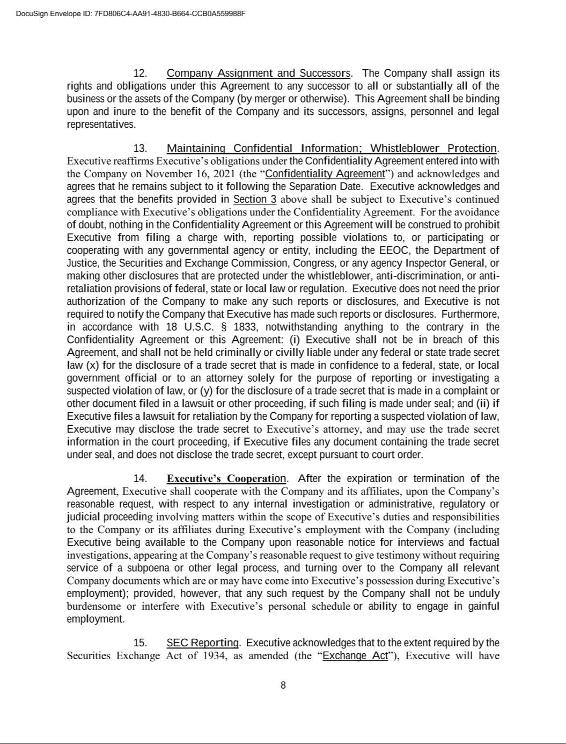

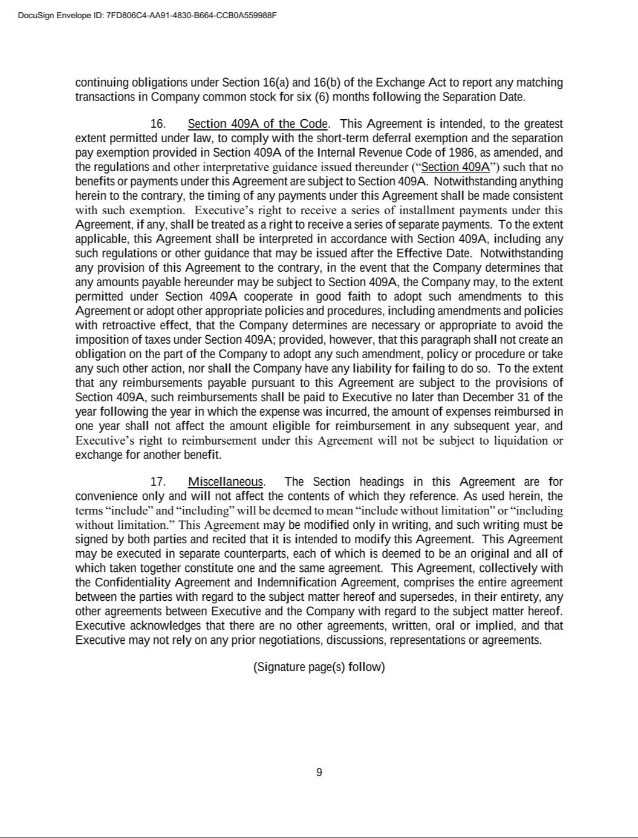

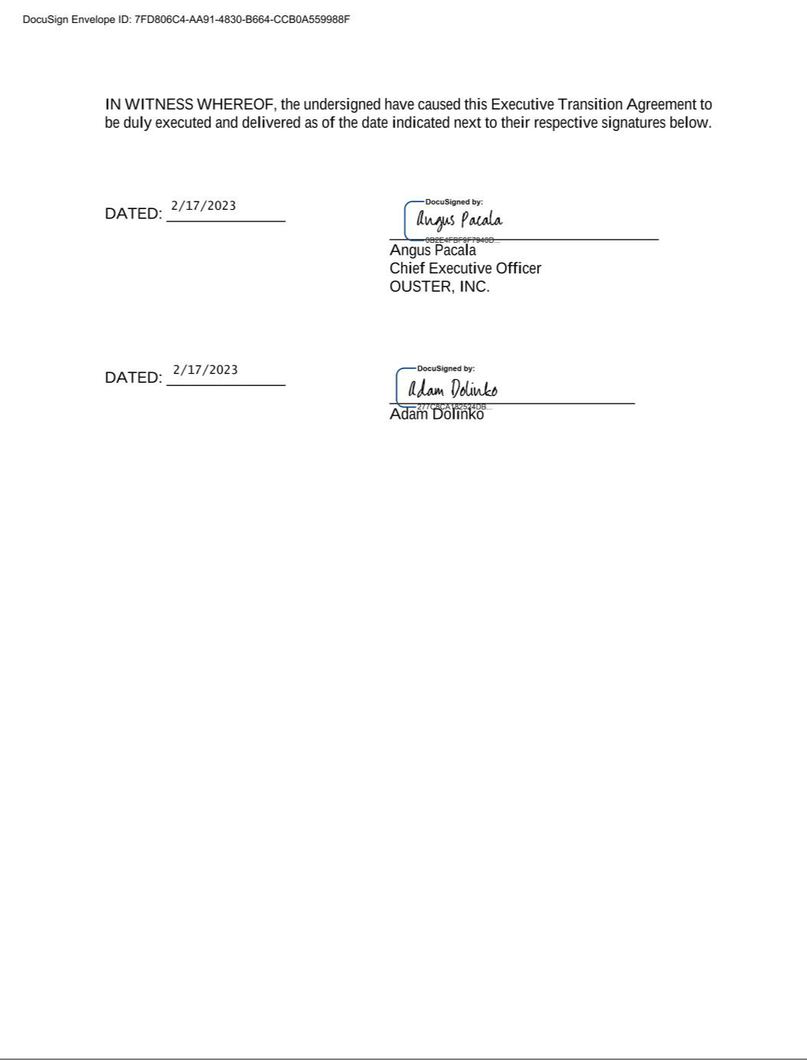

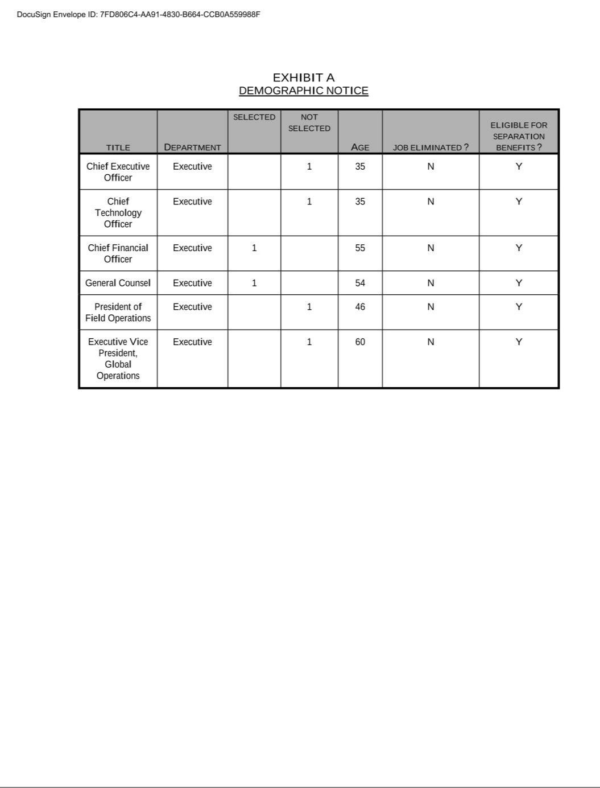

OUSTER, INC.

THIRD AMENDED AND RESTATED

NON-EMPLOYEE DIRECTOR COMPENSATION PROGRAM

This Ouster, Inc. (the “Company”) Third Amended and Restated Non-Employee Director Compensation Program (this “Program”) has been adopted in accordance with the Company’s 2021 Incentive Award Plan, as amended from time to time (the “2021 Plan”), and the Velodyne Lidar, Inc. 2020 Equity Incentive Plan, as amended from time to time (the “Velodyne Plan”), and amends and restates in its entirety the Amended and Restated Non-Employee Director Compensation Program. For the purposes of this Program, “Plan” shall mean (a) in respect of any grant being made under the Program, (i) the Velodyne Plan for each Non-Employee Director who, as of the date of grant, is eligible for an Award to be granted under the Velodyne Plan and (ii) the 2021 Plan for each Non-Employee Director who, as of the date of grant, is not eligible for an Award to be granted under the Velodyne Plan and (b) in respect of any Award being administered under the Program, (i) the Velodyne Plan if such Award was granted under the Velodyne Plan and (ii) the 2021 Plan if such Award was granted under the 2021 Plan. This Program shall be effective as of April 8, 2024 (the “Effective Date”). Capitalized terms not otherwise defined herein shall have the meaning ascribed in the 2021 Plan.

Cash Compensation

Effective upon the Effective Date, annual retainers will be paid in the following amounts to Non-Employee Directors:

Board Service

Non-Employee Director |  | $40,000
Chair of the Board |  | $60,000
Vice Chair of the Board |  | $60,000
Committee Service
 | Chair | Non-Chair
Audit Committee Member | $20,000 | $10,000
Compensation Committee Member | $15,000 | $6,000
Nominating and Corporate Governance Committee Member | $10,000 | $5,000

All annual retainers are additive and will be paid in cash quarterly in arrears promptly following the end of the applicable calendar quarter, but in no event more than 30 days after the end of such quarter. If a Non-Employee Director does not serve as a Non-Employee Director, or in the applicable positions described above, for an entire calendar quarter, the retainer paid to such Non-Employee Director shall be prorated for the portion of such calendar quarter actually served as a Non-Employee Director, or in such position, as applicable.

|US-DOCS\149581593.4||

Election to Receive Restricted Stock Units (“RSUs”) In Lieu of Annual Retainers

General:

Election Method:

The Board or the Compensation Committee may, in its discretion, provide Non-Employee Directors with the opportunity to elect to convert all or a portion of their annual retainers into awards of RSUs (“Retainer RSU Awards”) granted under the applicable Plan, with each such Retainer RSU Award covering a number of shares of Common Stock calculated by dividing (i) the amount of the annual retainer that would have otherwise been paid to such Non-Employee Director on the applicable grant date by (ii) the average per share closing trading price of the Common Stock over the most recent 30 trading days as of the grant date (such election, a “Retainer RSU Election”).

Each Retainer RSU Award automatically will be granted on the fifth day of the month immediately following the end of the quarter for which the corresponding portion of the annual retainer was earned. Each Retainer RSU Award will be fully vested on the grant date.

Each Retainer RSU Election must be submitted to the Company in the form and manner specified by the Board or its Compensation Committee (the “Compensation Committee”). An individual who fails to make a timely Retainer RSU Election shall not receive a Retainer RSU Award and instead shall receive the applicable annual retainer in cash. Retainer RSU Elections must comply with the following timing requirements:

- Initial Election. Each individual who first becomes a Non-Employee Director may make a Retainer RSU Election with respect to annual retainer payments scheduled to be paid in the same calendar year as such individual first becomes a Non-Employee Director (the “Initial Retainer RSU Election”). The Initial Retainer RSU Election must be submitted to the Company on or before the date that the individual first becomes a Non-Employee Director or, if later, within thirty (30) days following the date this Program is adopted (the “Initial Election Deadline”), and the Initial Retainer RSU Election shall become final and irrevocable as of the Initial Election Deadline.

- Annual Election. No later than December 31 of each calendar year, or such earlier deadline as may be established by the Board or the Compensation Committee, in its discretion (the “Annual Election Deadline”), each individual who is a Non-Employee Director as of immediately before the Annual Election Deadline may make a Retainer RSU Election with respect to the annual retainer relating to services to be performed in the following calendar year (the “Annual Retainer RSU Election”). The Annual Retainer RSU Election must be submitted to the Company on or before the applicable Annual Election Deadline and shall become effective and irrevocable as of the Annual Election Deadline.

2

|US-DOCS\149581593.4||

Equity Compensation

Initial RSU Award:

|US-DOCS\149581593.4||

Each Non-Employee Director who is initially elected or appointed to serve on the Board after the Effective Date shall be granted an award of RSUs under the applicable Plan covering that number of shares of Common Stock calculated by dividing (i) $300,000 by (ii) the average per share closing trading price of the Common Stock over the most recent 30 trading days as of the grant date (the “Initial Long-Term RSU Award”).

The Initial Long-Term RSU Award will be automatically granted on the date on which such Non-Employee Director commences service on the Board, and will vest as 1/12th of the shares subject thereto on each quarterly anniversary of the applicable date of grant such that the shares subject to the Initial Long-Term RSU Grant are fully vested on the third anniversary of the date of grant, subject to the Non-Employee Director continuing in service on the Board through each such vesting date.

Each Non-Employee Director who is initially elected or appointed to serve on the Board on or after the Effective Date shall be granted an award of RSUs under the applicable Plan covering that number of shares of Common Stock calculated by dividing (i) the product of $175,000 multiplied times a fraction, the numerator of which is the number of full months between the date the Non-Employee Director is appointed to serve on the Board and the next scheduled annual meeting of the Company’s stockholders (an “Annual Meeting”) and the denominator of which is 12, by (ii) the average per share closing trading price of the Common Stock over the most recent 30 trading days as of the grant date (the “Initial Short-Term RSU Award” and, together with the Initial Long-Term RSU Award, the “Initial RSU Awards”).

The Initial Short-Term RSU Award will vest in substantially equal quarterly installments through, and with the last installment vesting on, the date of the Annual Meeting, subject to the Non-Employee Director continuing in service on the Board through the date of the applicable Annual Meeting.

3

Annual RSU Award:

Each Non-Employee Director who is serving on the Board as of the date of an Annual Meeting and will continue to serve as a Non-Employee Director immediately following such Annual Meeting, shall be granted an award of RSUs under the applicable Plan covering a number of shares of Common Stock calculated by dividing (i) $175,000 by (ii) the average per share closing trading price of the Common Stock over the most recent 30 trading days as of the grant date (the “Annual RSU Award”).

The Annual RSU Award will be automatically granted on the date of the applicable Annual Meeting, and will vest as to 1/4th of the shares subject thereto on each quarterly anniversary of the applicable date of grant such that the shares subject to the Annual RSU Grant are fully vested on the first anniversary of the date of grant, subject to the Non-Employee Director continuing in service on the Board through such vesting date. Notwithstanding the foregoing, in the event the next Annual Meeting occurs prior to the first anniversary of the date of grant, the Annual RSU Grant shall fully vest on the date of such Annual Meeting, subject to the Non-Employee Director continuing in service on the Board through the date of such Annual Meeting.

Unless otherwise determined by the Board, members of the Board who are Employees who subsequently terminate their employment with the Company and any Subsidiary and remain a member of the Board will not receive the Initial RSU Awards, but to the extent that they are otherwise eligible, will be eligible to receive, after termination from employment with the Company and any Subsidiary, Annual RSU Awards as described above.

4

|US-DOCS\149581593.4||

Election to Defer Issuances

General:

Election Method:

|US-DOCS\149581593.4||

Each Non-Employee Director shall have the opportunity to defer the issuance of the shares underlying RSUs granted under this Program, including Retainer RSU Awards, Initial RSU Awards and Annual RSU Awards, that would otherwise be issued to the Non-Employee Director in connection with the vesting or grant of the RSUs until the earliest of a fixed date properly elected by the Non-Employee Director, the Non-Employee Director’s Termination of Service or a Change in Control. Any such deferral election (“Deferral Election”) shall be subject to such rules, conditions and procedures as shall be determined by the Board or the Compensation Committee, in its sole discretion, which rules, conditions and procedures shall at all times comply with the requirements of Section 409A of the Code, unless otherwise specifically determined by the Board or the Compensation Committee. If an individual elects to defer the delivery of the shares underlying RSUs granted under this Program, settlement of the deferred RSUs shall be made in accordance with the terms of the Deferral Election.

Each Deferral Election must be submitted to the Company in the form and manner specified by the Board or its Compensation Committee. Deferral Elections must comply with the following timing requirements:

- Initial Deferral Election. Each individual who first becomes a Non-Employee Director may make a Deferral Election with respect to the Non-Employee Director’s Initial RSU Awards and Retainer RSU Awards to be paid in the same calendar year as such individual first becomes a Non-Employee Director (the “Initial Deferral Election”). The Initial Deferral Election must be submitted to the Company on or before Initial Election Deadline, and the Initial Deferral Election shall become final and irrevocable as of the Initial Election Deadline.

- Annual Deferral Election. No later than the Annual Election Deadline, each individual who is a Non-Employee Director as of immediately before the Annual Election Deadline may make a Deferral Election with respect to the Annual RSU Award and Retainer RSU Awards to be granted in the following calendar year (the “Annual Deferral Election”). The Annual Deferral Election must be submitted to the Company on or before the applicable Annual Election Deadline and shall become effective and irrevocable for the subsequent calendar year as of the Annual Election Deadline.

5

Change in Control

Upon a Change in Control of the Company, all outstanding equity awards granted under a Plan and any other equity incentive plan maintained by the Company that are held by a Non-Employee Director shall become fully vested and/or exercisable, irrespective of any other provisions of the Non-Employee Director’s Award Agreement.

Reimbursements

The Company shall reimburse each Non-Employee Director for all reasonable, documented, out-of-pocket travel and other business expenses incurred by such Non-Employee Director in the performance of his or her duties to the Company in accordance with the Company’s applicable expense reimbursement policies and procedures as in effect from time to time.

Miscellaneous

The other provisions of the applicable Plan shall apply to the RSUs granted automatically under this Program, except to the extent such other provisions are inconsistent with this Program. All applicable terms of the applicable Plan apply to this Program as if fully set forth herein, and all grants of RSUs hereby are subject in all respects to the terms of the applicable Plan. The grant of RSUs under this Program shall be made solely by and subject to the terms set forth in an Award Agreement in a form to be approved by the Board and duly executed by an executive officer of the Company.

* * * * *

6

|US-DOCS\149581593.4||

OUSTER, INC.

2021 INCENTIVE AWARD PLAN

RESTRICTED STOCK AWARD GRANT NOTICE

Ouster, Inc., a Delaware corporation (the “Company”), pursuant to its 2021 Incentive Award Plan, as amended from time to time (the “Plan”), hereby grants to the holder listed below (the “Participant”) the number of shares of the Company’s Common Stock set forth below (the “Shares”) subject to all of the terms and conditions as set forth herein and in the Restricted Stock Award Agreement attached hereto as Exhibit A (the “Agreement”) (including without limitation the Restrictions on the Shares set forth in the Agreement) and the Plan, each of which is incorporated herein by reference. Unless otherwise defined herein, the terms defined in the Plan shall have the same defined meanings in this Restricted Stock Award Grant Notice (the “Grant Notice”) and the Agreement.

Participant: | [_________________]
Grant Date: | [_________________]
Total Number of Shares of Restricted Stock: | [_________________]
Vesting Commencement Date: | [_________________]
Vesting Schedule: | [_________________]
 | If the Participant experiences a Termination of Service, any Shares that have not become vested on or prior to the
Termination: | date of such Termination of Service will thereupon be automatically forfeited by the Participant, and the Participant’s
Termination: | rights in such Shares shall thereupon lapse and expire.

By his or her signature and the Company’s signature below, the Participant agrees to be bound by the terms and conditions of the Plan, the Agreement and this Grant Notice. The Participant has reviewed the Plan, the Agreement and this Grant Notice in their entirety, has had an opportunity to obtain the advice of counsel prior to executing this Grant Notice and fully understands all provisions of the Plan, Agreement and this Grant Notice. The Participant hereby agrees to accept as binding, conclusive and final all decisions or interpretations of the Administrator upon any questions arising under the Plan, the Agreement or this Grant Notice. In addition, by signing below, the Participant also agrees that the Company, in its sole discretion, may satisfy any withholding obligations in accordance with Section 2.2(c) of the Agreement by (i) withholding shares of Common Stock otherwise issuable to the Participant upon vesting of the Shares, (ii) instructing a broker on the Participant’s behalf to sell Shares upon vesting and submit the proceeds of such sale to the Company, or (iii) using any other method permitted by Section 2.2(c) of the Agreement or the Plan.

OUSTER, INC.:

By:

Print Name:

PARTICIPANT:

By:

Print Name:

Title:

Address:

Address:

1

|US-DOCS\119855133.2||

EXHIBIT A

TO RESTRICTED STOCK AWARD GRANT NOTICE

RESTRICTED STOCK AWARD AGREEMENT

Pursuant to the Restricted Stock Award Grant Notice (the “Grant Notice”) to which this Restricted Stock Award Agreement (this “Agreement”) is attached, Ouster, Inc., a Delaware corporation (the “Company”), has granted to the Participant the number of shares of Restricted Stock (the “Shares”) under the Company’s 2021 Incentive Award Plan, as amended from time to time (the “Plan”), as set forth in the Grant Notice.

ARTICLE I.

GENERAL

I.1 Defined Terms. Capitalized terms not specifically defined herein shall have the meanings specified in the Plan and the Grant Notice.

I.2 Incorporation of Terms of Plan. The Award (as defined below) is subject to the terms and conditions of the Plan, which are incorporated herein by reference. In the event of any inconsistency between the Plan and this Agreement, the terms of the Plan shall control.

ARTICLE II.

AWARD OF RESTRICTED STOCK

II.1 Award of Restricted Stock.

- Award. Pursuant to the Grant Notice and upon the terms and conditions set forth in the Plan and this Agreement, effective as of the Grant Date set forth in the Grant Notice, the Company has granted to the Participant an award of Restricted Stock (the “Award”) under the Plan in consideration of the Participant’s past or continued employment with or service to the Company or any Subsidiary, and for other good and valuable consideration. The number of Shares subject to the Award is set forth in the Grant Notice.

- Escrow. The Participant, by acceptance of the Award, shall be deemed to appoint, and does so appoint, the Secretary of the Company or such other escrow holder as the Administrator may appoint to hold the Shares in escrow as the Participant’s attorney(s)-in-fact to effect any transfer of unvested forfeited Shares (or Shares otherwise reacquired by the Company hereunder) to the Company as may be required pursuant to the Plan or this Agreement and to execute such documents as the Company or such representatives deem necessary or advisable in connection with any such transfer.

- Removal of Notations. As soon as administratively practicable after the vesting of any Shares subject to the Award pursuant to Section 2.2(b) hereof, the Company shall remove the notations on any Shares subject to the Award which have vested (or such lesser number of Shares as may be permitted pursuant to Section 10.7 of the Plan). The Participant (or the beneficiary or personal representative of the Participant in the event of the Participant’s death or incapacity, as the case may be) shall deliver to the Company any representations or other documents or assurances required by the Company.

A-1

|US-DOCS\119855133.2||

II.2 Restrictions.

- Forfeiture. Notwithstanding any contrary provision of this Agreement, except as may otherwise be provided by the Administrator or as set forth in a written agreement between the Company and the Participant, upon the Participant’s Termination of Service for any or no reason, any Shares subject to Restrictions shall thereupon be forfeited immediately and without any further action by the Company, and the Participant’s rights in such Shares shall thereupon lapse and expire.

- Vesting and Lapse of Restrictions. As of the Grant Date, 100% of the Shares shall be subject to the risk of forfeiture set forth in Section 2.2(a) hereof and the transfer restrictions set forth in Section 3.3 hereof (collectively, such risk of forfeiture and such transfer restrictions, the “Restrictions”). The Award shall vest and Restrictions shall lapse in accordance with the vesting schedule set forth in the Grant Notice (rounding down to the nearest whole Share).

- Tax Withholding. As set forth in Section 10.5 of the Plan, the Company shall have the authority and the right to deduct or withhold, or to require the Participant to remit to the Company, an amount sufficient to satisfy all applicable federal, state and local taxes required by law to be withheld with respect to any taxable event arising in connection with the Award. The Company shall not be obligated to transfer Shares held in escrow to the Participant or the Participant’s legal representative until the Participant or the Participant’s legal representative shall have paid or otherwise satisfied in full the amount of all federal, state and local taxes applicable to the taxable income of the Participant resulting from the grant or vesting of the Award or the issuance of Shares.

- Stop Transfer Instructions. To ensure compliance with the Restrictions, the provisions of the charter documents of the Company and Applicable Law, and for other proper purposes, the Company may issue appropriate “stop transfer” and other instructions to its transfer agent with respect to the Restricted Stock. The Company shall notify the transfer agent as and when the Restrictions lapse.

II.3 | Consideration to the Company. In consideration of the grant of the Award pursuant hereto, the Participant agrees to render faithful and efficient services to the
Company or any Subsidiary.
 |  |  | ARTICLE III.
 |  |  | OTHER PROVISIONS
III.1 | Section 83(b) Election. If the Participant makes an election under Section 83(b) of the Code to be taxed with respect to the Restricted Stock as of the date of transfer

of the Restricted Stock rather than as of the date or dates upon which the Participant would otherwise be taxable under Section 83(a) of the Code, the Participant hereby agrees to deliver a copy of such election to the Company promptly after filing such election with the Internal Revenue Service.

III.2 Administration. The Administrator shall have the power to interpret the Plan and this Agreement and to adopt such rules for the administration, interpretation and application of the Plan as are consistent therewith and to interpret, amend or revoke any such rules. All actions taken and all interpretations and determinations made by the Administrator in good faith shall be final and binding upon the Participant, the Company and all other interested persons. No member of the Administrator or the Board shall be personally liable for any action, determination or interpretation made in good faith with respect to the Plan, this Agreement or the Award.

A-2

|US-DOCS\119855133.2||

III.3 Transferability. Until the Restrictions hereunder lapse or expire pursuant to this Agreement and the Shares vest, the Restricted Stock (including any Shares or other securities or property received by the Participant with respect to Restricted Stock as a result of stock dividends, stock splits or any other form of recapitalization) shall be subject to the restrictions on transferability set forth in Section 10.1 of the Plan.

III.4 Rights as Stockholder. Except as otherwise provided herein, upon the Grant Date, the Participant shall have all the rights of a stockholder of the Company with respect to the Shares, subject to the Restrictions, including, without limitation, voting rights and rights to receive any cash or stock dividends, in respect of the Shares subject to the Award and deliverable hereunder.

III.5 Tax Consultation. The Participant understands that the Participant may suffer adverse tax consequences in connection with the Restricted Stock granted pursuant to this Agreement (and the Shares issuable with respect thereto). The Participant represents that the Participant has consulted with any tax consultants the Participant deems advisable in connection with the Restricted Stock and that the Participant is not relying on the Company for any tax advice.

III.6 Adjustments Upon Specified Events. The Administrator may accelerate the vesting of the Restricted Stock in such circumstances as it, in its sole discretion, may determine. The Participant acknowledges that the Restricted Stock is subject to adjustment, modification and termination in certain events as provided in this Agreement and Article IX of the Plan.

III.7 Notices. Any notice to be given under the terms of this Agreement to the Company shall be addressed to the Company in care of the Secretary of the Company at the Company’s principal office, and any notice to be given to the Participant shall be addressed to the Participant at the Participant’s last address reflected on the Company’s records. By a notice given pursuant to this Section 3.7, either party may hereafter designate a different address for notices to be given to that party. Any notice shall be deemed duly given when sent via email or when sent by certified mail (return receipt requested) and deposited (with postage prepaid) in a post office or branch post office regularly maintained by the United States Postal Service.

III.8 Participant’s Representations. If the Shares issuable hereunder have not been registered under the Securities Act or any applicable state laws on an effective registration statement at the time of such issuance, the Participant shall, if required by the Company, concurrently with such issuance, make such written representations as are deemed necessary or appropriate by the Company or its counsel.

III.9 | Titles. Titles are provided herein for convenience only and are not to serve as a basis for interpretation or construction of this Agreement.
III.10 | Governing Law. The laws of the State of Delaware shall govern the interpretation, validity, administration, enforcement and performance of the terms of this
Agreement regardless of the law that might be applied under principles of conflicts of laws.
III.11 | Conformity to Securities Laws. The Participant acknowledges that the Plan and this Agreement are intended to conform to the extent necessary with all provisions

of the Securities Act and the Exchange Act, and any and all Applicable Law. Notwithstanding anything herein to the contrary, the Plan shall be administered, and the Award is granted, only in such a manner as to conform to such Applicable Law. To the extent permitted by Applicable Law, the Plan and this Agreement shall be deemed amended to the extent necessary to conform to such Applicable Law.

A-3

|US-DOCS\119855133.2||

III.12 Amendment, Suspension and Termination. To the extent permitted by the Plan, this Agreement may be wholly or partially amended or otherwise modified, suspended or terminated at any time or from time to time by the Administrator or the Board; provided, however, that, except as may otherwise be provided by the Plan, no amendment, modification, suspension or termination of this Agreement shall adversely affect the Award in any material way without the prior written consent of the Participant.

III.13 Successors and Assigns. The Company or any Subsidiary may assign any of its rights under this Agreement to single or multiple assignees, and this Agreement shall inure to the benefit of the successors and assigns of the Company and its Subsidiaries. Subject to the restrictions on transfer set forth in Section 3.3 hereof, this Agreement shall be binding upon the Participant and his or her heirs, executors, administrators, successors and assigns.

III.14 Limitations Applicable to Section 16 Persons. Notwithstanding any other provision of the Plan or this Agreement, if the Participant is subject to Section 16 of the Exchange Act, then the Plan, the Award and this Agreement shall be subject to any additional limitations set forth in any applicable exemptive rule under Section 16 of the Exchange Act (including any amendment to Rule 16b-3 of the Exchange Act) that are requirements for the application of such exemptive rule. To the extent permitted by applicable law, this Agreement shall be deemed amended to the extent necessary to conform to such applicable exemptive rule.

III.15 Not a Contract of Service Relationship. Nothing in this Agreement or in the Plan shall confer upon the Participant any right to continue to serve as an Employee or other service provider of the Company or any of its Subsidiaries or shall interfere with or restrict in any way the rights of the Company and its Subsidiaries, which rights are hereby expressly reserved, to discharge or terminate the services of the Participant at any time for any reason whatsoever, with or without cause, except to the extent expressly provided otherwise in a written agreement between the Company or a Subsidiary and the Participant.

III.16 Entire Agreement. The Plan, the Grant Notice and this Agreement (including all Exhibits thereto, if any) constitute the entire agreement of the parties and supersede in their entirety all prior undertakings and agreements of the Company and its Subsidiaries and the Participant with respect to the subject matter hereof, provided that the Shares shall be subject to any accelerated vesting provisions in any written agreement between the Participant and the Company or a Company plan pursuant to which the Participant participates, in each case, in accordance with the terms therein.

III.17 Limitation on the Participant’s Rights. Participation in the Plan confers no rights or interests other than as herein provided. This Agreement creates only a contractual obligation on the part of the Company as to amounts payable and shall not be construed as creating a trust. Neither the Plan nor any underlying program, in and of itself, has any assets. The Participant shall have only the rights of a general unsecured creditor of the Company and its Subsidiaries with respect to amounts credited and benefits payable, if any, with respect to the Shares issuable hereunder.

* * * * *

A-4

|US-DOCS\119855133.2||

Exhibit 31.1

CERTIFICATION

I, Angus Pacala, certify that:

- I have reviewed this Quarterly Report on Form 10-Q of Ouster, Inc.;

- Based on my knowledge, this report does not contain any untrue statement of a material fact or omit to state a material fact necessary to make the statements made, in light of the circumstances under which such statements were made, not misleading with respect to the period covered by this report;

- Based on my knowledge, the financial statements, and other financial information included in this report, fairly present in all material respects the financial condition, results of operations and cash flows of the registrant as of, and for, the periods presented in this report;

- The registrant’s other certifying officer and I are responsible for establishing and maintaining disclosure controls and procedures (as defined in Exchange Act Rules 13a-15(e) and 15d-15(e)) and internal control over financial reporting (as defined in Exchange Act Rules 13a-15(f) and 15d-15(f)) for the registrant and have:

  - Designed such disclosure controls and procedures, or caused such disclosure controls and procedures to be designed under our supervision, to ensure that material information relating to the registrant, including its consolidated subsidiaries, is made known to us by others within those entities, particularly during the period in which this report is being prepared;

  - Designed such internal control over financial reporting, or caused such internal control over financial reporting to be designed under our supervision, to provide reasonable assurance regarding the reliability of financial reporting and the preparation of financial statements for external purposes in accordance with generally accepted accounting principles;

  - Evaluated the effectiveness of the registrant’s disclosure controls and procedures and presented in this report our conclusions about the effectiveness of the disclosure controls and procedures, as of the end of the period covered by this report based on such evaluation; and

  - Disclosed in this report any change in the registrant’s internal control over financial reporting that occurred during the registrant’s most recent fiscal quarter (the registrant’s fourth fiscal quarter in the case of an annual report) that has materially affected, or is reasonably likely to materially affect, the registrant’s internal control over financial reporting; and

- The registrant’s other certifying officer and I have disclosed, based on our most recent evaluation of internal control over financial reporting, to the registrant’s auditors and the audit committee of the registrant’s board of directors (or persons performing the equivalent functions):

- All significant deficiencies and material weaknesses in the design or operation of internal control over financial reporting which are reasonably likely to adversely affect the registrant’s ability to record, process, summarize and report financial information; and

- Any fraud, whether or not material, that involves management or other employees who have a significant role in the registrant’s internal control over financial reporting.

Date: May 13, 2024 By: /s/ Angus Pacala

Angus Pacala

Co-Founder and Chief Executive Officer

(principal executive officer)

Exhibit 31.2

CERTIFICATION

I, Mark Weinswig, certify that:

- I have reviewed this Quarterly Report on Form 10-Q of Ouster, Inc.;

- Based on my knowledge, this report does not contain any untrue statement of a material fact or omit to state a material fact necessary to make the statements made, in light of the circumstances under which such statements were made, not misleading with respect to the period covered by this report;

- Based on my knowledge, the financial statements, and other financial information included in this report, fairly present in all material respects the financial condition, results of operations and cash flows of the registrant as of, and for, the periods presented in this report;

- The registrant’s other certifying officer and I are responsible for establishing and maintaining disclosure controls and procedures (as defined in Exchange Act Rules 13a-15(e) and 15d-15(e)) and internal control over financial reporting (as defined in Exchange Act Rules 13a-15(f) and 15d-15(f)) for the registrant and have:

  - Designed such disclosure controls and procedures, or caused such disclosure controls and procedures to be designed under our supervision, to ensure that material information relating to the registrant, including its consolidated subsidiaries, is made known to us by others within those entities, particularly during the period in which this report is being prepared;

  - Designed such internal control over financial reporting, or caused such internal control over financial reporting to be designed under our supervision, to provide reasonable assurance regarding the reliability of financial reporting and the preparation of financial statements for external purposes in accordance with generally accepted accounting principles;

  - Evaluated the effectiveness of the registrant’s disclosure controls and procedures and presented in this report our conclusions about the effectiveness of the disclosure controls and procedures, as of the end of the period covered by this report based on such evaluation; and

  - Disclosed in this report any change in the registrant’s internal control over financial reporting that occurred during the registrant’s most recent fiscal quarter (the registrant’s fourth fiscal quarter in the case of an annual report) that has materially affected, or is reasonably likely to materially affect, the registrant’s internal control over financial reporting; and

- The registrant’s other certifying officer and I have disclosed, based on our most recent evaluation of internal control over financial reporting, to the registrant’s auditors and the audit committee of the registrant’s board of directors (or persons performing the equivalent functions):

- All significant deficiencies and material weaknesses in the design or operation of internal control over financial reporting which are reasonably likely to adversely affect the registrant’s ability to record, process, summarize and report financial information; and

- Any fraud, whether or not material, that involves management or other employees who have a significant role in the registrant’s internal control over financial reporting.

Date: May 13, 2024 By: /s/ Mark Weinswig

Mark Weinswig

Chief Financial Officer

(principal financial officer)

Exhibit 32.1

CERTIFICATION PURSUANT TO

18 U.S.C. SECTION 1350, AS ADOPTED PURSUANT TO

SECTION 906 OF THE SARBANES-OXLEY ACT OF 2002

In connection with the Quarterly Report on Form 10-Q of Ouster, Inc. (the “Company”) for the period ended March 31, 2024 as filed with the Securities and Exchange Commission on the date hereof (the “Report”), I certify, pursuant to 18 U.S.C. § 1350, as adopted pursuant to § 906 of the Sarbanes-Oxley Act of 2002, that:

- The Report fully complies with the requirements of section 13(a) or 15(d) of the Securities Exchange Act of 1934; and

- The information contained in the Report fairly presents, in all material respects, the financial condition and results of operations of the Company.

Date: May 13, 2024 By: /s/ Angus Pacala

Angus Pacala

Co-Founder and Chief Executive Officer

(principal executive officer)

Exhibit 32.2

CERTIFICATION PURSUANT TO

18 U.S.C. SECTION 1350, AS ADOPTED PURSUANT TO

SECTION 906 OF THE SARBANES-OXLEY ACT OF 2002

In connection with the Quarterly Report on Form 10-Q of Ouster, Inc. (the “Company”) for the period ended March 31, 2024 as filed with the Securities and Exchange Commission on the date hereof (the “Report”), I certify, pursuant to 18 U.S.C. § 1350, as adopted pursuant to § 906 of the Sarbanes-Oxley Act of 2002, that:

- The Report fully complies with the requirements of section 13(a) or 15(d) of the Securities Exchange Act of 1934; and

- The information contained in the Report fairly presents, in all material respects, the financial condition and results of operations of the Company.

Date: May 13, 2024 By: /s/ Mark Weinswig

Mark Weinswig

Chief Financial Officer

(principal financial officer)

