UNITED STATES

SECURITIES AND EXCHANGE COMMISSION
Washington, DC 20549

SCHEDULE 14A

(Rule 14a-101)

INFORMATION REQUIRED IN PROXY STATEMENT

SCHEDULE 14A INFORMATION

Proxy Statement Pursuant to Section 14(a) of the

Securities Exchange Act of 1934 (Amendment No. )

Filed by the Registrant ☒

Filed by a Party other than the Registrant ☐

Check the appropriate box:

- Preliminary Proxy Statement

- Confidential, for Use of the Commission Only (as permitted by Rule 14a-6(e)(2))

- Definitive Proxy Statement

- Definitive Additional Materials

- Soliciting Material Pursuant to §240.14a-12

OUSTER, INC.

(Name of Registrant as Specified in its Charter)

(Name of Person(s) Filing Proxy Statement, if Other Than the Registrant)

Payment of Filing Fee (Check all boxes that apply):

- No fee required.

- Fee paid previously with preliminary materials.

- Fee computed on table in exhibit required by Item 25(b) per Exchange Act Rules 14a-6(i)(1) and 0-11.

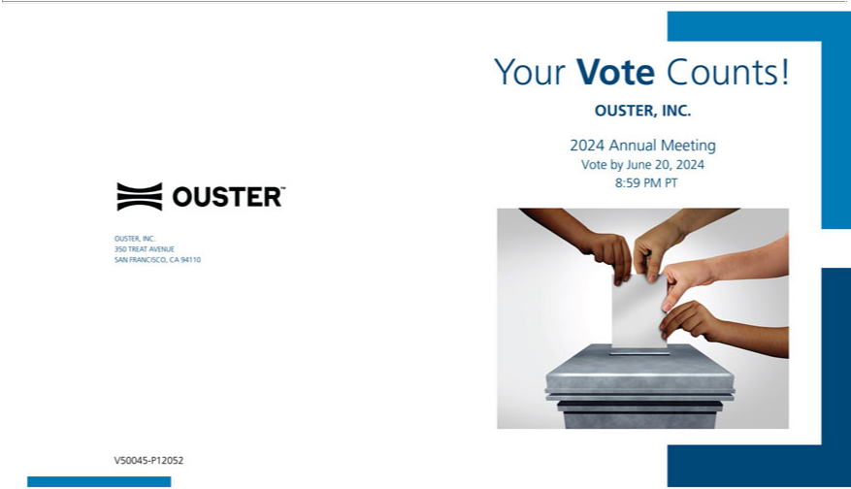

You invested in OUSTER, INC. and it’s time to vote!

You have the right to vote on proposals being presented at the Annual Meeting. This is an important notice regarding the availability of proxy materials for the stockholder meeting to be held on June 21, 2024.

Get informed before you vote

View the Notice and Proxy Statement and Annual Report online OR you can receive a free paper or email copy of the material(s) by requesting prior to June 7, 2024. If you would like to request a copy of the material(s) for this and/or future stockholder meetings, you may (1) visit www.ProxyVote.com, (2) call 1-800-579-1639 or (3) send an email to sendmaterial@proxyvote.com. If sending an email, please include your control number (indicated below) in the subject line. Unless requested, you will not otherwise receive a paper or email copy.
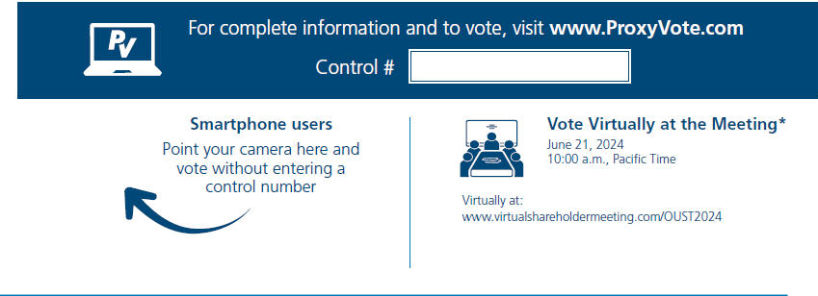

*Please check the meeting materials for any special requirements for meeting attendance.

Vote at www.ProxyVote.com

THIS IS NOT A VOTABLE BALLOT

This is an overview of the proposals being presented at the upcoming stockholder meeting. Please follow the instructions on the reverse side to vote these important matters.

 |  | Board
Voting Items |  | Recommends
1. | Election of Class III Directors
 | Nominees:
 | 01) Susan Heystee | For
 | 02) Angus Pacala
 | 03) Theodore L. Tewksbury, Ph.D.
2. | Ratification of the appointment of PricewaterhouseCoopers LLP as the Company’s independent registered public | For
 | accounting firm for the fiscal year ending December 31, 2024. | For
3. | Approval, on an advisory (non-binding) basis, of the compensation of the Company’s named executive officers. | For
4. | Approval of the amended and restated 2022 Employee Stock Purchase Plan to increase the number of shares | For
 | authorized for issuance. | For
5. | Approval of the Velodyne Lidar, Inc. 2020 Equity Incentive Plan. | For

NOTE: Such other business as may properly come before the meeting or any continuation, postponement or adjournment thereof.

Prefer to receive an email instead? While voting on www.ProxyVote.com, be sure to click “Delivery Settings”.

V50046-P12052

