UNITED STATES
SECURITIES AND EXCHANGE COMMISSION
Washington, D.C. 20549

FORM 8-K

CURRENT REPORT
Pursuant to Section 13 or 15(d)
of the Securities Exchange Act of 1934
May 5, 2026
Date of Report (date of earliest event reported)

Ouster, Inc.
(Exact name of registrant as specified in its charter)

Delaware |  | 001-39463 |  | 86-2528989
(State or other jurisdiction of  incorporation or organization) |  | (Commission  File Number) |  | (IRS Employer  Identification No.)
350 Treat Avenue
San Francisco, California 94110
(Address of principal executive offices) (Zip Code)
(415) 949-0108
(Registrant’s telephone number, including area code)
N/A
(Former name or former address, if changed since last report)

Check the appropriate box below if the Form 8-K filing is intended to simultaneously satisfy the filing obligation of the registrant under any of the following provisions:

☐ | Written communications pursuant to Rule 425 under the Securities Act (17 CFR 230.425)

☐ | Soliciting material pursuant to Rule 14a-12 under the Exchange Act (17 CFR 240.14a-12)

☐ | Pre-commencement communications pursuant to Rule 14d-2(b) under the Exchange Act (17 CFR 240.14d-2(b))

☐ | Pre-commencement communications pursuant to Rule 13e-4(c) under the Exchange Act (17 CFR 240.13e-4(c))
Securities registered pursuant to Section 12(b) of the Act:

Title of each class |  | Trading  Symbol |  | Name of each exchange  on which registered
Common stock, $0.0001 par value per share |  | OUST |  | Nasdaq Global Select Market
Indicate by check mark whether the registrant is an emerging growth company as defined in Rule 405 of the Securities Act of 1933 (§230.405 of this chapter) or Rule 12b-2 of the Securities Exchange Act of 1934 (§240.12b-2 of this chapter).
Emerging growth company ☐
If an emerging growth company, indicate by check mark if the registrant has elected not to use the extended transition period for complying with any new or revised financial accounting standards provided pursuant to Section 13(a) of the Exchange Act. ☐

Item 2.02. Results of Operations and Financial Condition.
On May 5, 2026, Ouster, Inc. announced financial results for the three months ended March 31, 2026. The full text of the press release issued in connection with the announcement is furnished as Exhibit 99.1 to this Current Report on Form 8-K.
The information in this Item 2.02 of this Current Report on Form 8-K (including Exhibit 99.1) shall not be deemed “filed” for purposes of Section 18 of the Securities Exchange Act of 1934, as amended, or otherwise subject to the liabilities of that section, nor shall it be deemed incorporated by reference in any filing under the Securities Act of 1933, as amended, except as expressly set forth by specific reference in such a filing.
Item 9.01 - Financial Statements and Exhibits
(d) Exhibits.

Exhibit  No. |  | Description
99.1* |  | Press Release, dated May 5, 2026
104 |  | Cover Page Interactive Data File (embedded within the Inline XBRL document)

* | Furnished herewith

SIGNATURE
Pursuant to the requirements of the Securities Exchange Act of 1934, as amended, the Registrant has duly caused this report to be signed on its behalf by the undersigned hereunto duly authorized.

 |  |  |  | OUSTER, INC.
Date: May 5, 2026 |  |  |  | By: |  | /s/ Kenneth P. Gianella
 |  |  |  | Name: |  | Kenneth P. Gianella
 |  |  |  | Title: |  | Chief Financial Officer
Exhibit 99.1

Ouster Announces Results for First Quarter 2026
Record product revenue, achieving 13th straight quarter of growth
Lidar and camera shipments of more than 12,600 units
New Rev8 OS digital lidar with native color sensing, 2x range and resolution, and functional safety
SAN FRANCISCO, CA – [May 5, 2026 at 4:05 PM ET] – Ouster, Inc. (Nasdaq: OUST) (“Ouster” or the “Company”), a leader in sensing and perception for Physical AI, announced today financial results for the three months ended March 31, 2026.
“Our first quarter demonstrated strong execution across our portfolio, delivering record product revenue and validating the growing demand for our solutions across key markets. We won new million-dollar contracts for Ouster BlueCity and secured several million-dollar deals to power industrial automation. Stereolabs has already proven to be a perfect complement, and the rapid integration and commercial success of our expanded camera vision portfolio was a tailwind during the quarter, with strong demand from companies building foundational AI models and advanced robotics platforms,” said Ouster CEO Angus Pacala.
“We are continuing the momentum of our unified sensing and perception platform with the introduction of our revolutionary Rev8 OS family, powered by our next-generation L4 Ouster Silicon. This launch represents a paradigm shift in AI perception as Rev8 sets a new standard for sensing, featuring the world’s first native-color lidar sensors with industry-leading resolution, range, and reliability designed for functional safety, affordability, and scale. By combining native color and perception across our entire product portfolio, we have solidified Ouster’s role as the foundational sensing and perception platform for Physical AI as we provide unified products and solutions that accelerate customer innovation and unlock new applications that sense, think, act, and learn in the physical world.”
First Quarter 2026 Highlights:

 |  |  | $49 million in revenue, up 49% year over year and down 22% sequentially. Total revenue of $62 million in the fourth quarter of 2025 included royalties of approximately $21 million, primarily one-time and related to long-term IP license contracts.

 |  |  | Product revenue was $48 million, up 55% year over year and 18% sequentially.

 |  |  | Shipped more than 12,600 lidar and camera sensors for revenue, of which lidar was approximately 65% of the total.

 |  |  | GAAP gross margin of 43%, up 200 bps year over year and down 1,700 bps sequentially.

 |  |  | GAAP net loss of $17 million, an improvement of $5 million year over year and down $21 million sequentially.

 |  |  | Non-GAAP gross margin1 of 46%, flat year over year and down 1,600 bps sequentially.

 |  |  | Adjusted EBITDA1 loss of $7 million, up $1 million year over year and down $20 million sequentially.

 |  |  | Cash, cash equivalents, restricted cash, and short-term investments of $175 million as of March 31, 2026.

1 | Adjusted EBITDA and non-GAAP gross margin are non-GAAP financial measures. See Non-GAAP Financial Measures for additional information and reconciliations of these measures to their respective most directly comparable financial measures calculated in accordance with U.S. GAAP.

Revenue
Ouster delivered first quarter revenue of $49 million, an increase of 49% year over year and a decrease of 22% sequentially. Product revenue was $48 million, up 55% year over year and 18% sequentially primarily driven by customers in the smart infrastructure and industrial verticals, for use cases in warehouse automation, yard logistics, and intelligent transportation. The Company shipped over 12,600 sensors, of which lidar was approximately 65% of the total.
Gross Margin
GAAP gross margin was 43%, compared with 41% in the first quarter of 2025 and 60% in the fourth quarter of 2025. Volume growth and operating efficiencies lifted profitability year over year. Non-GAAP gross margin was 46%, compared with 46% in the first quarter of 2025 and 62% in the fourth quarter of 2025. Non-GAAP gross margin excludes the impact of stock-based compensation expenses, and certain other items outside of ordinary operations.
Second Quarter 2026 Outlook:
For the second quarter of 2026, Ouster expects to achieve $49.5 million to $52.5 million in total revenue. This includes a full quarter of Stereolabs operations.
Upcoming Investor Events
Ouster management will participate in the following upcoming investor events:

 |  |  | Craig-Hallum Annual Institutional Investor Conference – May 28, 2026 in Minneapolis

 |  |  | Rosenblatt Securities 6th Annual Age of AI Scaling Summit – June 9, 2026 (virtual)

 |  |  | TD Cowen Inaugural Disruptive Technology Summit – June 17, 2026 in New York City
Conference Call Information
Ouster will host a conference call and live webcast for analysts and investors at 5:00 p.m. ET today, May 5, 2026 to discuss its financial results and business outlook. Interested parties may listen to a live webcast of the conference call. Registration for the webcast can be completed by visiting the following website: https://edge.media-server.com/mmc/p/pt46y4as. The webcast will be available for replay for at least 30 days after the conference call on Ouster’s investor website at https://investors.ouster.com/.
About Ouster
Ouster (Nasdaq: OUST) is a leader in sensing and perception for Physical AI across industrial, robotics, automotive, and smart infrastructure. With a unified platform of high-performance digital lidar, cameras, AI compute, sensor fusion and perception software, and AI models, Ouster delivers solutions that improve quality of life in the physical world. Headquartered in San Francisco, CA, Ouster has a global presence serving thousands of customers with offices in the Americas, Europe, and Asia-Pacific. For more information about our products, visit www.ouster.com, contact our sales team, or connect with us on X or LinkedIn.

Forward-Looking Statements
This press release contains forward-looking statements within the meaning of the Private Securities Litigation Reform Act of 1995. The Company intends such forward-looking statements to be covered by the safe harbor provisions for forward-looking statements contained in Section 27A of the Securities Act of 1933, as amended and Section 21E of the Securities Exchange Act of 1934, as amended. Such statements are based upon current plans, estimates and expectations of management that are subject to various risks and uncertainties that could cause actual results to differ materially from such statements. The inclusion of forward-looking statements should not be regarded as a representation that such plans, estimates and expectations will be achieved. Words such as “anticipate,” “expect,” “project,” “intend,” “believe,” “may,” “will,” “should,” “plan,” “could,” “continue,” “target,” “contemplate,” “estimate,” “forecast,” “guidance,” “predict,” “possible,” “potential,” “pursue,” “likely,” and the negative of these terms and similar expressions are intended to identify forward-looking statements, though not all forward-looking statements use these words or expressions. All statements, other than statements of historical fact, including statements regarding our future financial results and financial condition, our strategy, our market positioning, development of and demand for our products, the impact of our recent acquisition of Stereolabs, and future investor conference attendance, constitute forward-looking statements. All forward-looking statements are subject to risks and uncertainties that may cause actual results to differ materially from those that we expected, including, but not limited to, risks related to Ouster’s limited operating history and history of losses; the substantial research and development costs needed to develop and commercialize new products; Ouster’s limited sales history and the ability to maintain confidence in the Company’s long-term business prospect among customers in target markets; fluctuations in its operating results; its ability to maintain competitive average selling prices, high sales volumes and reduce product costs; competition in Ouster’s industry; the negotiating power and product standards of its customers; the adoption of its products and the growth of the lidar market generally; product quality and liability risks; Ouster’s future capital needs and ability to secure additional capital on favorable terms or at all; market acceptance of lidar and Ouster’s forecasts for market growth; Ouster’s ability to manage growth, including growing the sales and marketing organization; risks related to international operations, including international manufacturing; cancellation or postponement of contracts or unsuccessful implementations; the Company’s ability to manage its inventory; credit risk of customers; Ouster’s ability to use tax attributes; Ouster’s dependence on key third party suppliers, in particular Benchmark Electronics, Inc., Fabrinet, and other suppliers; supply chain constraints and challenges; conditions in the industries the Company targets or the global economy; Ouster’s ability to recruit and retain key personnel; its ability to complete, successfully integrate or achieve the anticipated benefits of new acquisitions or investments, including the Stereolabs acquisition; changes to trade policy, tariffs, and import/export regulations may have a material adverse effect on Ouster’s business, financial condition and results of operations; risks related to the use of AI tools by us and others; Ouster’s ability to adequately protect and enforce its intellectual property rights; legal and regulatory risks; risks related to operating as a public company; and other important factors discussed in the Company’s Annual Report on Form 10-K for the year ended December 31, 2025, and updated by the Company’s Quarterly Report on Form 10-Q for the quarterly period ended March 31, 2026, once filed, and as may be further updated from time to time in the Company’s other filings with the SEC. Readers are urged to consider these factors carefully and in the totality of the circumstances when evaluating these forward-looking statements, and not to place undue reliance on any of them. Any such forward-looking statements represent management’s reasonable estimates and beliefs as of the date of this press release. While Ouster may elect to update such forward-looking statements at some point in the future, it disclaims any obligation to do so, other than as may be required by law, even if subsequent events cause its views to change.
In addition, see information below concerning non-GAAP financial measures.

Non-GAAP Financial Measures
In addition to its results determined in accordance with generally accepted accounting principles in the United States (“GAAP”), Ouster believes the non-GAAP measures of Non-GAAP Gross Profit, Non-GAAP Gross Margin and Adjusted EBITDA are useful in evaluating its operating performance. Ouster calculates Non-GAAP Gross Profit as gross profit (loss) excluding amortization of acquired intangibles, acquisition and integration-related charges, and stock-based compensation expense. Non-GAAP Gross Margin is calculated as Non-GAAP Gross Profit divided by revenues. Adjusted EBITDA is calculated as net loss excluding interest expense (income), net, other (income) expense, net, stock-based compensation expense, provision for (benefit from) income taxes, amortization of acquired intangibles, depreciation expenses, acquisition and integration-related charges, certain litigation expenses, gain on lease termination and other items. Ouster believes that Non-GAAP Gross Profit, Non-GAAP Gross Margin, and Adjusted EBITDA may be helpful to investors because it provides consistency and comparability with past financial performance and may be helpful in comparison with other companies, some of which use similar non-GAAP information to supplement their GAAP results. Adjusted EBITDA is also used by the Board and management as a performance metric for compensation purposes. The non-GAAP financial information is presented for supplemental informational purposes only and should not be considered a substitute for financial information presented in accordance with GAAP, and may be different from similarly titled non-GAAP measures used by other companies. Reconciliation tables of the most comparable GAAP financial measures to the non-GAAP financial measures are included at the end of this press release.

OUSTER, INC.
CONDENSED CONSOLIDATED BALANCE SHEETS
(unaudited)
(in thousands)

 |  | March 31,  2026 |  |  |  | December 31,  2025
Assets
Current assets:
Cash and cash equivalents |  | $ | 78,720 |  |  | $ | 67,413
Restricted cash, current |  |  | 647 |  |  |  | 1,467
Short-term investments |  |  | 94,398 |  |  |  | 141,172
Accounts receivable, net |  |  | 26,195 |  |  |  | 27,753
Inventory |  |  | 29,878 |  |  |  | 23,566
Prepaid expenses and other current assets |  |  | 21,169 |  |  |  | 17,517
Total current assets |  |  | 251,007 |  |  |  | 278,888
Property and equipment, net |  |  | 33,826 |  |  |  | 31,891
Operating lease, right-of-use assets |  |  | 13,865 |  |  |  | 13,452
Goodwill |  |  | 38,525 |  |  |  | —
Unbilled receivable, non-current portion |  |  | 5,240 |  |  |  | 8,560
Intangible assets, net |  |  | 35,007 |  |  |  | 13,316
Restricted cash, non-current |  |  | 1,100 |  |  |  | 1,100
Other non-current assets |  |  | 2,942 |  |  |  | 2,309
Total assets |  | $ | 381,512 |  |  | $ | 349,516
Liabilities and stockholders’ equity
Current liabilities:
Accounts payable |  | $ | 17,403 |  |  | $ | 19,984
Accrued and other current liabilities |  |  | 38,193 |  |  |  | 26,200
Contract liabilities, current |  |  | 24,159 |  |  |  | 20,705
Operating lease liability, current portion |  |  | 4,561 |  |  |  | 4,142
Total current liabilities |  |  | 84,316 |  |  |  | 71,031
Operating lease liability, non-current portion |  |  | 12,824 |  |  |  | 12,938
Contract liabilities, non-current portion |  |  | 2,951 |  |  |  | 3,106
Deferred tax liability |  |  | 5,147 |  |  |  | —
Other non-current liabilities |  |  | 653 |  |  |  | 703
Total liabilities |  |  | 105,891 |  |  |  | 87,778
Commitments and contingencies
Stockholders’ equity:
Common stock |  |  | 48 |  |  |  | 48
Additional paid-in capital |  |  | 1,267,048 |  |  |  | 1,235,580
Accumulated deficit |  |  | (990,913 | ) |  |  | (973,448 | )
Accumulated other comprehensive (loss) income |  |  | (562 | ) |  |  | (442 | )
Total stockholders’ equity |  |  | 275,621 |  |  |  | 261,738
Total liabilities and stockholders’ equity |  | $ | 381,512 |  |  | $ | 349,516

OUSTER, INC.
CONDENSED CONSOLIDATED STATEMENTS OF OPERATIONS AND COMPREHENSIVE LOSS
(unaudited)
(in thousands, except share and per share data)

 |  | Three Months Ended March 31, |  |  |  |  |  |  |  | Three Months  Ended  December 31,
 |  | 2026 |  |  |  | 2025 |  |  |  | 2025
Revenue:
Product revenue |  | $ | 48,231 |  |  | $ | 31,105 |  |  | $ | 40,971
Royalties |  |  | 347 |  |  |  | 1,527 |  |  |  | 21,207
Total revenue |  |  | 48,578 |  |  |  | 32,632 |  |  |  | 62,178
Cost of revenue |  |  | 27,740 |  |  |  | 19,149 |  |  |  | 24,726
Gross profit |  |  | 20,838 |  |  |  | 13,483 |  |  |  | 37,452
Operating expenses:
Research and development |  |  | 16,082 |  |  |  | 14,985 |  |  |  | 15,261
Sales and marketing |  |  | 7,840 |  |  |  | 6,423 |  |  |  | 6,782
General and administrative |  |  | 16,128 |  |  |  | 15,905 |  |  |  | 14,505
Total operating expenses |  |  | 40,050 |  |  |  | 37,313 |  |  |  | 36,548
Income (loss) from operations |  |  | (19,212 | ) |  |  | (23,830 | ) |  |  | 904
Other income (expense):
Interest income |  |  | 2,474 |  |  |  | 1,705 |  |  |  | 2,746
Other income (expense), net |  |  | (175 | ) |  |  | 303 |  |  |  | 749
Total other income, net |  |  | 2,299 |  |  |  | 2,008 |  |  |  | 3,495
Income (loss) before income taxes |  |  | (16,913 | ) |  |  | (21,822 | ) |  |  | 4,399
Provision for income tax expense |  |  | 552 |  |  |  | 195 |  |  |  | 414
Net income (loss) |  | $ | (17,465 | ) |  | $ | (22,017 | ) |  | $ | 3,985
Other comprehensive income (loss)
Changes in unrealized gain (loss) on available for sale securities |  | $ | (120 | ) |  | $ | 46 |  |  | $ | (2 | )
Foreign currency translation adjustments |  |  | — |  |  |  | 80 |  |  |  | 42
Total comprehensive income (loss) |  | $ | (17,585 | ) |  | $ | (21,891 | ) |  | $ | 4,025
Net income (loss) per common share:
Basic |  | $ | (0.28 | ) |  | $ | (0.42 | ) |  | $ | 0.07
Diluted |  | $ | (0.28 | ) |  | $ | (0.42 | ) |  | $ | 0.06
Weighted-average shares used to compute basic and diluted net income (loss) per share
Basic |  |  | 61,824,843 |  |  |  | 52,488,199 |  |  |  | 60,468,355
Diluted |  |  | 61,824,843 |  |  |  | 52,488,199 |  |  |  | 64,733,573

OUSTER, INC.
CONDENSED CONSOLIDATED STATEMENTS OF CASH FLOWS
(unaudited)
(in thousands)

 |  | Three Months Ended March 31,
 |  | 2026 |  |  |  | 2025
CASH FLOWS FROM OPERATING ACTIVITIES
Net loss |  | $ | (17,465 | ) |  | $ | (22,017 | )
Adjustments to reconcile net loss to net cash used in operating activities:
Depreciation and amortization |  |  | 2,703 |  |  |  | 1,795
Loss on write-off and disposal of property and equipment |  |  | — |  |  |  | 16
Gain on lease termination |  |  | — |  |  |  | (65 | )
Stock-based compensation |  |  | 7,494 |  |  |  | 8,498
Deferred taxes |  |  | (360 | ) |  |  | —
Reduction of revenue related to stock warrant issued to customer |  |  | 1,101 |  |  |  | 397
Amortization of right-of-use asset |  |  | 820 |  |  |  | 1,245
Accretion on short-term investments |  |  | (454 | ) |  |  | (822 | )
Change in fair value of warrant liabilities |  |  | — |  |  |  | (112 | )
(Recovery) provision for inventory write-down |  |  | (488 | ) |  |  | 261
Recovery of doubtful accounts |  |  | — |  |  |  | (16 | )
Realized gain on sale of available for sale securities |  |  | (9 | ) |  |  | —
Changes in operating assets and liabilities, net of effects of business acquisition:
Accounts receivable |  |  | 6,472 |  |  |  | 4,137
Inventory |  |  | (3,665 | ) |  |  | 1,051
Prepaid expenses and other assets |  |  | (153 | ) |  |  | (3,883 | )
Accounts payable |  |  | (3,536 | ) |  |  | 4,120
Accrued and other liabilities |  |  | 134 |  |  |  | 8,691
Contract liabilities |  |  | 1,020 |  |  |  | (6,515 | )
Operating lease liability |  |  | (895 | ) |  |  | (1,660 | )
Net cash used in operating activities |  |  | (7,281 | ) |  |  | (4,879 | )
CASH FLOWS FROM INVESTING ACTIVITIES
Purchases of property and equipment |  |  | (2,561 | ) |  |  | (552 | )
Purchase of short-term investments |  |  | (10,802 | ) |  |  | (13,858 | )
Proceeds from sales and maturities of short-term investments |  |  | 57,919 |  |  |  | 27,000
Acquisition of Stereolabs, net of cash acquired |  |  | (27,493 | ) |  |  | —
Net cash provided by investing activities |  |  | 17,063 |  |  |  | 12,590
CASH FLOWS FROM FINANCING ACTIVITIES
Proceeds from exercise of stock options |  |  | 94 |  |  |  | 28
Payments received to fund employees tax obligation for vested RSUs |  |  | 611 |  |  |  | 632
Net cash provided by financing activities |  |  | 705 |  |  |  | 660
Effect of exchange rates on cash and cash equivalents |  |  | — |  |  |  | 80
Net increase in cash, cash equivalents and restricted cash |  |  | 10,487 |  |  |  | 8,451
Cash, cash equivalents and restricted cash at beginning of period |  |  | 69,980 |  |  |  | 48,099
Cash, cash equivalents and restricted cash at end of period |  | $ | 80,467 |  |  | $ | 56,550

OUSTER, INC.
RECONCILIATION OF GAAP TO NON-GAAP FINANCIAL MEASURES
(unaudited)
(in thousands)

 |  | Three Months Ended  March 31, |  |  |  |  |  |  |  | Three Months Ended  December 31,
 |  | 2026 |  |  |  | 2025 |  |  |  | 2025
GAAP net income (loss) |  | $ | (17,465 | ) |  | $ | (22,017 | ) |  | $ | 3,985
Interest income, net |  |  | (2,474 | ) |  |  | (1,705 | ) |  |  | (2,746 | )
Other income, net |  |  | 175 |  |  |  | (303 | ) |  |  | (749 | )
Stock-based compensation expense(1) |  |  | 7,494 |  |  |  | 8,498 |  |  |  | 7,271
Provision for income tax expense |  |  | 552 |  |  |  | 195 |  |  |  | 414
Amortization of acquired intangibles(2) |  |  | 1,709 |  |  |  | 1,120 |  |  |  | 1,134
Depreciation expense(2) |  |  | 994 |  |  |  | 675 |  |  |  | 941
Acquisition and integration-related charges(4) |  |  | 2,252 |  |  |  | — |  |  |  | 2,537
Litigation (recovery) expenses(3) |  |  | (119 | ) |  |  | 5,793 |  |  |  | 358
Gain on lease termination |  |  | — |  |  |  | (65 | ) |  |  | —
Adjusted EBITDA |  | $ | (6,882 | ) |  | $ | (7,809 | ) |  | $ | 13,145

(1) | Includes stock-based compensation expense as follows:

 |  | Three Months  Ended March 31, |  |  |  |  |  |  |  | Three Months  Ended  December 31,
 |  | 2026 |  |  |  | 2025 |  |  |  | 2025
Cost of revenue |  | $ | 826 |  |  | $ | 1,137 |  |  | $ | 901
Research and development |  |  | 2,616 |  |  |  | 4,305 |  |  |  | 2,829
Sales and marketing |  |  | 766 |  |  |  | 1,106 |  |  |  | 854
General and administrative |  |  | 3,286 |  |  |  | 1,950 |  |  |  | 2,687
Total stock-based compensation |  | $ | 7,494 |  |  | $ | 8,498 |  |  | $ | 7,271

(2) | Includes depreciation and amortization expense as follows:

 |  | Three Months  Ended March 31, |  |  |  |  |  |  |  | Three Months Ended  December 31,
 |  | 2026 |  |  |  | 2025 |  |  |  | 2025
Cost of revenue |  | $ | 1,311 |  |  | $ | 924 |  |  | $ | 1,027
Research and development |  |  | 880 |  |  |  | 642 |  |  |  | 808
Sales and marketing |  |  | 316 |  |  |  | 172 |  |  |  | 163
General and administrative |  |  | 196 |  |  |  | 57 |  |  |  | 77
Total depreciation and amortization expense |  | $ | 2,703 |  |  | $ | 1,795 |  |  | $ | 2,075

(3) | Represents litigation costs consisting primarily of legal fees and the estimated and actual costs to resolve the outstanding litigation cases offset by the estimated amounts recoverable and recovered under insurance, indemnity and contribution agreements for such costs.
(4) | Includes legal and accounting fees and transition related services and are not considered normal, recurring, cash operating expenses necessary to operate the Company’s business.

 |  | Three Months Ended  March 31, |  |  |  |  |  |  |  | Three Months Ended  December 31,
 |  | 2026 |  |  |  | 2025 |  |  |  | 2025
Gross profit on GAAP basis |  | $ | 20,838 |  |  | $ | 13,483 |  |  | $ | 37,452
Stock-based compensation |  |  | 826 |  |  |  | 1,137 |  |  |  | 901
Amortization of acquired intangible assets |  |  | 862 |  |  |  | 457 |  |  |  | 467
Gross profit on non-GAAP basis |  | $ | 22,526 |  |  | $ | 15,077 |  |  | $ | 38,820
Gross margin on GAAP basis |  |  | 43 | % |  |  | 41 | % |  |  | 60 | %
Gross margin on non-GAAP basis |  |  | 46 | % |  |  | 46 | % |  |  | 62 | %
Contacts
For Investors
investors@ouster.io
For Media
press@ouster.io

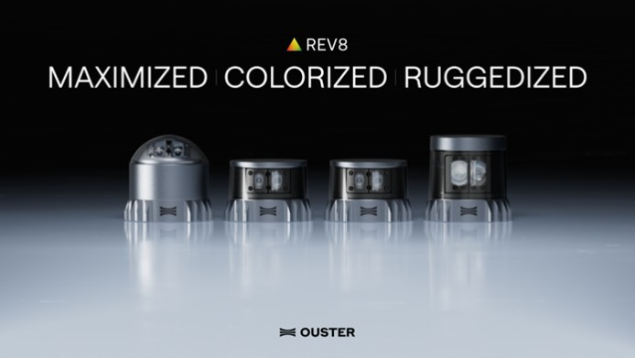
Caption 1: New Rev8 OS digital lidar with native color sensing, 2x range and resolution.

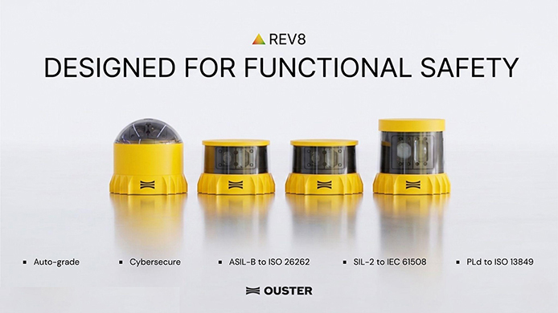
Caption 2: Ouster Rev8 OS Family: auto-grade, cybersecure, and designed for ASIL-B, SIL-2, and PLd functional safety certifications.


Caption 3: Native color point cloud, captured by Ouster Rev8 OS1 Max in San Francisco, CA.

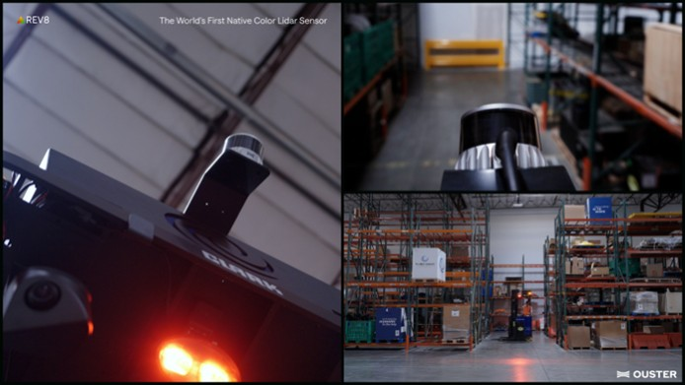
Caption 4: Ouster’s native color Rev8 OS1, designed for functional safety and reliability.

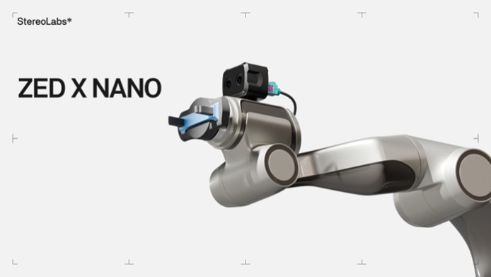
Caption 5: Stereolabs ZED X Nano, a wrist-mount stereo camera built for robotic manipulation and Physical AI.

